Sponsor Testimony of Representative Wes Retherford
Regarding the House Bill 108
Before the House Government Accountability and Oversight Committee
Tuesday, December 6th, 2016

Chairman Blessing, Vice Chair Rezabek and Ranking Member Clyde, thank you for this opportunity to present sponsor testimony on House Bill 108.
As my joint sponsor has testified, this bill is a common sense solution to transparency in the committee process. Besides offering the transparency to the public, allowing them to watch and listen to the witnesses and questioning through the Ohio Channel, it would also provide a valuable tool to ourselves as well.
I am sure many of you find yourself in the same position as I am on many committee days. I currently have 2 committees scheduled at the same time, add onto that sponsor testimony in other committees, constituent meetings and the regular negotiations that happen as part of this job, there are often times where you miss some of the testimony and Q&A. While Hannah and Gongwer, along with other news sources provide some of this, it is hard to cover everything that was asked and answered. Of course all written testimony is available now, but how much better would it be to be able to go and watch the Q&A of testimony, or even to be able to go back and refresh your memory.
By providing this service to ourselves and to our constituents, we can make the process even better. Remember, sunshine is the best disinfectant, and HB 108 allows a lot more sunshine into the process.
I know that this late in the year, we will see little action on HB 108, but I hope that this committee take a serious consideration of the bill going into the next GA. I want to thank Rep. Ramos for allowing me to be a part of this proposed legislation and I want to thank you, Mr. Chairman and the members of this committee for giving us your time and attention.

Thank you.
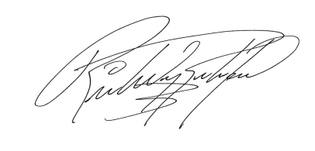

Wes Retherford
State Representative
Ohio House District 51

