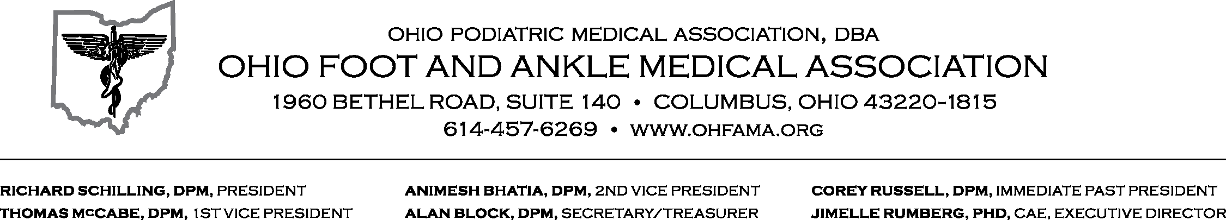

May 3, 2016

Chairwoman Sears, Ranking Member Bischoff, members of the committee, on behalf of Ohio’s podiatric physicians that make up the Ohio Foot & Ankle Medical Association (OHFAMA), I am offering our association’s written testimony in support of Senate Bill 129, the prior authorization modernization legislation jointly sponsored by Senators Randy Gardner and Capri Cafaro. OHFAMA appreciates the hard work of Senators Gardner and Cafaro on this bill and our podiatric physicians were very pleased when SB 129 passed the Ohio Senate with overwhelming support from both sides of the aisle. This bill is a very positive step forward for patients and will allow podiatric physicians and other providers to provide quality, cost-effective care in a more efficient manner.

As you know, prior authorizations (PA’s) are utilization management tools used by insurers with health care providers and patients regarding the level of utilization of services and goods (such as durable medical equipment, pharmaceuticals) that are permitted for use under the insurer’s coverage plan. While there are many divergent opinions concerning the positive benefits of prior authorizations and if the concepts of PA’s truly benefit patients through costs savings to the overall health care system, PA’s are a utilization management technique that is part of today’s health care environment and providers must deal with this administrative measure on behalf of their patients.
Ohio’s podiatric physicians and surgeons have routinely voiced their concerns to our association about the fact that prior authorizations, in their current form, have become administrative burdens for our physicians and their staffs. They spend countless hours communicating with insurers over recommended treatment regimens for their patients. I have also heard similar complaints from executive directors from other prominent health care organizations. This administrative function obviously takes time away from providers and their staffs in doing what they should; that is, spending time with their patients communicating and formulating plans to get them better and back to work and into their everyday lives.

My podiatric physician and surgeon members have told me about countless endless telephone delays, non-responses, and retroactive arbitrary rulings on previously approved PA decisions. Furthermore that is great difficulty in even making and communicating those PA decisions as being huge administrative impediments to providing timely, quality care. Some of my members have even shared with me the fact that they have had to hire extra staff to simply handle the amount of PA requirements required by the insurer. Simply put, this is far from a common sense approach to business. Legislative retooling is needed to help our member offices and the patients they serve.

Additionally, because it seems each PA process with each insurer is different, providers and their staffs spent countless time trying to determine what specific information is needed by what specific insurer on behalf of each patient. My members pride themselves on being true advocates for each of their patients, but it appears to OHFAMA that changes need to be made to the PA system to better deliver care.

For the reason that SB 129 attempts to address some of the many problems in the current system, OHFAMA is pleased to support the concepts being discussed by Senators Gardner and Cafaro in their bill. This important legislation will make positive changes to this currently burdensome system and truly benefit patients, providers and insurers. Many business groups come before this legislature to ask you to provide them relief from burdensome regulatory or administrative hassles that impede their productivity. Many health care providers like the ones OHFAMA represents are such small business owners and is asking for sensible regulatory and administrative relief through SB 129.

Improvements made by this bill will help both providers and insurers through the delivery of timely, quality care. Among its many components, SB 129 contains issues such as allowing providers to obtain PA’s through a web-based system, having a standardized PA form for use by provider and insurers, guaranteeing PA decisions are “good” for a certain period of time, prohibiting retroactive denial once a final PA decision has been rendered; all positive steps to making this a more streamlined, effective system that allows providers to deliver quality, cost-effective care to their patients. OHFAMA understands that discussions and meetings between the sponsors, insurers and specific health care provider groups have and will continue in attempt to reach a solution to this issue that will achieve the original goal of SB 129.

However, one issue that is of great importance to OHFAMA and a few other specific provider groups in the bill concerns the providers that will be make and review adverse PA decisions (Lines 133-140 of the original bill). As currently written, these adverse PA decisions would be made by either a physician or nurse under the direction of the medical director of the health insuring corporation or by a panel of reviewers of “other appropriate” health care providers, with at least one physician on the panel who is at least board certified or board eligible in the same specialty as the treatment under review. OHFAMA strongly believes that in the case of PA decisions regarding a podiatric physician and surgeon for services we perform under our recognized scope of practice, this language is not appropriate because a podiatric physician or surgeon is not guaranteed direct input into this process.

We can do much better in this section of the bill. OHFAMA, in conjunction with the Ohio Optometric Association and the Ohio Dental Association, has jointly submitted language to this section of the bill that would require (in these three areas) a provider of similar licensure to be involved in the adverse PA mechanism designed in SB 129. In the case of podiatric physicians and surgeons, our doctors have specific expertise in the defined services our members provide to both public and private program beneficiaries. This expertise should be openly welcomed and fully utilized in rendering these important decisions on behalf of patients, providers and insurers. OHFAMA would assume that insurers would embrace this expertise in order to provider a quality of care process for decision-making regarding the care of these important patients. OHFAMA is strongly and respectfully asking this committee to adopt this amendment to SB 129.

On behalf of Ohio’s podiatric physicians and surgeons, who serve many patients in the communities you serve throughout Ohio, I thank you for allowing me to submit written testimony today in support of the concepts being discussed in SB 129 as well as our strong request for additional language to the bill. As always, please do not hesitate to contact me if you have any questions.
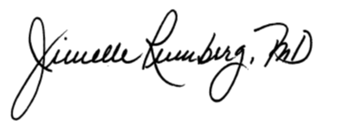

Jimelle Rumberg, Ph.D., CAE
Executive Director

