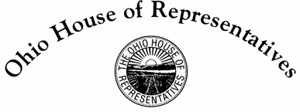
Representative Niraj Antani
42nd House District

Sponsor Testimony House Bill 427
Judiciary Committee
January 26, 2016
Chairman Butler, Vice-Chairman Manning, and Members of the Judiciary Committee, thank you for allowing me to provide sponsor testimony on House Bill 427, which would create a system to ensure the people receive the full benefit of a sealed or expunged record by having the Attorney General work with a third party to identify and remove sealed or expunged criminal records from data repositories and web sites that receive those records.
Currently, when your record is sealed or expunged, there is no way for private entities to know to seal or expunge the record. The public entities, such as courts, law enforcement agencies, and the state communicate with each other when a record is sealed or expunged; however, private databases and repositories have no way of knowing.
Thus, a person may think their record is sealed or expunged, when in reality the record still lives in private databases and repositories. There have been instances where people who have thought their record was truly sealed applied for jobs and left their criminal history blank; however, a background check comes up with a criminal history because the private repository didn’t know to seal the record. The person is then disqualified for employment for lying on their application, even though they thought their criminal history had been expunged or sealed.
This bill will provide a solution to this problem that will not burden the courts or the private entities. It will offer a non-mandatory service to the person seeking a sealed or expunged record.
This legislation is necessary for the people of Ohio because they are not afforded the true benefits they deserve, or are entitled, through the expungement and sealing of records. This bill will benefit both employers and job seekers throughout the state of Ohio.
Thank you for the opportunity to testify in support of House Bill 427. I would be happy to answer any questions at this time.

