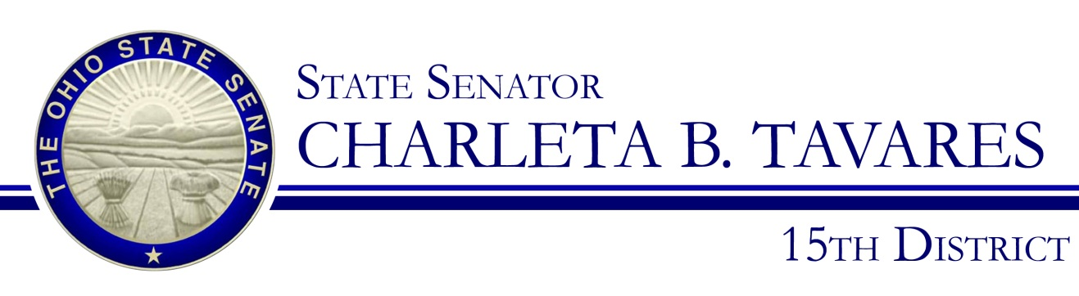

Sponsor Testimony
Presented by: Senator Charleta B. Tavares
Senate Bill 65
Civil Justice
Senator Kevin Bacon, Chair
Wednesday, March 25, 2015

Good morning, Chairman Bacon, Ranking Member Brown and members of the Civil Justice Committee. Thank you for the opportunity to present Senate Bill 65, that would make it an unlawful discriminatory practice for an employer to use a person’s credit rating, credit score or consumer credit history as a factor in making decisions regarding that person’s employment. The bill prohibits using an individual’s credit history in hiring, tenure, terms, conditions, or privileges of employment, or any matter directly or indirectly related to employment.

This bill will also allow a person to file a claim with the Civil Rights Commission alleging that another person has engaged in or is engaging in an unlawful discriminatory practice by using a person’s credit rating, score or consumer credit history as a factor in making decisions regarding that person’s employment and allows the Civil Rights Commission to conduct a preliminary investigation relating to that unlawful discriminatory practice.

Under federal law, employment credit checks are legal. The Fair Credit Reporting Act (FCRA) permits employers to request credit reports on job applicants and existing employees. Under the statute, employers must first obtain written permission from the individual whose credit report they seek to review. Employers are also required to notify individuals before they take “adverse action” (in this case, failing to hire, promote or retain an employee) based in whole or in part on any information in the credit report. The employer is required to offer a copy of the credit report and a written summary of the consumer’s rights along with this notification. After providing job applicants with a short period of time to identify and begin disputing any errors in their credit report, employers may then take action based on the report and must once again notify the job applicant.

The original intent of credit reports were not designed as an employment screening tool. Instead, they were developed as a means for lenders to evaluate whether a would-be borrower would be a good credit risk.

Those that would be most adversely impacted would be among the low- and middle-income households with credit card debt. Poor or declining credit is associated with households experiencing job loss, lack of health coverage, or having medical debt. The racially discriminatory potential of employment credit checks is the key reason that civil rights organizations such as the NAACP, the National Council of La Raza, the Leadership Conference on Civil and Human Rights, and the Lawyers Committee for Civil Rights under Law have publicly opposed the use of employment credit checks.

As of September 2014, eleven states (California, Colorado, Connecticut, Delaware, Hawaii, Illinois, Maryland, Nevada, Oregon, Vermont and Washington) have passed legislation to restrict the use of credit checks in employment and an additional 19 states introduced bills in 2014 to do so.

I am aware that a credit report may be necessary. The California bill lists eight types of positions that a credit report can be used when making a hiring decision. They are:
- A managerial position
- A position in the state Department of Justice
- That of a sworn peace officer or other law enforcement
- A position for which the information contained in the report is required by law to be disclosed or obtained
- A position that involves regular access, for any purpose other than the routine solicitation and processing of a credit card applications in a retail establishment
- A position in which the person is, or would be, any of the following:
  - A named signatory on the bank or credit card account of the employer
  - Authorized to transfer money on behalf of the employer
  - Authorized to enter into financial contracts on behalf of the employer
- A position that involves access to confidential or proprietary information, including a formula, patter, compilation, program, device, method, technique, process or trade secret
- A position that involves regular access to cash totaling ten thousand dollars ($10,000) or more of the employer, a customer, or client, during the workday.

U.S. Representative Steve Cohen (D-TN) and U.S. Senator Elizabeth Warren (D-MA) both introduced the Equal Employment for All Acton the federal level. This legislation would have amended the Fair Credit Reporting Act to prohibit the use of employment credit checks. “Using a job applicant’s credit history to deny employment is not fair because personal credit history is not an accurate predictor of job performance, Congressman Cohen stated. “We should be doing everything in our power to help people find jobs during these tough economic times – not hinder them.”

Chairman Bacon and members of the Committee, I appreciate your attention to this important issue and I respectfully request your favorable consideration and passage of Senate Bill 65. Thank you and I am happy to respond to questions from the committee.

15 U.S.C. § 1681 et seq

