November 17, 2015

Introduction to AFCC and Debt Settlement Issues and Comment on Ohio SB 226

Summary of Comment

- Introduction to AFCC
- Introduction to Debt Settlement
- General Industry Comment
- HB 173 provides strong consumer protections in its regulation of debt settlement providers.
- The fee provisions in HB 173 create strong consumer protection.
  - The FTC Rule regarding fees for debt settlement companies provides significant protection.
  - The benefit to an individual in debt settlement should be measured by comparing the total cost of the consumer’s other options. Under such comparison, debt settlement compares very favorably.
- HB 173 would create jobs in Ohio and create additional tax revenue
- The true story and statistics about complaints.
- Myths about debt settlement.
- Testimonials by consumers who have been helped by debt settlement.
A. Introduction to AFCC

AFCC, formerly known as TASC, is the leading national association of settlement companies. It was formed to provide operating standards for member companies and to promote effective and fair legislation affecting the industry. AFCC’s goals are to promote good business practice in the debt settlement industry, protect the interests of consumer debtors, and educate legislators and regulators at all levels of government with respect to the issues involved in the debt settlement industry. The mission of AFCC is to encourage debt settlement companies to provide services in accordance with the highest professional and ethical standards in order to retain the confidence of the public, the credit industry and local, state, and federal government. The standards AFCC upholds and promotes nationwide are available on its website at www.americanfaircreditcouncil.org.

To help ensure that the association’s rules and guidelines are in fact being followed by our members, AFCC started two programs of self-regulation – one is a secret shopping program performed by a company that calls each AFCC member debt settlement company posing as a consumer. The shopper makes certain inquiries and evaluates the responses on a check list to gauge whether the company is abiding by AFCC standards. The second program involves an examination of each debt settlement company member’s website to ensure that the advertising and statements made on the website are consistent with AFCC standards. Companies who do not pass the examinations satisfactorily are notified of the issues and are shopped again shortly afterwards. Continued failure to meet AFCC standards will result in revocation of that company’s membership in AFCC. AFCC has terminated the membership of non-compliant companies as well as imposed discipline on other members for various violations of its standards.

AFCC has supported stringent regulation for debt settlement companies on the state level that provides significant consumer protections including bills that have passed and become law in more than 13 states. Recently, Texas, Colorado, Missouri, and Maryland passed bills supported by AFCC that contain strong consumer protections. Nevada and a number of other states have recently revisited the issue of fee caps and have passed legislation to eliminate fee caps on the provision of debt settlement law. Fee caps are generally considered to be unnecessary in light of the FTC Rule, which became effective after Nevada passed its original debt settlement law.

B. Introduction to Debt Settlement

Debt settlement is an effective and needed debt relief option for consumers at a time when they need more options in managing their unsecured debt, not fewer options. Debt settlement does not involve mortgages, loan modification, foreclosure, or any other secured debt issues. Debt settlement serves those who cannot qualify for or afford other options such as bankruptcy and traditional credit counseling. Debt settlement is also effective when compared to these other debt relief options. The national rate of completion for confirmed Chapter 13 bankruptcy plans is 33%. Nonprofit credit counseling companies historically have an approximate success rate of 21-26%. Debt settlement completion rates for AFCC members prior to the FTC Rule were higher – approximately 34.5%-40%. However, according to the first industry benchmark data analysis prepared by Greg Regan at the forensic accounting firm Hemming & Morse (the “Regan Report”), while it’s still a bit premature to determine the ultimate completion rate for post FTC Rule clients, the data indicates completion rates should stabilize at over 50%. Moreover, unlike credit counseling, even those who only complete part of the debt settlement plan often benefit – for example, someone who had 10 debts coming into the program and now has 5 may leave the program comfortable that his debt is at a manageable level. Nonprofit credit counselors often cite similar benefits of partial completion and have recently even used “completion rates” that are based on consumers completing 60% of the credit counseling program. If the debt settlement industry used similar measurements, our completion rates would be significantly higher as well.

Another difference between debt settlement and credit counseling is that debt settlement is a reduction in principal of the debt, not just a reduction in the interest rate. As detailed in the Regan Report and depicted in the chart below, all clients regardless of status (i.e. active, completed, terminated), realized an average debt reduction of $3.15 for every $1.00 in fees paid to the debt settlement company (pre-FTC Rule and post-FTC Rule clients combined). Completed clients received an average debt reduction of $4.40 for every $1.00 paid in fees to the debt settlement company.

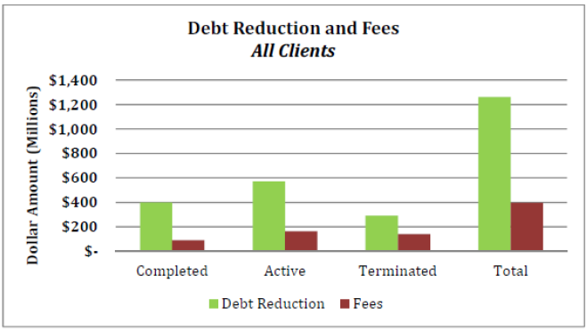

As depicted in the below chart, for clients enrolled post-FTC Rule, they routinely experience a net benefit regardless of status as they do not pay a fee until after a settlement is obtained. 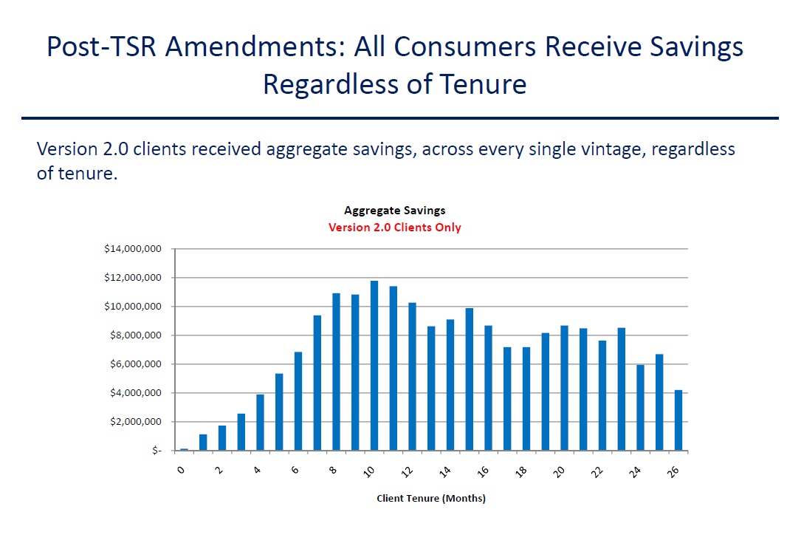

Another dramatic effect of the FTC Rule was the significant shortening in the amount time that elapses before a client experiences their first settlement. In fact, the average client receives a settlement within 4 months of enrollment in a debt settlement program. The below chart further illustrates the settlement timing breakdown, pre-FTC Rule and post-FTC Rule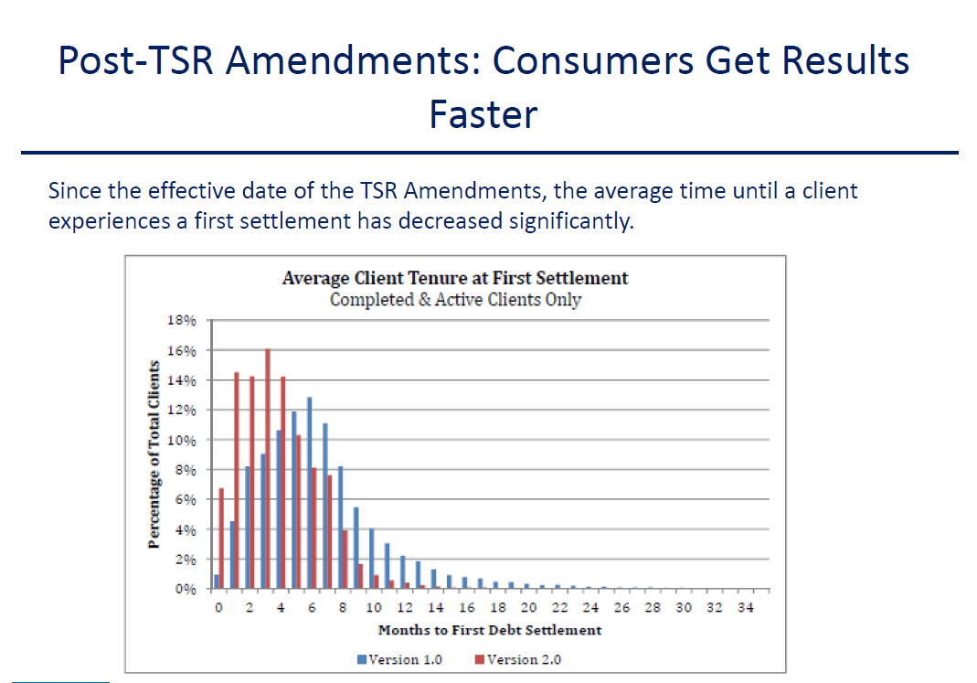

- The Debt Settlement Industry is Highly Regulated at the Federal Level

- The FTC, as part of the Telemarketing Sales Act of 2010, prescribes strong consumer protections in its regulation of debt settlement providers.

  - The FTC Rule regarding fees for debt settlement companies provides significant protection.

    - The FTC Rule provides the following protections:
      - The fees must be clearly and conspicuously disclosed prior to the consumer entering into an agreement with the provider.
      - No fees are chargeable until a settlement is reached.
      - The consumer has another opportunity to reject the fees by rejecting the settlement. Until a satisfactory settlement accepted by the consumer is reached, the consumer pays no fees.
      - The consumer not only must approve of the settlement, but must affirm that approval by making a payment towards the settlement.
    - The FTC Rule imposes a fee structure that is limited in the timing of when a provider may collect fees. It also is structured to ensure that fees must be proportionately collected, thus, protecting against fees being front-loaded in the program.
    - Market forces do work especially when it comes to pricing. While critics may claim otherwise, when limited to the specific price of a product or service, it is hard to refute the evidence that competition sets the market price. Even the FTC in the release of its Rule stated that the fee amount itself should be determined by the market. As such, requiring a specific fee cap is unnecessary and concerns that fees will be unfairly high is unfounded.

  - The benefit to an individual in debt settlement should be measured by comparing the total cost of the consumer’s other options.

When examining an individual’s “savings” in debt settlement, you must account for the time value of money of any other options. For example, if applied to the United States national debt, if the U.S. could pay off its debt in three years at what it owed today, the U.S. would still receive a great benefit. The U.S. pays $400 billion a year in interest. So really the U.S. would benefit by $1.2 trillion over those 3 years (and trillions in future interest).

The total cost of a debt management plan, credit counseling plan or other debt relief option likewise is much greater than just the principal amount of the debt because: (1) there is no reduction in principal; and (2) interest continues to accrue and is paid as part of the service. With debt settlement, reduction in principal provides significantly greater consumer benefit even including fees. For instance, if there was a 50% reduction in principal and a 25% fee (only paid if the consumer accepts settlement), the total consumer cost for debt settlement would equal $18,850 compared to $37,606 for credit counseling. The following chart illustrates this difference in consumer cost of various debt relief options.

$25,000 debt | Debt Settlement | Credit Counseling | Debt Consolidation Home Equity Loan[1] | Pay Minimum Due @ 2.5% of Balance
Months to pay off debt | 36 | 60 | 120 | 565 Mo | 47 Yrs
Interest Rate | 0 | 13%[2] | 9.00%[3] | 21.00%
Monthly Fees | 0 | $3,476.00[5] | $1,500.00[6]
Fair Share by Creditor to nonprofit CCCS |  | $2,730.00[7]
Total fees | $6,250.00[4] | $6,206.00 | $1,500.00
Interest[8] | 5,000.00[10] | $9,130.00[8] | $13,000.00[8] | $57,377.37[8]
Amount of Debt on Day 1 | $25,000.00 | $25,000.00 | $25,000.00 | $25,000.00
Amount paid on debt | $12,600.00[11] | $34,180.00 | $38,000.00 | $82,377.37
Total Cost inc. fees: | $18,850.00 | $37,606.00[9] | $39,500.00 | $82,377.37
- The true story and statistics about complaints.
The industry’s opponents have always cited significant complaint volume as support for their positions yet relied only on individual cases or anecdotal evidence. Every single one of the complaints deals with: a) pre FTC Rule fact pattern; or b) a company charging fees in advance of settlement either in violation of the FTC Rule or utilizing an exemption to the FTC Rule. SB 226 would make it clear in Ohio that FTC rules apply in addition to protections under Ohio law so that anyone trying to operate in the current “gray area” would be unable to charge advance fee.
- Myths about debt settlement.

Critics have additionally attacked debt settlement by using the following arguments:

- Debt settlement takes advantage of uneducated, low income individuals.
Debt settlement clients are not usually low income individuals. In order for an individual to accumulate enough debt to require the services of an AFCC member company, the consumer must have had a well-paying job to qualify for enough credit to accumulate the debt. Most companies do not take clients with less than $10,000 in debt and some have an even higher threshold. The average consumer in a debt settlement program enrolls around $20,000 to $30,000 in debt; usually comprised of 6 credit cards. Debt settlement clients often do not qualify for Chapter 7 bankruptcy because of the means test (that they make less than the median level of income for the State) and have typically experienced some financial hardship such as a divorce, job loss, or medical issue that created the financial problem.

- There is no reason to use a debt settlement provider since an individual can negotiate his or her own debt.
While debt settlement can be done by an individual herself, so can credit counseling/debt management. So can changing the oil in one’s car or fixing a leaky pipe. However, individuals usually are in a situation where they are seeking assistance with their debt and do not want to do it on their own. Further, negotiating down the principal of a debt is more difficult than asking for a reduction in interest. Debt settlement providers also provide an expertise and knowledge that helps provide an advantage in many ways including knowing who to contact, when to negotiate, tendencies of certain creditors and the many changing policies of creditors. In addition, they are able to settle a large number of debts in bulk, thus leading to economies of scale.

Consumers often do not qualify for credit counseling programs and continually report to debt settlement providers that attempts to work directly with the creditors have failed. A large AFCC member reports that a majority of consumers that they talk to have tried and failed to get creditors to work out an affordable arrangement. An example is given in the below testimonial from a consumer who finished the debt settlement program:

“I attempted to call the credit card companies to see if they would work with me on some type of payment plan so that I could get caught up with all the late payments and extra fees that they tacked on my balance. They would not work with me at all. The settlement on my largest debt so far exceeded my expectations . . . . Keep in mind this was the same creditor that would not talk to me at the beginning. There is no way I could do this by myself.” Brian L.

- Debt settlement causes individuals who would otherwise pay their debts timely to default on their debt.
This is absolutely not true. Consumers that qualify for a debt settlement program are either already behind or imminently about to fall behind on their debt payments. They make a conscious, voluntary choice to cease attempting to pay off the debt they can no longer afford and, instead, focus on attempting to pay back as much as they can afford. Creditors are often unwilling to work with these consumers and consumer credit counseling is simply not affordable for the average debt settlement client.

- Debt settlement is not effective because interest and late fees continue to accrue.
Interest and late fees do accrue, but interest accrues with any debt relief option a consumer may choose. Some critics have also misrepresented the problem. Interest and late fees do not continue to accrue for the life of the debt – once the debt is charged off (typically when debt has been 6 months late) the debt is written off and usually the contractual terms expire. Federal regulations require that banks charge off revolving credit accounts 180 days after delinquency at which time the debt is removed from the creditors’ books. Thus, typically after 6 months, creditors charge off the accounts and accrual of interest stops altogether. Suze Orman, host of The Suze Orman Show on CNBC, recognizes this and states, ”At the time the account is charged off, the creditor usually stops the clock on interest charges . . .” Again, the debtor would normally have experienced the same charges regardless of the debt settlement program.

- Testimonials by consumers who have been helped by debt settlement.
AFCC has numerous testimonials in favor of debt settlement and positive testimonials greatly outweigh the negative testimonials. As an example, the FTC sought comment on its proposed rule and received approximately 200 consumer testimonials regarding debt settlement of which only 4 were negative and of those, 3 of the negative comments focused on creditors. These testimonials are available at www.ftc.gov. Also see www.consumercreditrights.org for video and audio recordings of consumers who have had positive experiences. A sampling is provided below. AFCC can provide more testimonials upon request.

Lucida
Upon your companies advice I looked into Consumer Credit Counseling and decided that it simply would take too long and I would not be able to afford those kinds of payments. By going through your debt settlement program I have learned to recognize my finances and put myself on a budget. I really feel that you have helped me out not just now but for the rest of my life.”

Kregg
I was really ready to end it all just about a year ago . . . faith in God and your encouragement helped me through.

Lisa
I’d like to thank you and your organization ONE MORE TIME for all that you have/will do for me. I am extremely sure at this point, that you did indeed, literally, save my life.

Rick
Debt settlement not only saved me a lot of money, but it taught me how not to get into trouble again.”

Mary
“Bankruptcy was not the answer . . . I feel the fees have been more than fair because of the settlements I have received already.

Joseph
. . . due to you [sic] program I now do not have any unsecured debt which I NEVER would have been able to do without you. I also learned valuable lessons that have changed my lifestyle. Due to the counseling you gave me in the debt settlement program I have a much better idea of how to budget so that I never have to be in that position ever again.

In closing, AFCC believes the FTC Rule provides sufficient and significant protection for consumers, and addresses the key concern voiced about the industry, the charging and collection of advance fees. Together with the other protections offered by SB 226 including bonding, independent third-party auditing and protections under the state’s Consumer Sales Practices Act, consumers in Ohio would be amongst the strongest protected in the country. Consumers today need more options to help manage their debts, not fewer options. Further, consumer protection involves not only preventing harm, but providing help. SB 226 accomplishes both of these goals and AFCC supports its passage.

Respectfully submitted,
American Fair Credit Council (AFCC)

TASC changed its name to coincide with the industry wide changes occurring after the new FTC Rule took effect.
Demographic data provided by some AFCC members shows the average household income for its clients was $70,000 which is greater than the means test requirement for Chapter 7 bankruptcy.
Credit counseling monthly payments are often approximately 2.5% of the debt – the same amount as many individuals’ minimum payments.
“Bankruptcy by the Numbers: Measuring Performance in Chapter 13” by Gordon Bermant and Ed Flynn, Executive Office for the U.S. Trustees.
Credit Counseling in Crisis: The Impact on Consumers of Funding Cuts, Higher Fees and Aggressive New Market Entrants, Consumer Federation of America and National Consumer Law Center, April 2003.
TASC Comment Letter to FTC, October 2009.
An executive summary of the Regan Report is attached as “Addendum A” hereto.
See Joel Winston letter as well
[1] Assumes good credit and sufficient home equity.
[2] Testimony of nonprofit credit counseling agency at a committee hearing in Salem, Oregon, February 9, 2009 – the credit counselor stated she was unable to obtain concession rates better than 16% for her consumers; Credit Counseling in Crisis: The Impact on Consumers of Funding Cuts, Higher Fees and Aggressive New Market Entrants, Consumer Federation of America and National Consumer Law Center, April 2003 – average of concession rates was approximately 13%.
[3] Per Bankrate.com for Denver, Colorado area - Wells Fargo Bank. [4] Assumes a fee of 25% of debt ($25,000 x 0.25).
[5] $75 initial fee + (5x$100) annual counseling fee + (8.5% x monthly payment) per Ohio R.C. Section 4710.02 =
[6]Assumes 10 year loan and total fees 6% of loan value.
[7] 8% of client payments fair share - See page 2, lines 41-43 of H.P. 895, Legislative Document No. 1289, 124th Maine Legislature. [8] Interest calculated by using Bankrate.com or CNNMoney.com calculators; does not include potential late fees, penalties, other costs.
[9] $25,000 principal + $9,130 interest + $3,476 fees = $37,606. Fair share comes out of the principal/interest payment. [10] The 50% settlement figure is based off of debt at time of enrollment and any interest accrued is factored into the settlement percentage for this example. Similar numbers can be calculated using accretion rates and corresponding settlement percentages. [11] ($25,000 + $5,000) x 0.42 = $12,600. Based on average settlement percentage of 42% of total balance per TASC Comment Letter to FTC, October 2009
Demographic data provided by Freedom Debt Relief shows the average household income for its clients was $70,000 which is greater than the means test requirement for Chapter 7 bankruptcy.
Delivering Value to Consumers in a Debt Settlement Program, Hasnain Walji, Ph.D., October 16, 2009 – Source: QSS 2009 Survey, an independent third-party survey company.
The debtor may still incur collection charges.
Cackley, Alicia Puente (2009). Credit Cards: Fair Debt Collection Practices Act Could Better Reflect the Evolving Debt Collection Marketplace and Use of Technology
Collection charges may be separately imposed for attempts to collect a debt.
http://www.suzeorman.com/igsbase/igstemplate.cfm?SRC=MD012&SRCN=aoedetails&GnavID=84&SnavID=20&TnavID=&AreasofExpertiseID=19
Excerpt from testimonial - Source: Quality Survey Services (QSS) 2009 Survey, an independent third-party survey company.
Excerpt from testimonial submitted by AFCC for FTC Workshop on Debt Settlement, Sept. 25, 2008.
Id.
Excerpt from testimonial - Source: Quality Survey Services (QSS) 2009 Survey, an independent third-party survey company.
Id.
Id.

