TESTIMONY

BEFORE

THE OHIO SENATE
FINANCE COMMITTEE

Wednesday, June 10, 2015

OHIO ASSOCIATION OF AREA AGENCIES ON AGING

Presented by

Billie Johnson
President and CEO
Area Office on Aging of Northwestern Ohio

Chairman Oelslager, Ranking Member Skindell, and members of the Committee, thank you for giving me the opportunity to testify today. My name is Billie Johnson, and I am the Vice President of the Board of Directors for the Ohio Association of Area Agencies on Aging (o4a) and President and CEO of the Area Office on Aging of Northwestern Ohio, which is based in Toledo, Ohio and serves ten counties in the surrounding area.

Our Association represents the twelve regionally-based Area Agencies on Aging in Ohio (ten of which are nonprofit organizations) that fund, plan, and coordinate services for, as well as advocate for, older adults and their families throughout Ohio. The Area Agencies on Aging were established under the federal Older Americans Act in 1973 to serve as the “on the ground” organizations charged with assisting older persons to live with independence and dignity in their homes and communities. The Area Agencies on Aging have over 40 years of experience serving our communities.

In 2009, my Area Agency on Aging received $744,000 from the Senior Community Services block grant. At that time, our average cost per meal was $3.54, this meant we were able to serve 210,150 meals to 4,421 home bound senior citizens. By 2014, our award was cut to $547,000, at the same time our cost per meal increased to $7.10! Now we are able to serve only 77,000 meals yet 5,492 people have been assessed to need these meals. The consequences of these cuts are tragic.
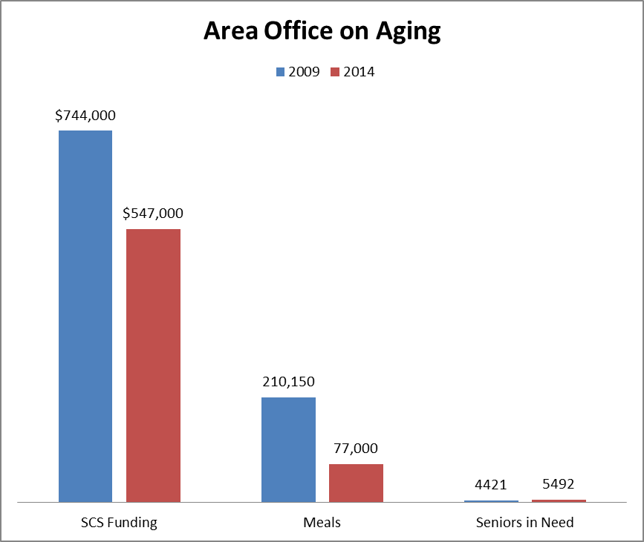

Senior citizens, who have worked their entire lives, are no longer able to obtain the nourishment they need to maintain their health and live productively in their community. We were forced to cut our weekend and evening meal services. Each meal is designed to meet 1/3 of the nutritional needs of an older adult. If only five meals per week are eaten, only 23% of nutritional needs are being met. Hunger is a health issue and the lack of adequate nutrition can have many medical consequences. Medications may not work properly, unnecessary emergency room or hospital admission can occur and worst of all death can be the results of malnutrition.

I would like to share with you three real profiles of seniors who were willing to publicly admit to food insecurity and the lack of proper nutrition.

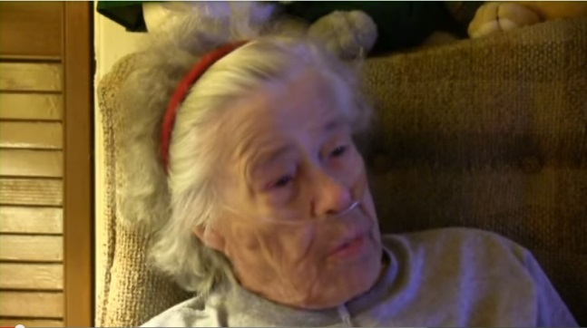
Mary (not her real name) was 94 years old. She received Social Security but it didn’t come close to covering her bills and she had very little left for groceries. She typically had one meal a day, amounting to a little more than 400 calories, the same amount as a caramel Frappuccino. Mary was very grateful for the one meal a day that she received from the local home delivered meals program. Mary worked before she retired and waited on people all her life; she never thought the day would come when she would depend on others to “wait on” her and provide food for her daily nutrition. Mary has since passed away. No one knows if her lack of nutrition may have been part of the cause of her death but clearly we all hurt that we didn't have enough resources to provide more meals to help Mary during her later years of life.
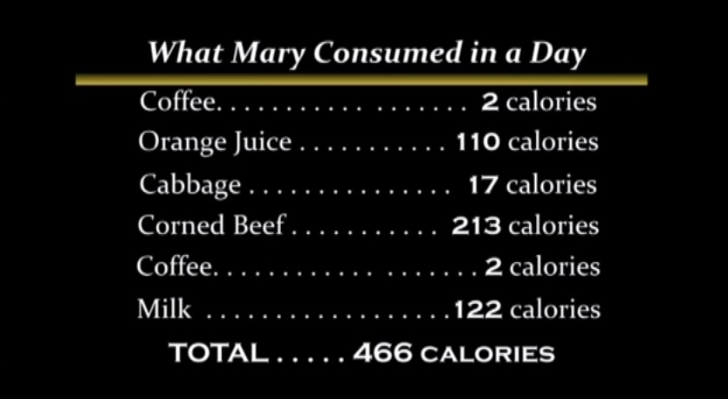

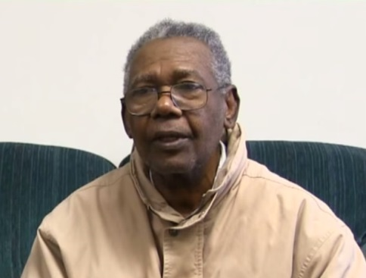
Paul (not his real name), worked as an accountant, an electrician and a laborer. Often, he has had to choose whether to pay for his heart medication or to go without food. Sometimes he says it is easier to go without food for a day. When he runs out of medication and cannot afford to buy more, he has ended up in the hospital; five days in the hospital cost over $45,000.

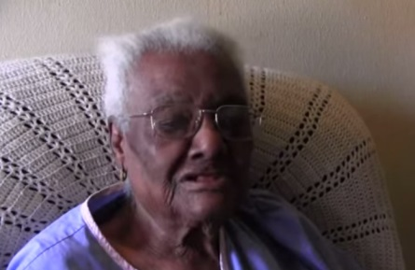
Bobbie (not her real name) is 91 years old. She has no teeth and no dentures. She gets one home delivered meal per day Monday through Friday. She receives no other food. On most days she has no other human contact other than the person who delivers her meals. She makes her meal last all day and goes to bed hungry. She feels ashamed that she has worked all her life but cannot now buy food for herself. She doesn’t tell people she is hungry.

These three seniors are from northwestern Ohio. They are featured on a video entitled “Silent Hunger” that the Area Office on Aging put together to put faces to the problem of senior hunger in our community. https://youtu.be/L0oRIP6ae4A?list=FLPNR73RCDFiY_xSGqb8LlMA

They won’t tell you they are hungry. They try to make the food they have last for as long as they can. They go without medication, or without food, and end up in the hospital or in a nursing home.

We estimate that in our region there are over 12,000 stories similar to Mary, Paul and Bobbie’s.

Our agency does what it can to provide senior nutrition programs to seniors in our area, but it is not enough.

We rely on funding from the Older Americans Act, the Senior Community Services block grant, and local levy and private donations to support our senior nutrition programs, and yet seniors still go hungry. Unfortunately, funding for senior nutrition programs has not kept pace with the needs and growth of the population, and has been subject to cuts at the federal and state levels. Many programs have developed waiting lists or scaled back service to homebound seniors.

Senior nutrition programs are a cost effective way to address senior hunger. One year’s worth of meals is about $1800. That same amount is less than one day in the hospital, and about 7 days in a nursing home. Senior nutrition programs allow people to live in their homes, help to keep them out of the hospital and provide them with social interaction they may not otherwise have.

We are asking you to commit to fighting senior hunger by restoring cuts to the Senior Community Services block grant, within the Department of Aging’s budget.

A small increase in state funding for senior nutrition programs can actually save the state money in more expensive Medicaid health care and long term care costs. At its peak in 2001, the Senior Community Services block grant was at more than $15 million per year; unfortunately, it has continued to be cut and currently it is less than half that level, at $7 million per year.

SENIOR COMMUNITY SERVICES BLOCK GRANT - Budget year funding, in millions
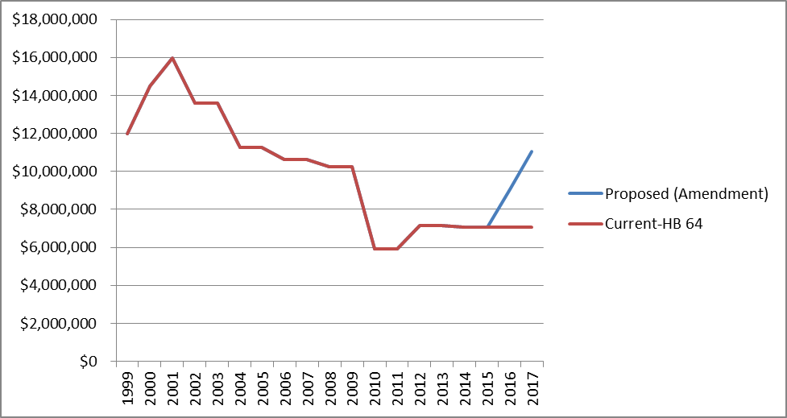

HB 64 proposes level funding for the next two years. We ask that you gradually restore the cuts to the Senior Community Services block grant in this biennium by a $2 million increase in SFY 2016 and a $ 4 million increase in SFY 2017. This small amount can serve over a thousand more hungry Ohio seniors each year.

Thank you for the opportunity to testify today and thank you for your continued support of Ohio’s seniors. I will be happy to answer any questions you may have.

