Senate Education Finance Subcommittee
House Bill 64 Testimony
Randall R. Bertram
Treasurer, Middletown City School District

Chairman Hite, Vice Chair Sawyer, and members of the subcommittee, thank you for the opportunity to address you concerning the provisions of HB 64. My name is Randy Bertram, Treasurer for the Middletown City School District.

Let me begin by recognizing that HB 64 does provide significant additional funding for public education. We appreciate the additional dollars that have been earmarked for primary and secondary education. After reviewing HB 64, we have the following observations and suggestions for your consideration.

With the releases of the House’s proposal and now your proposal they contain significant changes from the Executive budget. The most relevant change from Middletown’s perspective was the lowering of the funding cap from 10% each year to 7.5% each year in both the house’s and Senate’s versions. Baseline comparisons as it relates to the Middletown City School District is illustrated below.

*Based on the Executive Budget simulations

We are appreciative of the proposed increases, however, we believe that holding the guarantees for many other districts, which funds them at more than 100%, is resulting in the inability to fully fund our district and many more at the 100% they deserve as well. As you can see by the illustration above our district is being underfunded by a third ( $16,600,00 to 18,300,000) resulting in the need to borrow money for cash flow purposes ($3,500,000 in FY15 and $2,500,000 in FY16) and resulted in 37 teaching professionals leaving our district this summer to go to other districts for much greater pay. We submit the following information for the Senate’s consideration.

The House added an additional $101.6 million to hold all school districts financially harmless from foundation formula losses an additional $100+ million was added at the end to hold all school districts financially harmless of any loss caused by the reduction in Tangible Personal Property Tax Loss Reimbursement and the Senate as also proposed the guarantee and holding district harmless.

If the legislative bodies are interested in getting all districts on the formula you need to look at the following data for Middletown City Schools pertaining to a 7.5% cap and 10% cap.

7.5% Growth Cap Forecast Model
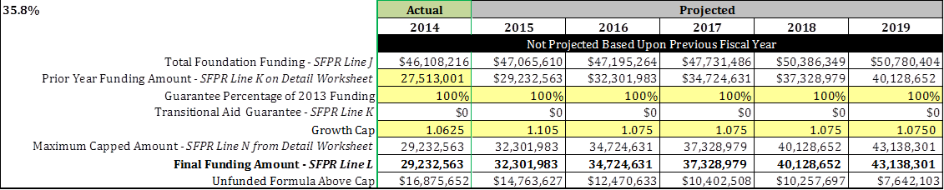

10% Growth Cap Forecast Model
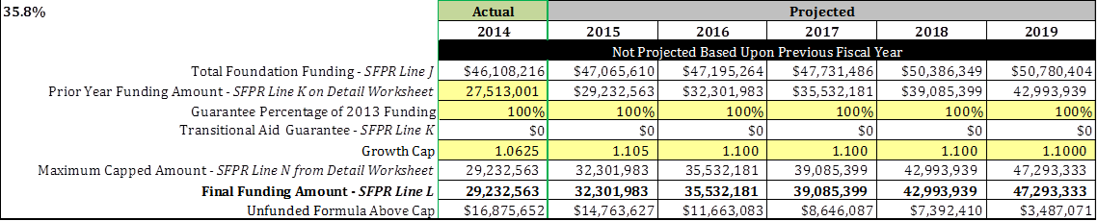

*Based on current May 2015 five-year forecast modeling

So with the growth cap at either 7.5% or 10%, Middletown City Schools will not be formula funded through fiscal year 2019. The Governor framed his school funding proposal on the basis of increasing funding to those school districts that need the money and Middletown City Schools surely needs the money to stop the cash flow borrowing and to retain high quality experienced teachers.

Median income is a key indicator of a district’s residents’ ability to pay. Middletown’s median income is less than half of Mason’s, Loveland’s and Lakota’s median income and it is 36% lower than Princeton’s median income. Income level is also a key indicator in the level of academic support that a community will need to attain an adequate education. As illustrated below in the Local Tax Effort Index the residents of Middletown City Schools contribute about 3 times as much local revenue as their counterparts in abilities to pay.

Ultimately, all of the funding factors lead to your ability to pay your teaching staff. Middletown lags Lakota by $6,984, Mason by $8,719, Princeton by $8,386 and Loveland by $11,999 in average teacher pay. This is precisely what Governor Kasich was getting at when he developed the Executive Budget. The districts in need of financial resources are the ones that the state should direct their funding to in order to meet the educational needs of all students. Lakota, Mason, Princeton and Loveland all have substantially more capacity to raise revenue per pupil and that plays out in more programs for students and higher average teacher salary.

But wait, there is more. A review of the 5 year financial forecasts that were submitted in May 2015 shows the following Cash Balances and Percentages of Revenue as of June 30, 2019 for our comparison districts that are hiring our trained teaching and administrative staff:

Is it good public policy to hold wealthy school districts financially harmless while we place the lower wealth school districts on funding caps? The House version and now the Senate’s version of the budget maintains funding levels to school districts that are already collecting substantially more than the state average revenue per pupil and tells school districts that are on the cap to accept 2.5% less per year as compared to the Executive Budget in order for the wealthy districts to continue paying their staff higher salaries.

This is a serious problem because we have several wealthier school districts within a 30 minute drive and we lose a significant number of teachers to those districts each year (37 this year).

We hope this information will be helpful to you as the budget continues through the process in the Senate and, in all likelihood, a conference committee. I ask you to look at creative ways to help our district, and districts in the similar situation, and find a happy medium between the guarantee (districts over funded for the students they currently have) and our districts that are grossly underfunded by 10%, 20% and even 33% or more as we are. Middletown City Schools currently educates 5,928 students but we are being funded as though we are educating just 3,197. In other words we are being under funded by 2,731 students because of the effect of the growth cap.

The Middletown City School District is appreciative of your efforts. We believe the Senate’s formula has merit but that the caps need to move closer to the Executive version. TPP loss reimbursement needs to be phased out, and districts need to be weaned off the guarantee in a measured and reasonable time line that allows school districts to manage that change. Poor Rural school districts need to see an increase as well.

To continue to fund school districts for student enrollments from several years ago does not make sense. Continuing to fund wealthy school districts at the expense of poorer districts simply to keep the electors and leaders of rich school districts happy or quiet is not a good public policy and will allow the funding disparities to continue.

At this point it has not been an issue for Middletown because of the funding caps, but when we come out from under the funding caps we will have to project our annual funding including an assumed reduction of students. Essentially, the public policy statement being made is as follows:

Once again, I thank you for your time and attention. Should you have any questions, I would be happy to try to answer them at this time.

Respectfully,
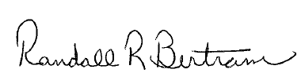
Randall R. Bertram, Treasurer/CFO
rbertram@middletowncityschools.com
(513) 423-0781 Office
(513) 420-4579 Fax

Source data for this testimony is the 2014 Cupp Report, May 2014 Financial Forecasts and Funding Simulations.

