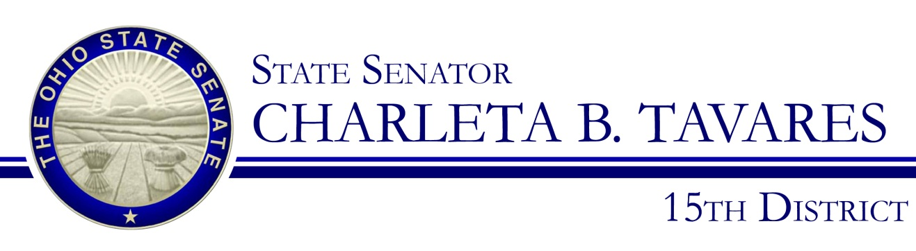

Sponsor Testimony
Presented by: Senator Charleta B. Tavares
Senate Bill 74
Health and Human Services
Chair Senator Shannon Jones

Good morning, Chairwoman Jones, Vice-Chair Lehner and members of the Senate Health and Human Services Committee. Thank you for the opportunity to present Senate Bill 74 which will prohibit a person, who is licensed to provide professional counseling, from engaging in sexual orientation change efforts with a person less than 18 years of age. This will not prohibit counseling that provides acceptance, support, and understanding of a person or facilitates a person’s coping, social support, and identity exploration and development, including sexual orientation-neutral interventions to prevent or address unlawful conduct or unsafe sexual practices provided that these do not also seek to change sexual orientation.

The intent of this legislation is to discourage the perception of homosexuality as a psychological disorder and prevent treatment that, in addition to being forty years out of date, is ineffective and provides harmful treatments to minors. Sexual orientation is not a disorder and perception as such can lead to increased depression and greater suicide risks. LGBT youth are not diseased or psychological underdeveloped and should not be subjected to treatments that reinforce such futile and obsolete practices.

Senate bill 74 will protect minors from being forced to undergo “conversion/reparative therapy” in order to change their sexual orientation or gender identity. Such therapy has been reported to be unethical, harmful and generally opposed by numerous psychological and medical organizations and associations. In 2015 Ohio and 15 other states introduced legislation that would eliminate conversion therapy and New Jersey, California, Oregon, Illinois, and the District of Columbia have already banned the practice.

In 2007, a task force of the American Psychological Association undertook a thorough review of the existing research on the efficacy of reparative therapy. Their report noted that there was very little methodologically sound research on sexual orientation change efforts (SOCEs) and that the "results of scientifically valid research indicate that it is unlikely that individuals will be able to reduce same-sex attractions or increase other-sex sexual attractions through SOCE." In addition, the task force found that "there are no methodologically sound studies of recent SOCE that would enable the task force to make a definitive statement about whether or not recent SOCE is safe or harmful and for whom.

Here are some quotes from professional medical associations concerning “conversion” or “reparative” therapy:

American Academy of Child Adolescent Psychiatry
"Clinicians should be aware that there is no evidence that sexual orientation can be altered through therapy, and that attempts to do so may be harmful. There is no empirical evidence adult homosexuality can be prevented if gender nonconforming children are influenced to be more gender conforming. Indeed, there is no medically valid basis for attempting to prevent homosexuality, which is not an illness. On the contrary, such efforts may encourage family rejection and undermine self-esteem, connectedness and caring, important protective factors against suicidal ideation and attempts."

American Medical Association
"Our AMA… opposes, the use of 'reparative' or 'conversion' therapy that is based upon the assumption that homosexuality per se is a mental disorder or based upon the a priori assumption that the patient should change his/her homosexual orientation."

Other groups that oppose conversion therapy include:
- American Academy of Pediatrics
- American Association for Marriage and Family Therapy
- American College of Physicians
- American Counseling Association
- American Psychiatric Association
- American School Counselor Association
- American School Health Association
- National Association of Social Workers
- Pan American Health Organization (PAHO): Regional Office of the World Health Organization
- United Nations Human Rights Council

Undergoing conversion therapy can be detrimental to a person’s mental wellbeing and unlike an adult, minors are unable to end their “treatment” under their own volition. They are essentially forced to endure a very traumatic process that can have lifelong repercussions. According to the American College of Physicians

“Available research does not support the use of reparative therapy as an effective method in the treatment of LGBT persons. Evidence shows that the practice may actually cause emotional or physical harm to LGBT individuals, particularly adolescents or young persons. Research done at San Francisco State University on the effect of familial attitudes and acceptance found that LGBT youth who were rejected by their families because of their identity were more likely than their LGBT peers who were not rejected or only mildly rejected by their families to attempt suicide, report high levels of depression, use illegal drugs, or be at risk for HIV and sexually transmitted illnesses. The American Psychological Association literature review found that reparative therapy is associated with the loss of sexual feeling, depression, anxiety, and suicidality.”

Unfortunately Ohio knows all too well the tragic consequences that result from a young person forced to undergo conversion therapy. On December 28, 2014, Cincinnati teen Leelah Alcorn completed suicide. Leelah, who was transgender, had been subjected to conversion therapy by her parents and heartbreakingly chose to end her own life rather than be made to believe that she was fundamentally flawed and needed to be “fixed”. Leelah’s death sparked a nationwide conversation about conversion therapy. In April of 2015, President Obama issued a statement asking that states act in interest of its citizens’ health and safety by working to end conversion therapy. I stand with the President, the various medical and counseling organizations, and the overwhelming scientific evidence and urge Ohio to become the 5th state to no longer allow this harmful practice to be used on minors.

Chairwoman Jones and members of the Committee, I appreciate your attention to this important issue and I respectfully request your favorable consideration and passage of Senate Bill 74. Thank you and I am happy to respond to questions from the committee.

Human Rights Campaign, http://www.hrc.org/resources/entry/the-lies-and-dangers-of-reparative-therapy
http://www.guideline.gov/content.aspx?id=38417#Section420
H-160.991 Health Care Needs of the Homosexual Population
Lesbian, Gay, Bisexual, and Transgender Health Disparities: Executive Summary of a Policy Position Paper From the American College of Physicians

