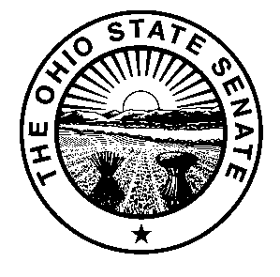
Scott Oelslager
State Senator
29th District
Senate Building
Columbus, Ohio 43215
Phone: (614) 466-0626
Oelslager@ohiosenate.gov

Senate Bill 363
Sponsor Testimony
Senate Transportation, Commerce & Labor Committee
November 30, 2016

Chairman LaRose, Vice Chair Manning, Ranking Member Cafaro, and members of the Senate Transportation Committee, thank you for the opportunity to offer sponsor testimony on Senate Bill 363. This legislation would create the Buckeye Corvettes, Inc. License Plate. The proceeds from the sale of this plate will be used for charitable giving. I have included a sample of license plate at the bottom of my testimony.

Established in Canton in March of 1960, Buckeye Corvettes sought to bring together Corvette enthusiasts in Northeast Ohio. In addition to social gatherings, the group organized philanthropic events to benefit the Muscular Dystrophy and Spina Bifida Associations. Today, members continue to gather together to hold fundraisers for various charities, including Wounded Warrior Project, Akron Children’s Hospital, Community Hospice, Pegasus Farm, Akron-Canton Food Bank, and others. Additionally, Corvettes from the club are displayed at local car shows, homecomings, and the prestigious National Pro Football Hall of Fame Grand Parade.

The creation of this license plate will allow members of Buckeye Corvettes, Inc. to continue supporting charitable organizations across Ohio. Thank you for allowing me to testify on Senate Bill 363, and I am happy to answers any questions you might have.

