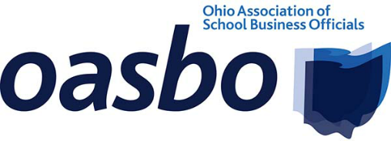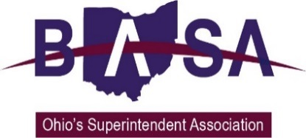

Date: January 16, 2018

To: The HonorableTim Schaffer, Chairman
House Ways and Means Committee

From: Barbara Shaner, OASBO
Jay Smith, OSBA
Tom Ash, BASA

Re: Continued Opposition to Amended House Bill (Am. HB) 343

C: Speaker Cliff Rosenberger
House Ways and Means Committee

We are writing to confirm our continued opposition to Am. HB 343, the recent amendments to the bill notwithstanding. We believe the bill to be unnecessary and potentially harmful to school districts. We urge you to reject Am. HB 343.

Our three organizations represent public school district boards of education, superintendents, treasurers/CFOs, business managers, and other school business officials from around the state. On behalf of our members, we maintain that Ohio’s current property valuation and tax system has worked to benefit its citizens for decades. We believe it affords all interested parties the ability to participate in the process by providing a proper procedure for checks and balances to preserve and maintain fair and equal taxation practices. Am. HB 343’s unnecessary changes to this long-respected system are highly objectionable.

The recent amendment that scaled back the number of resolutions required by a board of education when challenging property valuations is, of course, an improvement to the as-introduced version of the bill. However, we continue to question the purpose and advisability of the requirement for the board to take a vote. We also oppose the requirement that school districts send notifications to the property owner prior to the board taking action.
- The Board of Revision is already required to notify the property owner when values are challenged.
- The unfunded mandate for notification will add unnecessary cost to school districts and taxpayers.
- The required advance notice of the property owner before the board of education votes to challenge property values will make the decision of the board more political.
  - Am. HB 343 opens the process to become politicized by giving property owners the ability to put pressure on the board not to challenge property values prior to board action. This has the potential for removing all objectivity from the process.
  - Ohio law is clear that the sale price of a property is the best determiner of the property’s value. Therefore, challenges based on sales are reasonably evident, and no purpose is served by a property owner urging the board of education not to file a claim.

In a recent hearing on Am. HB 343, a witness was asked what the bill would require him to do that he and his board do not already do. The implication was that if the district is already utilizing “best practices,” why would he oppose the bill? The following are the differences between what districts do now and what is required in the bill:

- Notify the property owner that the district is considering a Board of Revision filing on the value of their property.
- Passing a board resolution naming all the properties where the board intends to challenge values (after notification is made and before a filing can occur).

As we have already stated, these requirements are either redundant or unnecessary. This begs the question: what is the purpose of the bill?

We agree with the bill sponsor’s assertion in sponsor testimony that school board members should be aware that the district is taking action to challenge property values when believed to be valued too low. That is why we have offered the attached list of “best practices” that would serve as a substitute to the provisions in Am. HB 343. (See the attachment at the end of this memo.)

We believe our list satisfies the concerns that have been raised in the committee hearings and interested party meetings. Otherwise, we can only conclude that the purpose of the bill is to create a chilling affect against the ability for boards of education to participate in the Board of Revision process.

Again, we urge you to reject Am. HB 343 or adopt the list of “best practices” contained in the attached. Remember that when a school district successfully challenges property values that are set too low, all the other taxpayers in the district stand to benefit.

Thank you for your consideration.

HB 343 ~ Suggestions for Addressing Perceived Abuses in the Board of Revision (BOR) Process

We believe the majority of school districts engaging in the BOR process by filing claims requesting valuation increases (or counterclaims defending the auditor’s values) operate in a fair and ethical manner. Our associations oppose the proposed major changes in the process that would affect every school district regardless of prior behavior and thereby create an imbalance in the system; creating differences in how property owners and taxing entities are treated.

The following are suggestions for addressing the perceived abuses of the privilege of participating in the BOR process:

- Boards of education (and other local government taxing entities) that intend to file claims and counterclaims to request valuation increases (to defend the auditor’s values) must pass a resolution setting the parameters for the district’s participation in the BOR process. The superintendent and/or treasurer/CFO must then follow the board’s policy when administering the challenges and counter challenges the district files with the BOR.

- Contracts with any agent (attorney) working on behalf of a school district or other taxing entity must include only a fee-for-service payment arrangement. There would be no contingency payments based on the results of valuation challenges.

**Note: It is our understanding that it is customary for attorneys representing property owners to operate on a contingency basis (performance/results). We have no objection to this practice by the property owner.

- Contracts with any agent must stipulate that no claims or counterclaims may be submitted to the BOR without prior approval by the school district administration (treasurer/CFO or superintendent, as determined by the district). The administration could be required to provide the list of properties that have been determined to warrant a challenge or counter challenge to the members of the board of education.

The following points are proposed as options for increasing awareness among property owners about the potential for property values being challenged. We believe these could be accomplished administratively and not necessary to be codified in law.

- When a property is sold, the conveyance fee statement could include a notice that, based on the sale price of the property, the property value may be subject to review at the request of local taxing entities.

- When a claim is submitted to the BOR by the property owner, the BOR must provide information, along with other information provided to the property owner about the ability for the affected local taxing entities to participate by filing a counterclaim.

- When counties undergo a six-year reappraisal, notices to property owners regarding the auditor’s determination of value must include information regarding the BOR process.

