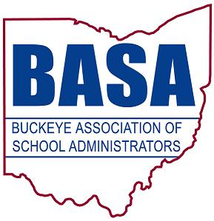

May 15, 2017

The Honorable Peggy Lehner, Chair
Senate Education Committee
Ohio Senate
Statehouse
Columbus, Ohio 43215

Dear Senator Lehner,

We are writing in support of Senate Bill 8, a bill that would provide an alternative for school districts for utilizing Ohio School Facilities Commission (OSFC) funds. SB 8 offers districts the opportunity to access OSFC funds for smaller projects when it is not advantageous for the district to participate in a full facilities replacement or remodeling project.

SB 8 is permissive and gives districts more flexibility for utilizing OSFC funds for things such as security, IT infrastructure, or other projects already permitted under a full scale facilities project. It should also be noted that districts will still have an obligation to match any state funding. We appreciate efforts to give districts more tools for meeting students’ needs such as this new option in SB 8.

Thank you for your consideration. Feel free to contact us if you have questions.

Respectfully submitted,

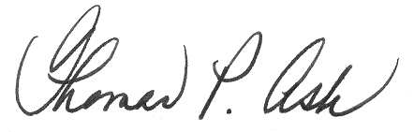
Thomas P. Ash
BASA Director of Governmental Relations

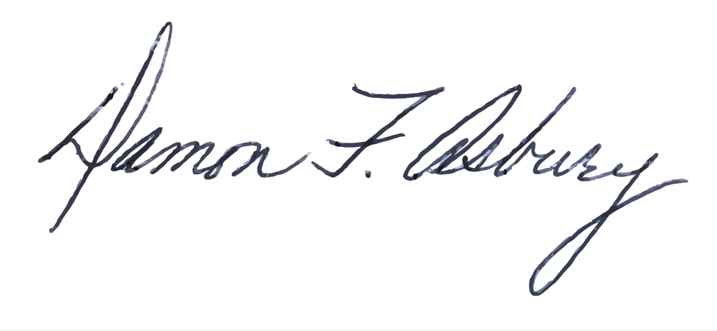
Damon Asbury
OSBA Director of Legislative Services

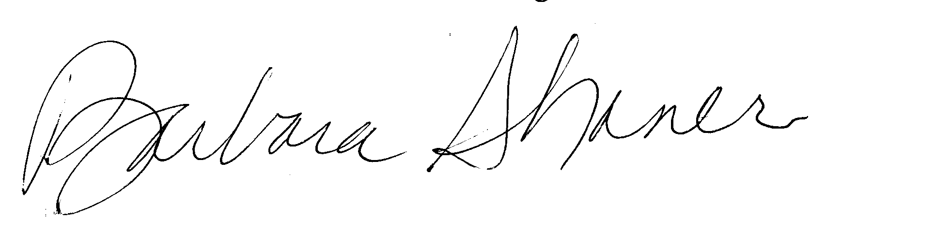
Barbara Shaner
Advocacy Specialist for OASBO

C: Senate Education Committee

