Cuyahoga County
Office of Early Childhood
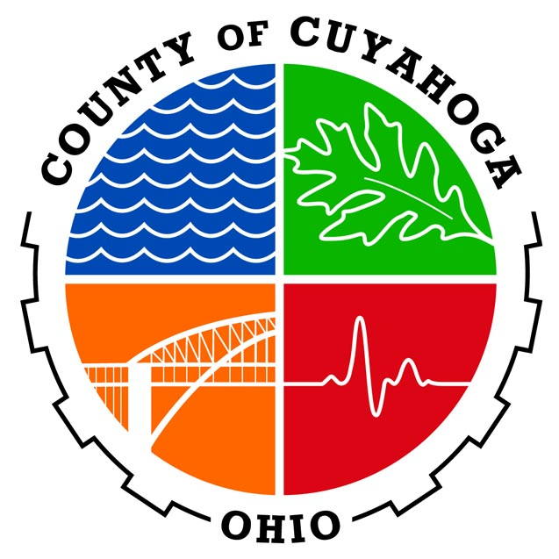
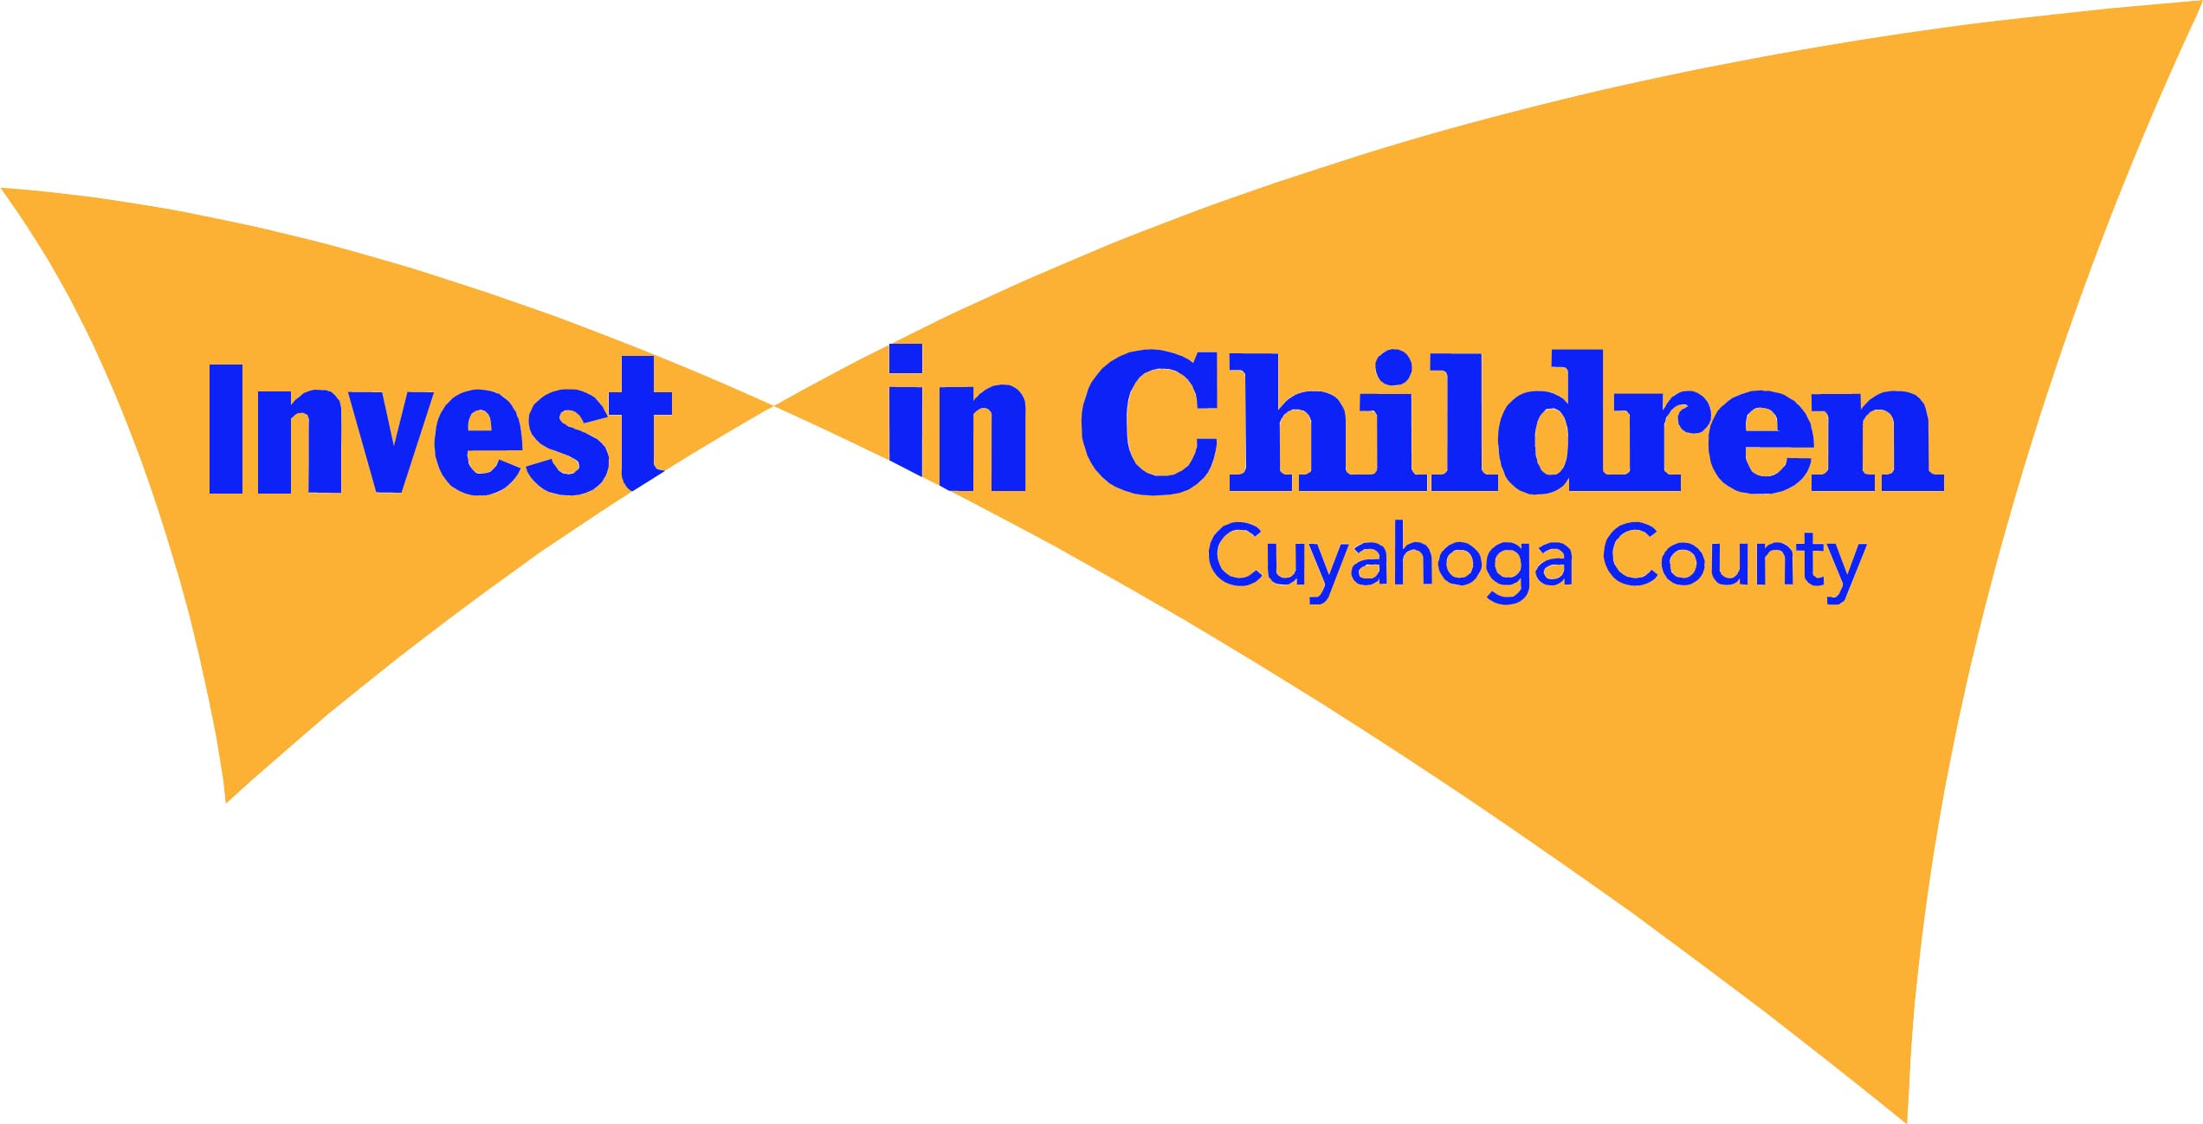

Testimony of Dr. Rebekah L. Dorman
SB 216
December 5, 2017

Much progress has been made in Ohio in early childhood education system building because we are acutely aware, based on statewide data on the KRA( and before it the KRA-L), that the majority of Ohio’s children start school at a disadvantage, not possessing the knowledge and skills they need to succeed from day one in Kindergarten.
Over the past decade, at both the state and local levels, government has been working to enhance our early childhood education systems so that Ohio’s children will be ready to succeed upon their entrance to Kindergarten. At the state level, investments have been made in additional early childhood education slots in high quality preschool settings to offer children from low income families the opportunity to become “kindergarten ready.” Data from the KRA showing the number of children not prepared provided clear justification for this investment and a metric that could be used going forward to measure the success of this program.
In Cuyahoga County, expanding and sustaining our Universal Prekindergarten (UPK) program is a top priority of county government and is being implemented via a strong public/private funding partnership. Private funders (listed on the attached page) have committed 12.4 million dollars to fund the UPK expansion, which is combined with $10 million public dollars. These funders expect and deserve to see the impact of their significant investment on KRA scores.
Elimination of the KRA as a mandatory assessment presents a significant step backward in our ability to assess the impact of early childhood system building at the local and state level. For example, the recent validation study of Ohio’s Step Up to Quality rating system used KRA scores as the outcome measure and was able to confirm that providers with higher ratings do produce better kindergarten readiness outcomes for children.
In Cuyahoga County, we are currently funded by the US Department of Education to conduct a Pay for Success Feasibility Study of Universal Prekindergarten Program and are utilizing KRA scores as the key outcome in that study as a potential cashable outcome for investors.
Elimination of the KRA as a mandatory assessment eliminates the key starting data point which allows us to track children’s educational trajectory. A study conducted by Case Western Reserve University on children in Cleveland utilized KRA-L score to predict performance on the Third Grade Reading Assessment and found that for every point higher on the KRA-L a study scores, their chances of passing the Third Grade Test were 12% higher. A similar study conducted in Columbus produced nearly the same result. Given that the KRA provides a more complete picture of the child, it is likely that the KRA will have even greater predictive power.
In closing, to be good stewards of both taxpayer and private investors funding early childhood programs must have a standardized metric to measure their success and allow for comparisons across the state and within communities. The KRA is that metric and must be maintained to allow for program accountability and to measure the success Ohio is having in changing the odds for low income children by providing them with a high quality preschool experience.

Private Investors in Universal Prekindergarten

Audrey and Albert Ratner
Bruening Foundation
Jill and Paul Clark
Cleveland Browns Foundation
Cleveland Cavaliers
Cleveland Clinic
Cleveland Foundation
Dealer Tire
Eaton Corporation
Forest City Enterprises
Fowler Family Foundation
Jewish Federation of Cleveland

Gary Oatey
Huntington Bank
KeyBank Foundation
Lubrizol
Medical Mutual of Ohio
Mt. Sinai Health Care Foundation
PNC Bank
St. Luke’s Foundation
George Gund Foundation
Third Federal Foundation
Treu-Mart Fund

