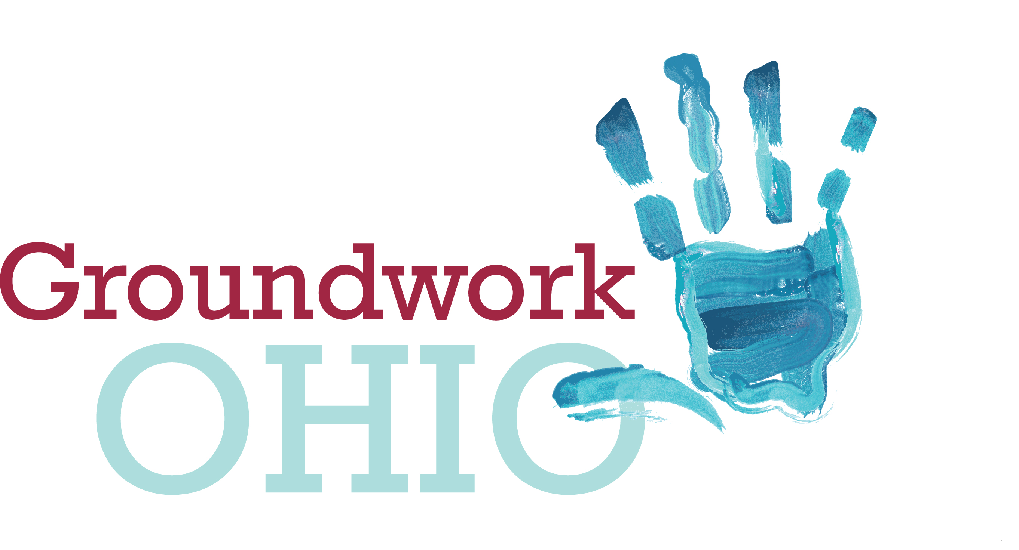
SHANNON JONES
Executive Director
sjones@groundworkohio.org
mobile: 937-671-8575
172 E. State Street, Suite 400
Columbus, Ohio 43215

Ohio Senate Education Committee
Senate Bill 216
Groundwork Ohio
Shannon Jones, Executive Director
December 6, 2017

Good Afternoon, Chairman Lehner, Vice Chair Huffman, Ranking Member Sykes and members of the committee. I am Shannon Jones, Executive Director of Groundwork Ohio. Thank you for the opportunity to be here today and give testimony concerning Senate Bill 216. My testimony is limited to comment and concern on those portions of the bill concerning the Kindergarten Readiness Assessment (KRA).

As you may know, Groundwork is Ohio’s statewide advocacy leader for early care and education. In addition to myself and my staff, Groundwork is governed by a robust steering committee of child-focused experts from around the state, including those who are leading the early care and education charge in their local communities, public school leaders, child advocates, and center- and home-based child care providers. We enjoy consistent support from our funders, our largest including the United Way of Greater Cincinnati and The George Gund Foundation, and have cast a wide net of support including to those in the business community who share our belief that quality early learning and development is the most transformative strategy to improve school outcomes, increase the life-long success of Ohio’s children, and lay a strong foundation for economic prosperity in our state.

All of us in the early care and education space know that brains are built on early experiences, with 90% of the brain development occurring between birth and age 5. The brain science has long been established. I know you have heard this before, and in the interest of time I won’t restate the well-established facts, but suffice to say the evidence is clear… we have a critical period of time to position all Ohio children for success.

It is also true that kids who start behind often stay behind, thus making the need to identify kids who would benefit from personalized instruction or other evidence-based interventions and supports even more essential. We are committed to assessing the needs of our earliest learners to understand how we can better serve them. The Kindergarten Readiness Assessment (KRA) is the first and most critical assessment in a child’s academic career and provides a roadmap for parents, teachers, and policy makers.

The KRA verifies whether our early childhood education system is preparing the children it serves for Kindergarten. Both public and private institutions rely on this measure when making significant local and state investments. For example, the state uses district KRA scores to evaluate need when they allocate quality child care slots to private providers and public preschool slots to the public school districts. Private philanthropy has used KRA scores to determine where their private investments can leverage these local and state resources to benefit the most at-risk kids.

The KRA is, of course, not just useful to those working outside of a Kindergarten classroom. If properly used, it can be a powerful instructional tool for Kindergarten teachers. Ohio educators were instrumental in every part of its development, validation, and reduction processes and is based upon standards that our state developed over the course of two years with child development experts and educators across Ohio. These standards are reflected in the assessment in all essential areas of school readiness including language and literacy development, cognition and general knowledge (including early mathematics and early scientific development), approaches toward learning, physical well-being and motor development, and social and emotional development, because Ohio educators know that all of these domains are essential to learning. If the KRA is eliminated, Ohio will not be able to identify strengths and needs of children across ALL the essential domains of school readiness that are known to predict later academic and social success.

Beyond the Kindergarten classroom, the KRA helps schools and districts achieve grade level reading proficiency for third grade students. Because Kindergarten readiness is a predictor of future academic success, including third grade reading proficiency, the KRA provides a lever for districts to engage earlier, so that they can get kids on track by the time they get to third grade when they shift from “learning to read” to “reading to learn.” This year will be the first cohort of children in third grade who have taken the KRA, so additional learnings and conclusions will be made from this data over time.

Not only does the KRA instruct state and local policymakers and teachers and school administrators, it is often times the first useful feedback parents get on how their child is doing in school. We see, particularly in areas where children do not have access to quality early childhood experiences, including rural communities and Ohio’s Appalachian region, that the KRA assessment results are often the first clue for many families as to how their child is performing in relation to their peers. The KRA results are required to be sent home as part of the state’s Third Grade Reading Guarantee and, as such, are serving as a useful tool for parental engagement in their child’s academic success.

Public and private institutions, teachers, schools, districts and parents are all benefiting from the information that a statewide kindergarten readiness assessment provides. The Ohio Business Roundtable reminds us in their most recent report on early learning in Ohio, released in October of this year, “the real purpose of measuring something is to drive action – and to get results.” Since its inception, because we are holding ourselves and each other accountable, we are, indeed, driving action and getting results. We are moving more kids from lower performance bands to become students who are demonstrating readiness for kindergarten.

Why is this urgent that we stay the course?

- We know that kindergarten readiness is a predictor of future academic success and third grade reading proficiency, and only 40% of all Ohio kindergartners (White 46.2%, Black 23.5%, Hispanic 22.3%) come to the classroom ready to learn.
- We know that 3rd grade reading proficiency is a make or break moment predicting future academic success in later grades and ultimately, high school graduation. Currently, only 63.7% of all Ohio third graders are proficient in the English/Language Arts domain.
- We know high school graduation predicts post-secondary attainment in addition to an individual’s health, income and opportunities for success, and in Ohio, only 83.4% of high schoolers (87.7% white, 67.3% black, 72.8% hispanic) graduate in four years.
- We know postsecondary attainment predicts income, opportunities for success and the ability to participate in the workforce, and in Ohio, only 43% of adults have a postsecondary degree or credential that leads to meaningful employment. This low attainment rate is particularly concerning when you consider that 65% of jobs in 2020 will require more than a high school diploma.

It is no coincidence that only 40% of Ohio Kindergartners come to the classroom ready to learn and only 43% of Ohio adults have a postsecondary degree or credential that they need for the jobs that will be available. This gap cannot be closed unless we understand and respond to it when it first emerges, which is before Kindergarten.

We ask the committee to invest in our future workforce by preserving the statewide Kindergarten assessment that allows us to measure our progress before, during and after Kindergarten so that we can close this attainment gap. The KRA is one of the most critical measures we have to ensure our state’s economic future.

