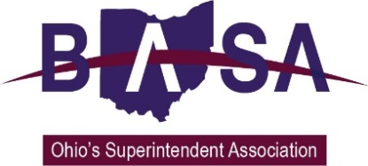

Senate Education Committee
HB 21 Proponent Testimony
Ohio School Boards Association

Buckeye Association of School Administrators

Ohio Association of School Business Officials

February 21, 2018

Chair Lehner, Vice Chair Huffman, Ranking Minority Member Sykes, and members of the Committee. My name is Thomas Ash, and I am the Director of Governmental Relations for the Buckeye Association of School Administrators (BASA). Joining me today to provide this testimony and to answer your questions are Barbara Shaner representing the Ohio Association of School Business Officials (OASBO) and Jennifer Hogue, Director of Legislative Services for the Ohio School Boards Association (OSBA). Thank you for the opportunity to speak to you today to express our support for substitute version six of HB 21.

One of the principal challenges in the present system of verifying the district of residence for community school students is that the resident district has no authority to require the parents of community school students to verify their addresses with the resident school district. Obviously, it is important that the correct and current resident district be identified for appropriate funding.

We understand that the parents of community school students might not see the need to notify the school when they change residences as no notification requirement exists under current law. We believe that this latest version of HB 21 addresses the situation by placing additional responsibilities on the community school sponsor to address this problem.

We feel that the additional steps outlined in Substitute HB 21 are appropriate for the sponsors since the overall supervision of the school is an obligation of sponsorship.

Specifically, HB 21 primarily addresses the issue through the contract between the sponsor and the governing authority of the community school. Contracts would require provisions for the governing authority to adopt an enrollment and attendance policy whereby parents would be required to notify the community school when there is a change in the location of the of the parent’s primary residence.

Additionally, the contract would require the governing authority to adopt an address verification policy for students enrolled in the school.

The governing authority, and not the school district of residence, would be required to conduct a monthly review of residency records. The governing authority would be required to verify the student’s current address to the Ohio Department of Education upon enrollment and then only on an annual basis.

However, it should be noted that it is the governing authority of the community school (and not the resident school district) which will adopt the policy prescribing both the number of documents and the information required for address verification.

The district of residence would be permitted but not required to review the determination of the district of residence.

We feel that this version of the bill appropriately assigns the responsibility for the monitoring of students’ residences to the entity that ultimately is responsible for the supervision and oversight of the community school.

Chair Lehner, thank you for this opportunity to express our support for this version of HB 21, and we will be happy to respond to questions at the pleasure of the chair.

