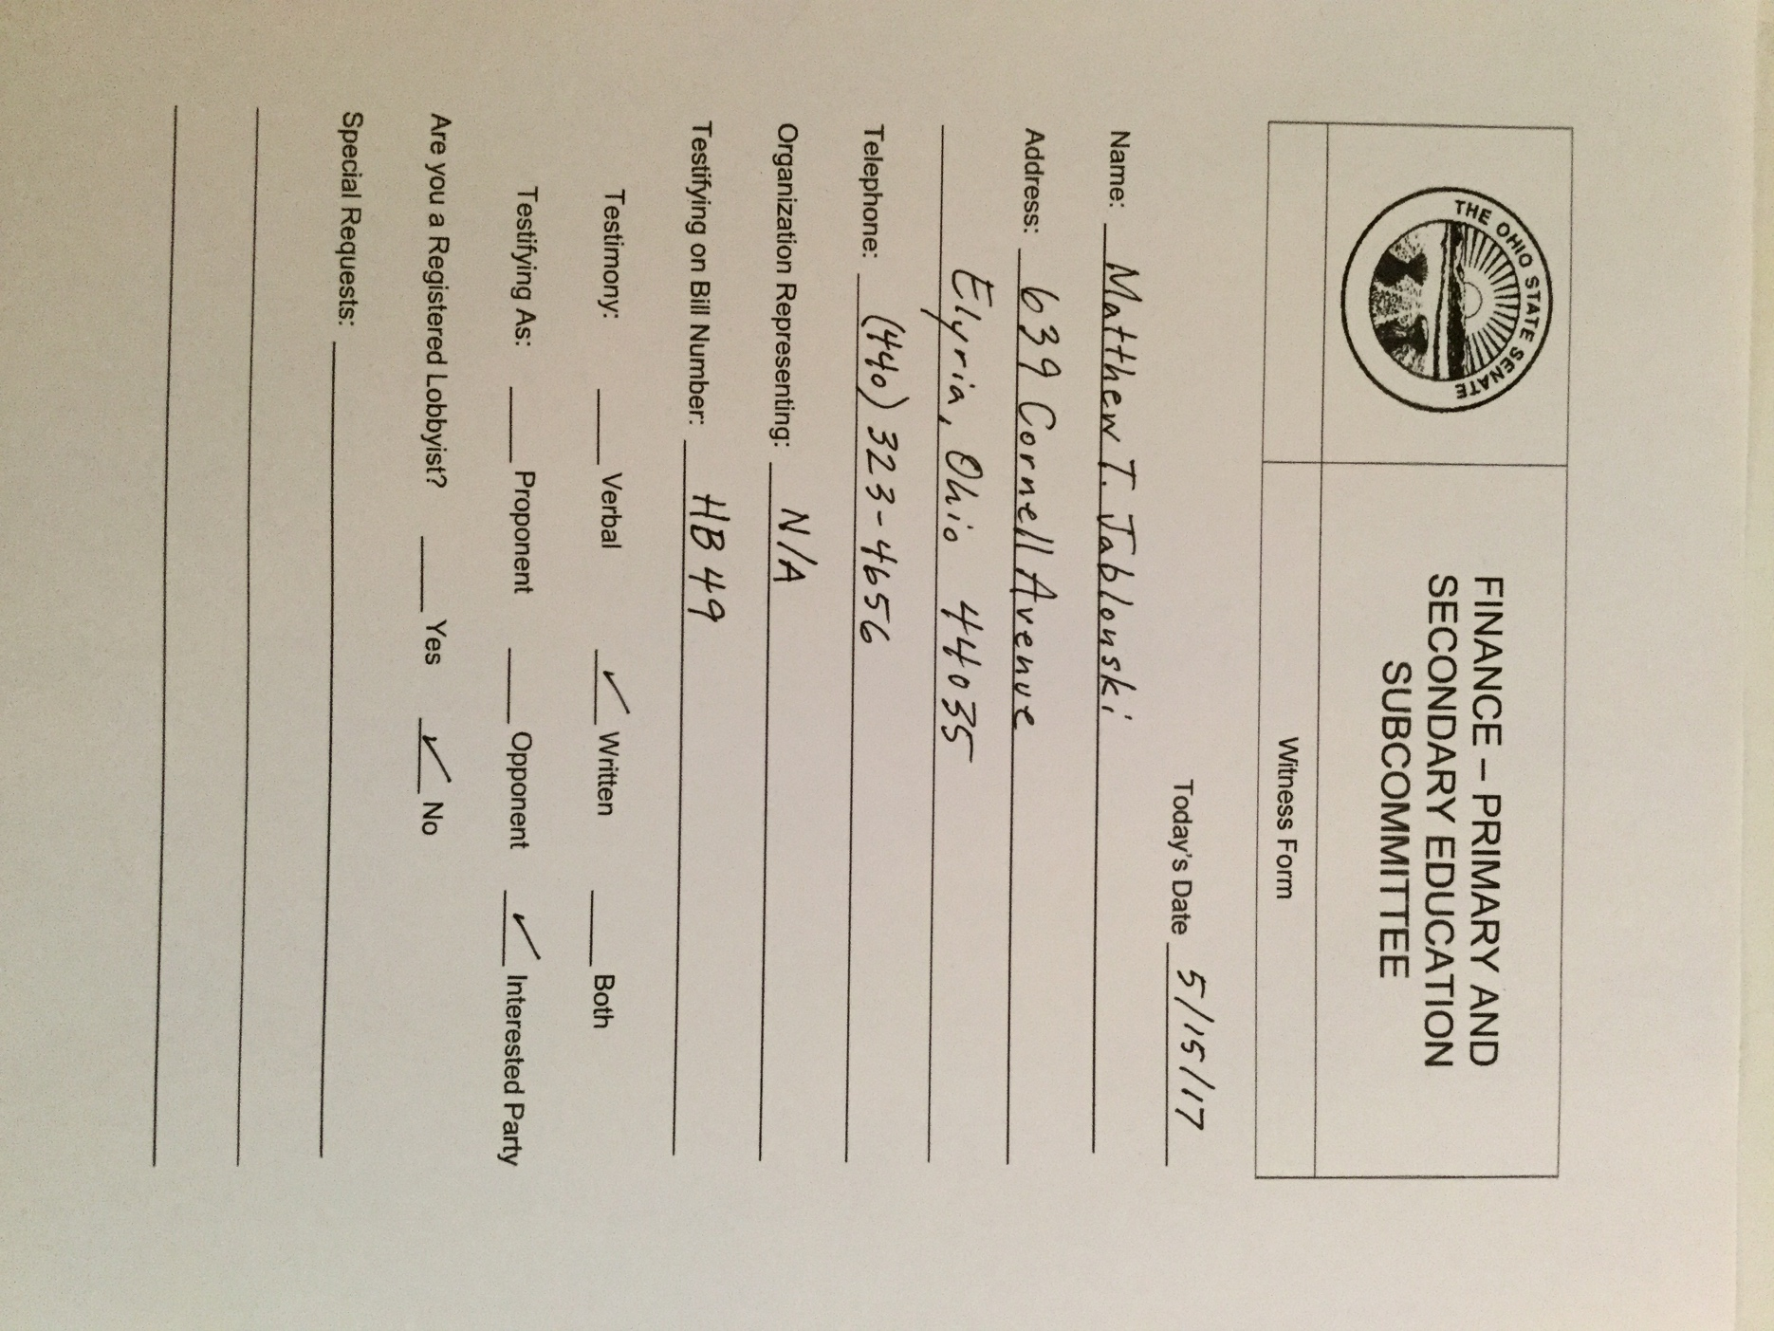

Thank you members of the Senate Finance Primary and Secondary Education Subcommittee for allowing these thoughts to be heard.

With regard to the ongoing crisis related to Ohio's graduation requirement, I believe a safe harbor for the class of 2018 is the only equitable solution considering the 3 year assessment mess that created the situation. I would sincerely encourage the Senate to include language in the budget bill that disconnects assessments from the graduation requirement. This should be followed by a sincere move toward the minimization of assessments overall, and abandonment of high stakes measures associated with them, as has been recommended by stakeholders statewide.

When my wife and I first looked at the scores from the class of 2018's PARCC tests nearly two years ago, we were terribly alarmed. With 20-30% passing rates in some subjects in urban districts, we anticipated 40% graduation rates in those places. While this was speculation, and we hoped we were wrong, as a teacher I recognized that remediation and retesting would have a limited impact on both learning and scores. Teaching and living in one of Ohio's urban areas, Elyria, I became concerned for my students, my neighbors, and my community. My wife and I proceeded to contact decision makers at all levels, and were generally told to wait and see. The time for waiting is over.

Much has already been said, and is now widely accepted about the existing "Graduation Crisis," which the Ohio Department of Education admits will result in 30% of Ohio's students being prevented from receiving a diploma. As we had feared early on, in Ohio's urban centers the percentage of non-graduates could reach 60-70%. This year's juniors are the first graduating class required to satisfy the new requirements which demand earning a total of 18 points from 7 state assessments. The tests have changed vendor and/or form in each of their high school years.

As students and parents panic, and schools scramble to provide remediation for tens of thousands of retakes statewide, some facts have gotten lost in the discussion. Most important among these is the fact that there is absolutely no federal regulation that insists graduation be tied to standardized tests. Ohio is one of only 14 states with this requirement.

Advocates of the system insist that the assessments bring "increased rigor" that improves education. They argue that the assessments are necessary because students have been found lacking in work skills, and been in dire need of remediation when entering college. No evidence suggests that a change or increase in assessments can change student performance.
No Child Left Behind ushered in this test and punish mentality in 2001. During the time since, scores for high school students have stagnated on the NAEP, SAT scores declined between 2006 and 2014, and ACT scores have been flat. A generation of students tested has not resulted in any significant improvements and yet we persist with this philosophy.

As a long time teacher of American History, a tested subject linked to graduation in Ohio, I believe we should question the value of the assessments overall, and the data they provide. It is widely accepted that High School GPA remains the best predictor of college success. The assessments or other graduation pathways do nothing to promote student pursuit of vocational programs. Even when the ODE was forthcoming with data from state assessments, which they are not now, the only real purpose it served was to direct educators to help students be more successful on assessments.

If the concern is the development of work skills, a recent survey of business leaders by Forbes indicated the top 5 qualities of graduates: teamwork, decision making, communication skills, organizational management, and the ability to obtain information. Generally speaking, these are soft skills, not qualities that can be measured by a standardized assessment.

Ohio students will be prevented from graduating in order to provide data with little meaning, due to an assessment system that has not improved achievement by any measure, and cannot measure the soft skills needed to be successful in college and on the job, the very things the state claims we're measuring.

All ODE materials on the graduation requirement celebrate the options created through the Three Paths to graduation which include the WorkKeys and ACT remediation free routes. These are often framed as a solution to the problems created by the standardized assessment system. Unfortunately, even these "expanded" opportunities seem primed to result in far fewer graduates.

According to The Ohio Education Policy Institute, in analysis of 2014 state data, only 15.1% of students scored remediation free on the ACT in districts with greater than 90% economically disadvantaged students. In areas with high rates of poverty this is not a viable path to graduation. In districts with only 10% economically disadvantaged the percent of students scoring remediation free is only 69%. Not an assured solution in either case, the remediation free rate is 4.5 times greater in richer than in poorer districts. The premise that students who are scoring poorly on state standardized assessments will score remediation free on a college entrance exam seems contrary to conventional educational logic, especially when you consider past results on those exams. They simply will not graduate.

As for the vocational certification, a 2014 report by the Fordham Institute indicates that only one in four students in Ohio's Career and Technical Planning Districts earned an industry credential. Superintendent of Eastland-Fairfield Career Center, Bonnie Hopkins, told the Columbus Dispatch, "Not all programs have credentials to earn in high school, and other programs have industry credentials that aren't on the state's list," she said. These issues make the career path open to very few students.

State leaders have suggested that they anticipate graduation rates stabilizing over time. In an economy lagging behind average national growth, and the Governor himself warning of a localized recession, Ohio may not have that kind of time time. The Bureau of Labor Statistics reports that high school graduates earn a median weekly income of $678, while non-graduates earn $493. If the current graduation requirements are not sufficiently remedied, state education leaders risk exacerbating economic issues as well.

If we are to move toward excellence in education, we should be more concerned with providing opportunities for students, as opposed to doling out punishments. In that, education on the whole needs to become less reliant on the weight of standardized test scores which have always, though especially recently, provided negligible data. If it is philosophically impossible to eliminate standardized tests as a determinant for graduation, again federal law does not require it, then they should at least be limited to something akin to the OGT. In combination with this, the point totals necessary for graduation should be lowered AND additional ways of earning points should be established. Standardized tests do not measure, nor do they promote, career or college readiness. They also do not begin to convey the level of work that is required of a student through the process of their education. Offering points for active participation in student groups, service organizations, taking on leadership roles, internships or employment, course grades, extracurriculars and otherwise should be considered.

It is, however, far too late to consider these things for the class of 2018. What these students deserve from our state, first and foremost, is an apology for the abysmal assessment system that they and their peers have been subjected to, a system that has only limited their educational opportunities, and not measured what state leaders claim. Then, they deserve a safe harbor for graduation, the elimination of any connection between Ohio's assessment system and their ability to graduate.

While I seriously question the need for an excessive testing system such as we have in Ohio, I understand, politically, that some testing will remain. However, the time for punishing students on the basis of standardized tests is over. Please consider a safe-harbor for the class of 2018. Then move forward toward the minimization of assessments overall, and abandonment of high stakes measures associated with them, according to the demands of stakeholders statewide.

If there is anything that I can do to be of assistance, please let me know.

On behalf of myself and my students, thank you for your time and service to the state of Ohio.

Yours in education,

Matthew T. Jablonski
639 Cornell Avenue
Elyria, Ohio 44035
(440)323-4656
jablosfarm@aol.com

