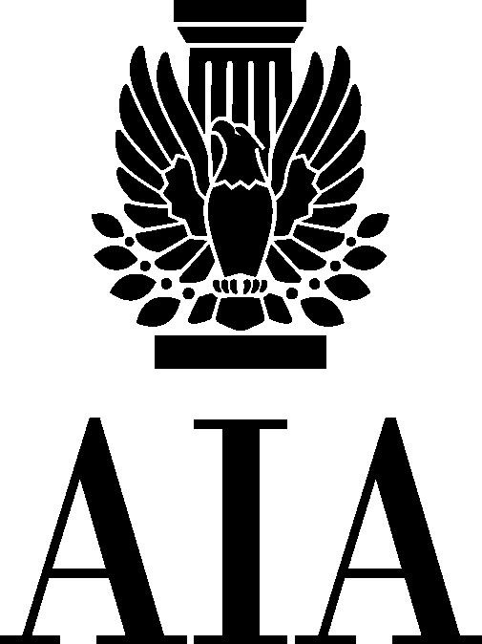

AIA Ohio
(A Component of the American Institute of Architects)

OPPONENT TESTIMONY
to language that would allow DAS to award its own design and construction contracts as “supplies” or “services” contracts under R.C. Chapter 125

Senate Finance Primary and Secondary Education Subcommittee
Subcommittee
May 24, 2017

by
David W. Field, CAE, Hon. AIA
Executive Vice President
AIA Ohio

AIA Ohio
17 S. High Street, Suite 200
Columbus, Ohio 43215
614-221-0338

aiaohio@Assnoffices.com
www.aiaohio.org

Sub. HB 49
David W. Field, CAE, Hon. AIA

My name is David Field, Executive Vice President of the Ohio Component of the American Institute of Architects. AIA Ohio would like to submit the following testimony opposed to the House inserted provision in Sub. HB 49 that would allow the Department of Administrative Services (DAS) to award its own design and construction contracts as “supplies” or “services” contracts under R.C. Chapter 125, thereby circumventing R.C. Chapter 153 construction law.

Background: In 2012-2013, comprehensive construction reform provided the most significant change to Ohio’s public construction law in more than 130 years. One positive result of this collaboration between industry and government was the centralization of construction authority into OFCC, creating consistency and transparency in Ohio’s public construction projects.

This House amendment to the state’s Budget Bill, Sub. HB 49, takes a step backward by allowing for the establishment of a second construction authority in the Ohio Department of Administrative Services (DAS), causing confusion, inconsistency and the potential of significant legal entanglements.

Details: The language would allow DAS to award its own design and construction contracts as “supplies” or “services” contracts under R.C. Chapter 125, thereby circumventing R.C. Chapter 153 construction law. Using this language, DAS could authorize a private third-party administrator to bid and award construction contracts, without the transparency and fair processes required under ORC 153. Further, DAS could use its cooperative purchasing authority to extend this same contract to all political subdivisions. The state’s construction authority, OFCC, could not challenge these contracts since “a contract awarded by DAS takes precedence over the commission’s authority” according to the bill.

AIA Ohio Believes: This language is not in the best interests of public construction in Ohio because:

- It bypasses the competitive processes and protections of standard construction under ORC Chapter 153, including advertising, bonding, subcontractor protections, etc.;
- It creates a path for all political subdivisions to avoid competitive bidding for construction;
- It makes the award of construction contracts less transparent;
- It breeds confusion and a sense of unfairness within the design and construction industry in Ohio;
- It provides no legal recourse to challenge the appropriateness of a construction contract awarded by a non-construction agency (DAS).

AIA Ohio respectfully requests that this language be removed from Sub. HB 49.

