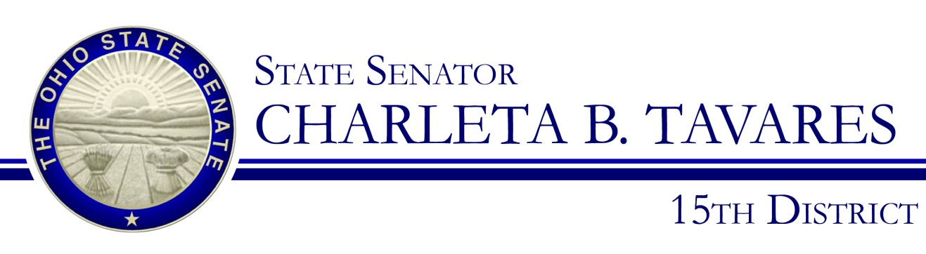
Sponsor Testimony
Presented by: Senator Charleta B. Tavares
Senate Bill 15
Senate Government Oversight and Reform Committee
Wednesday February 28, 2017

Good morning, Chairman Coley, Ranking Member Yuko and members of the Senate Government Oversight & Reform Committee. Thank you for the opportunity to present Senate Bill 15 which will require community colleges, state community colleges, technical colleges, and university branches to comply with minority business enterprise set-aside requirements, and to require the Director of Administrative Services to establish guidelines for these entities and the Northeast Ohio Medical University to establish procurement goals for contracting with EDGE business enterprises.

As you know, the state’s goal for MBE purchases of goods and services is fifteen percent and for EDGE businesses is five percent. While four-year colleges must comply with these goals two years institutions do not. There is no substantive reason that community colleges should not be held to same standard concerning MBE/EDGE goals. There are many community colleges that are larger than some four-year traditional universities and have comparable budgets. We should bring the community colleges and technical colleges in line with the four-year institutions.

Community colleges are growing at a steady rate with the boom in technical fields such as oil and gas, green energy, construction, truck driving and other growth industries. To meet the demand in these fields most individuals are enrolling into community colleges to obtain the right training and industry certification. With this influx of students, community colleges are expanding in order to meet this demand. The growth of students necessitates the expansion and construction of facilities. In order to construct or modify a facility professional services are needed such as those of architects, engineers etc. Community colleges should be required to set-aside the same fifteen percent of their contracts for minority businesses and five percent for EDGE certified businesses in order to grow & be fair & equitable to our small and minority businesses, and be fair and equitable among our colleges and universities.

Chairman Coley and members of the Committee, I appreciate your attention to this important issue and I respectfully request your favorable consideration and passage of Senate Bill 15. Thank you and I am happy to respond to questions from the committee.

