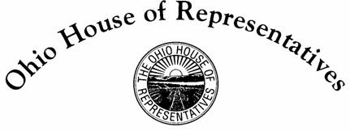

Dorothy Pelanda
State Representative, 86th District

Senate Government Oversight and Reform Committee
Sponsor Testimony – House Bill 18
Representatives Dorothy Pelanda and Wes Retherford
January 17, 2018

Thank you Chairman Coley, Vice-Chair Uecker, Ranking Member Schiavoni, and members of the Government Oversight and Reform Committee for the opportunity to offer Sponsor Testimony on House Bill 18.

HB 18 will eliminate the requirement of holding a special election to fill a vacancy in a party nomination for the office of representative of Congress under specific circumstances. This will apply only when there is one person that has filed a valid declaration of candidacy or no person has filed a valid declaration of candidacy.

Ohio’s current special elections laws require that a special election be held in the instance of a congressional candidate withdrawing from a race 90 days prior to a general election. Current law already specifies procedures in which a candidate can be appointed without the holding of a special election.

As Secretary of State Husted correctly surmised in a Gongwer article from August 1, 2016: “It is a waste of time and tax dollars to hold a special election when only one candidate is running. I hope the legislature will change the law to avoid this problem in the future.” This specific situation recently transpired with an unneeded special election for the 8th Congressional District in Ohio and this common sense legislation will prevent such situations from happening in the future.

I would like to just add that I am aware Senator LaRose has similar legislation, Senate Bill 10, which is currently pending in the House Government Accountability and Oversight Committee and I am happy to work with the Senator as our bills are in the other’s respective chambers.

HB 18 passed the House Government Accountability and Oversight Committee with unanimous support and by a vote of 92-1 on the House floor. I appreciate your consideration of the bill.

Thank you, Mr. Chairman.

