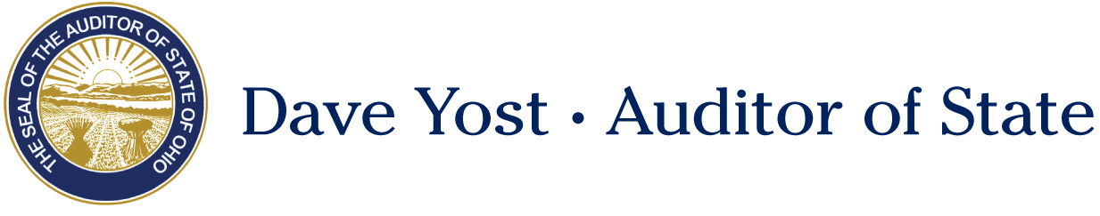

Senate Government Oversight and Reform Committee

Shawn Busken
Director of Policy and Legislative Affairs
Auditor of State

Substitute Senate Bill 239
February 20, 2018

Chairman Coley, Vice-Chair Uecker, Ranking Member Schiavoni and members of the Senate Government Oversight and Reform Committee, thank you for allowing me to testify today in support of Substitute Senate Bill 239.

SB 239 would reform the statutes surrounding Councils of Government “COGs” in an effort to improve transparency and accountability. As noted in Senator Dolan’s sponsor testimony, SB 239 will remedy some of the issues the Auditor of State’s office has faced with Ohio’s growing number of COGs. By way of background a COG is a collection of governments that organize to perform a specific function such as insurance pooling, energy consortiums, or advocacy functions. COGs are an effective and efficient way for local jurisdictions to join together to pool resources and share services. However, a recent string of court cases surrounding a COG has caused our Office some concern.

The Ohio Public Entity Consortium Healthcare Cooperative, “OPEC-HC” recently registered as a COG with the Auditor of State’s office. OPEC-HC is a self-insurance program organized as a Council of Governments (COG) under Chapter 167 of the Revised Code. The purpose of OPEC HC was to lower health-care costs for more than 3200 public employees as part of 160 political subdivisions.

Although just registered with our office, OPEC-HC has been operating as a COG since 2013. As of August 2017, the COG is running a deficit of at least $12 million. Had our office known sooner about this COG, we could have audited the books and provided some advice on a course correction to help them get back into the black. Furthermore, the financial mismanagement of OPEC-HC has led many members of the COG to attempt to leave and seek insurance coverage elsewhere. However, OPEC-HC is placing every roadblock they can to prevent members from leaving and is a party to several court cases against local jurisdictions seeking to leave the COG. One of the core tenants of SB 239 is that a COG will not be able to take any kind of legal action until they notify the Auditor of State’s office of their existence. As noted in the sponsor’s testimony, COGs are already required to notify our office of their existence, but there is no enforcement mechanism to compel reporting.

Our Office would also like to clarify the current law to state that members of a COG are not private or classified information. Why would a unit of government have anything to hide, especially something as trivial as the membership of their COG? SB 239 takes a step forward in transparency by preventing a COG from asserting any potential trade secret exception in the area of public records, documents, and membership of the COG. The legislation will also make members of a COG, who are not public officials, subject to Ohio’s ethics laws. However, the financial disclosure portion of the ethics laws would not apply to members of a COG Board.

Finally, SB 239 clarifies who may claim sovereign immunity due to their participation and relationship with the COG. Members and employees of the COG may still claim this protection unless they take an action that would constitute a violation of the ethics laws. If an otherwise private employee sits on a COG Board they cannot use that fact as a shield to liability when there have been violations of the ethics laws.

The Auditor of State’s office supports SB 239 and would like to thank Senator Dolan for his leadership on this issue. Thank you Chairman Coley and members of the committee, I would be happy to answer any questions you may have at this time.

