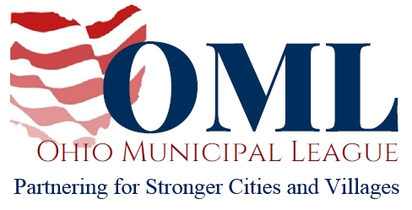

WRITTEN TESTIMONY TO THE SENATE GOVERNMENT OVERSIGHT AND REFORM COMMITTEE
SB 239
March 7, 2018
Chair Coley, Vice Chair Uecker, Ranking Member Schiavoni and members of the Senate Government Oversight and Reform Committee, thank you for the opportunity to testify on SB 239.
SB 239 modifies the law concerning regional councils of governments to create more transparency via reporting requirements to the Auditor of State’s office while working to eliminate areas where conflicts of interest may arise.
Regional councils of government can be useful tools that municipalities and other political subdivisions can use to work on areas of common interest by sharing services and pooling resources. However, problems arise when individuals elect to use regional councils of government to benefit themselves rather than the public. SB 239 closes many of the gaps in the current law those individuals can use presently to prevent that scenario from occurring in the future.
The accountability provisions within SB 239 are necessary to ensure regional councils of government remain useful tools for the public interest, rather than personal gain. We appreciate that Sen. Dolan has recognized the need for this legislation and we urge your support of this bill.
Thank you for your consideration.
Sincerely,
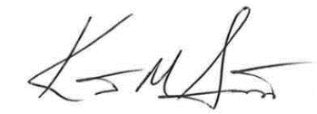

Kent Scarrett
Executive Director
Ohio Municipal League

