March 21, 2018

Chairman William Coley II
Senate Government Oversight and Reform Committee
1 Capitol Square, 1st Floor
Columbus, OH 43215

Chairman Coley and members of the Senate Government Oversight and Reform Committee:

On behalf of small business owners from across the state, I would like to take this opportunity to express support for Senate Bill 255. SB 255 provides you, the legislature, with much needed authority and review of Ohio’s occupational boards. The legislation provides you with the authority to ensure that the board is acting within its regulatory scope and allows each standing committee to offer recommendations and suggestions.

The majority of occupational licensing boards oversee and regulate practitioners within small business owners or employees of small businesses. Given that small businesses are the most fragile and vulnerable employers in the state, it is important that their regulators be assessed and evaluated periodically; within SB 255 this would take place every five years. One key provision of SB 255 is providing the Common Sense Initiative Office (CSIO) with notification of each board’s upcoming review. We feel that this is crucial since CSIO has developed relationships with small businesses and can offer unbiased feedback as to how businesses are impacted by the regulation of each occupational board.

Finally, it is important to note that if SB 255 is enacted, it would likely not take effect until the next governor’s administration. Therefore, the current administration should not see this as a impedance or an attack on their occupational board practices but as a preventative measure for future administrations. A new administration can take office with the full understanding of what is expected and can more easily incorporate these five year reviews into their workload.

Chairman Coley, thank you for the opportunity to submit written testimony in support of SB 255. If you or any committee members should have questions, please do not hesitate to contact me.

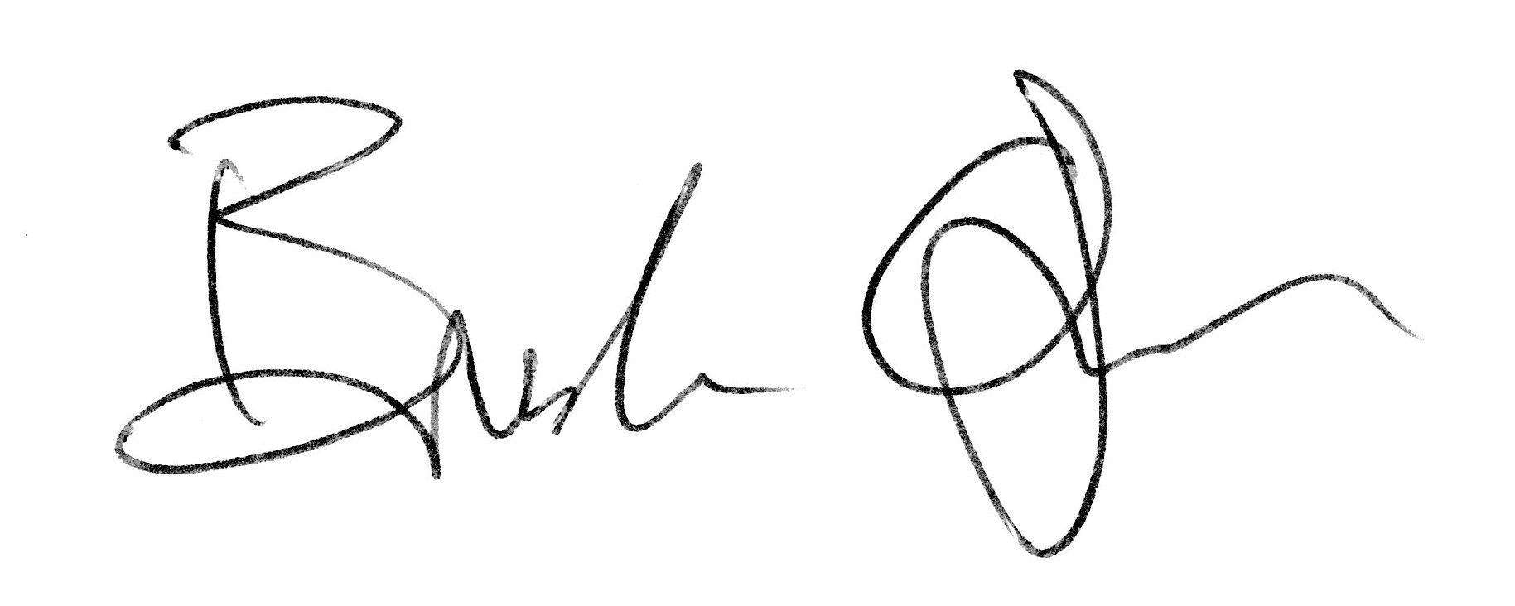
Sincerely,

Brandon S. Ogden
President, Small Business Consultants of Ohio, LLC
sbcohio.com

