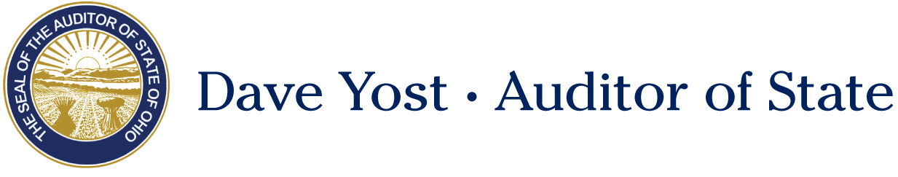

Senate Government Oversight and Reform Committee

Shawn Busken, Director of Policy and Legislative Affairs

Senate Bill 268
April 18, 2018

Chairman Coley, Vice Chair Uecker, Ranking Member Schiavoni, thank you for allowing me to provide testimony today on Senate Bill 268.
Since Auditor Yost took office in 2011, our office has charged 74 corrupt officials with theft in office, for stealing a total of $2,263,814.00. Our Public Integrity Assurance Team works diligently to find fraud, theft, waste, and abuse and help prosecute the criminals who commit these acts.
We see cases where high dollar amounts have been stolen but under the current theft in office statute those individuals can only be charged with an F-3. You have probably heard of some of these cases in the news. The Mount Sterling Village Administrator stole over $724,000 over four years, putting the village in fiscal emergency. Under the current theft in office statute, this was an F-3. To ensure the individual was justly punished, prosecutors gathered information to charge him under other crimes and ensure 10 years of jail time. The Village of Ripley Utility Clerk stole nearly $1 million through several methods and was charged with three counts of Theft in Office, each an F-3. A Mayor’s Court Clerk in the Village of Arlington Heights was convicted of one F-3 count of Theft in Office, after stealing $262,297. Under the theft statute, these would have been escalated to an F-1 and an F-2, respectively.
Government officials who steal taxpayer money should be held to the highest level of accountability and prosecuted to the fullest extent. A theft in office conviction bars the individual from holding public office or a position of trust at any point in the future and for that reason is preferred in these cases. Senate Bill 268 would bring parity to the theft in office and theft statutes. Under the bill, theft of over $750,000 would carry an F-1 penalty, while amounts between $150,000 and $750,000 would carry an F-2.
The second prong of this legislation clarifies that judges may order forensic audit costs as restitution when the victim is a public entity. Currently, these costs are not considered a “direct and proximate result” of the theft. Adding insult to injury, an entity may be robbed of tens of thousands of dollars, and be left footing the bill to catch the criminal. The STAR Community Justice Center paid $27,200 to discover $20,090 in theft. The language included in SB 268 allows local entities to be made whole, and would only be applicable to theft in office cases. Some would like to cap the cost of the forensic audit at the amount stolen, however, investigators don’t know how much is stolen until they have performed the forensic audit. We cannot put artificial numerical caps on the ability of auditors to root out what was stolen from a local government. Should the legislature wish to cap this cost at the amount stolen, the Auditor’s Office would be left holding the bill for these audits.
SB 268 ensures that those who use a position of trust to steal taxpayer money are held responsible for their actions. Our office would like to thank Senator Wilson for his leadership on this issue. At this time, I can take any questions you may have.

