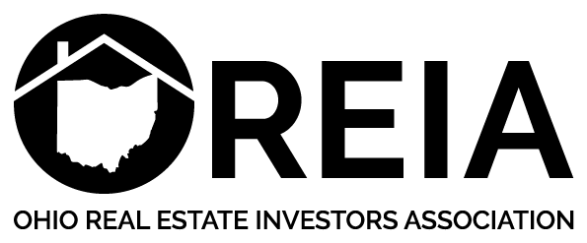

Dan Acton
House Bill 228 Proponent Testimony
Senate Government Oversight and Reform Committee
December 3, 2018

Chairman Coley, Vice Chairman Uecker, Ranking Minority Member Schiavoni and members of the committee, my name is Dan Acton and I am the Government Affairs Director of the Ohio Real Estate Investors Association (OREIA). OREIA represents 12 local chapters across Ohio whose membership consists of small to mid-size real estate investors and housing providers who collectively own tens of thousands of single family homes and thousands of multifamily units as well. I am providing a written statement as a proponent on a small portion of House Bill 228.
OREIA does not have a position on the totality of House Bill 228, but we support the addition of language to House Bill 228 that is the exact language of Senator LaRose's efforts in Senate Bill 234. We support the language for several reasons. While many of our members choose not to participate in the federal government housing programs to which House Bill 228 would apply, there are members that do accept the most commonly known federal program dollars, Section 8. Our members face unwanted regulation every day, mostly from local governments regulating various aspects of our property ownership, and any effort to prevent an overreach of the government on private property rights of property owners or tenants is an important issue for us. Our members strive to provide the safest and most secure properties that they can for the families and individuals to whom they rent. We must balance the need to protect the individual liberty of legal firearm ownership guaranteed under the 2nd amendment to the U.S. Constitution with our charge of housing provider. For this reason, we support the individual property rights of tenants. Further, adding this protection sets an important precedent in landlord tenant law in preventing landlords from overstepping and preventing other actions from occurring in the rental unit.
Equally as important to the property owner in this scenario is the inclusion of landlord protection language in the bill. Landlords, in general, are in a position of not knowing or controlling what activities are occurring in their properties, nor should they. Most leases include language, or it is simply understood as a citizen that you should not conduct or permit to be conducted criminal activity in your rental unit. Landlords should not be held liable, unless through collusion or a knowingly acknowledged situation for a tenant's activity. We accept the terms of our liability outlined in the bill. Firearms, when used properly, are safe instruments. However, when used improperly and without due care, they are tools for criminal action. Additionally, we support the language added to protect the tenant's right to recover damages, court costs and attorney's fees for the prevention of the tenant's rights only if the tenant, household member, or tenant guest legally possessed the firearm.
Firearm ownership is a serious matter and owners should take due care to protect themselves and properly store these firearms. OREIA appreciates the effort in House Bill 228 to balance personal liberty and property rights and adds its support for passage of House Bill 228, specifically the language mirroring Senate Bill 234.

