December 4th, 2018

WRITTEN TESTIMONY ON HOUSE BILL 228
Opponent Testimony

Good day Chairman Coley, Vice Chair Uecker, Ranking Member Schiavoni, and members of the Ohio Senate Government Oversight and Reform Committee.

My name is William Tarter, Jr. and I am a resident of Broadview Heights, Ohio. I write as a concerned citizen, and not representative of any other organization. I am writing to urge you to vote “No” on House Bill 228.

Earlier this year, as I was walking door to door hanging election information at 5:30 p.m., it was already getting dark due to Daylight Savings Time. As I was walking away from placing the election literature on the door, I encountered a homeowner who was walking out of the garage. In theory, they could’ve easily perceived me as a threat. Under HB 228, this bill shifts the burden of proof from the individual proving self-defense, to the prosecutor having to prove beyond a reasonable doubt that the individual didn’t act in self-defense. In the above case, it would have been too late for me, I could already be dead.

Legal experts note that there are already laws on the books which provide legal coverage for self-defense. Research has shown that states that have passed similar Stand Your Ground bills have seen increased instances of justifiable homicides after the law was passed. There have and could be instances like the above example, where the mere *presence* of someone (walking in a parking lot at night, for example), could conceivably think that person a threat and cite that as reasons for using lethal force. I am especially sensitive to that as an African American male. National research shows that when an African American is the victim, and stand your ground is invoked, there is a higher likelihood that it would be ruled a justifiable homicide. As the 2nd Vice President of the Cleveland Branch of the NAACP, I am grateful that my fellow members of the NAACP are strongly against this bill.

HB 228 also eliminates the requirement for a concealed handgun permit holder to keep their hands in plain sight during a traffic stop. It is important to underscore that the Ohio State Highway Patrol, the Ohio Fraternal Order of Police, the Ohio Association of Police Chiefs, and the Ohio Prosecuting Attorneys Association in being against this bill.

There are many other things I could write, but time and space do not permit me to do so. I urge you, for the safety and well-being of Ohioans like me, please vote “No” on House Bill 228.

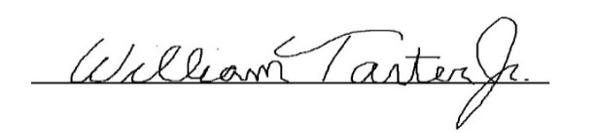
Respectfully submitted,

William Tarter, Jr., Broadview Heights, Ohio

