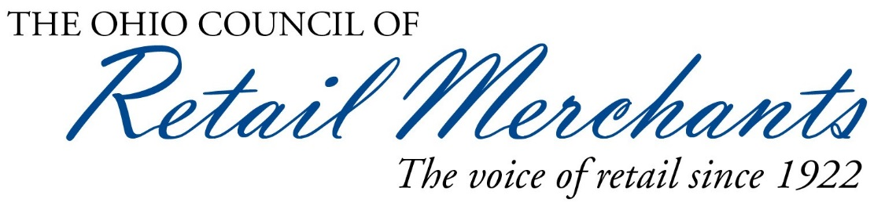

Proponent Testimony on Senate Bill 210

Senate Health, Human Services & Medicaid Committee

Lora Miller

Director of Governmental Affairs & Public Relations
Ohio Council of Retail Merchants

January 30, 2018

Good afternoon Chairman Burke, Vice Chairman Beagle, Ranking Member Tavares and members of the Senate Health, Human Services & Medicaid Committee. I am Lora Miller, Director of Governmental Affairs & Public Relations for the Ohio Council of Retail Merchants. I am here today on behalf of our more than 7,500 members in support of Senate Bill 210 to prohibit municipalities from imposing taxes, fees, assessments or other charges on auxiliary containers, which are often touted as a means of reducing litter in the environment.

The business of retail obviously does not operate in a vacuum. Even if all retailers were independent operators--which is certainly not the case--they still must make business decisions based on many factors including consumer preferences, regional trends, product availability and pricing, competitor strategies, manufacturer offers and incentives, and of course, government regulations.

The onus of local government regulations can sometimes prove the most challenging factor for retail businesses, especially for multi-state retailers that utilize macro regional strategies for merchandising, marketing and standard operating procedures. The cost of doing business is artificially increased when retailers must design their operations at a micro level based on regulations that vary from municipality to municipality. For that reason, statewide solutions are preferred over local regulations.

A case in point is a proposed carry-out bag fee ordinance for certain types of business and consumers that is currently before the Cuyahoga County Council. If adopted, businesses and consumers in Cuyahoga County would be treated differently than those in other Ohio counties. As with any proposal that targets a small segment of the state, those businesses within the jurisdiction where a tax or fee is imposed are placed at a disadvantage, particularly if they do business throughout the state. Uniformity is very important in the retail sector and having a patchwork of differing regulations across local government borders is both administratively and financially burdensome.

Additionally, these types of regulations also drive business out of a jurisdiction. It is human nature to avoid paying more for something when there is a less expensive option. Many shoppers will take their business to neighboring counties where there is no tax on carry-out bags. One only has to look at the cross-border activity that occurs during Ohio’s three-day back-to-school sales tax holiday to confirm that people are highly incentivized to avoid taxes and fees when they can.

It is very important to acknowledge that the Ohio Revised Code has clearly defined anti-littering statutes and a comprehensive statewide solid waste management strategy managed by Ohio’s 52 solid waste management districts (SWMD), with recycling serving as a cornerstone of waste management philosophy in Ohio. Solid waste districts have been integral to initiating and maintaining the infrastructure necessary for Ohio’s recycling efforts. While some districts provide funding and education for recycling efforts, others actively provide recycling services. Ohio EPA has a grant program for market development, recycling and litter abatement. EPA staff works with local solid waste districts and the private sector to create robust public/private partnerships which capitalize on the latest trends in sustainability. We believe it yields greater results when everyone works together on programs.

From the retail perspective, “zero waste” is the goal of many merchants and a key part of the business plan for numerous national retailers. They view environmental sustainability as a corporate responsibility and incorporate waste elimination, reduction and reuse into every aspect of daily operations. Many also offer consumers the opportunity to reduce waste by providing onsite containers for the disposal of recyclable plastics to complement local government recycling programs. While it is true that such local programs are not universally available or as successful as others, we believe that local governments should be doing more to encourage voluntary recycling instead of implementing costly mandates that rarely achieve their stated goal. As was said by a representative of one of our national retail members, “The only thing worse than an imperfect voluntary program is a government mandated one.”

Chairman Burke, Vice Chairman Beagle and Ranking Member Tavares, I appreciate the opportunity to appear before you today in support of Senator Coley’s Senate Bill 210. Our thanks to the committee and our special thanks to Senator Coley for his leadership on this issue. I am available to try to answer any questions you may have.

