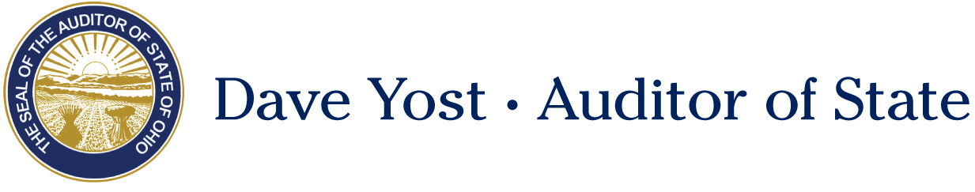

Senate Health, Human Services and Medicaid Committee

Shawn Busken, Policy Director
Ohio Auditor of State

Senate Bill 218
May 15, 2018

Chairman Burke, Vice Chair Beagle, and Ranking Member Tavares, thank you for allowing me to testify today on Senate Bill 218, which would reduce fraud and increase accountability in the Medicaid sector.
The Auditor of State’s office contains a Medicaid Audit Unit that performs compliance examinations of providers that bill Medicaid for their services. Since Auditor Yost took office in 2011, this unit has found nearly 36 million dollars in overpayment and fraud. Cases believed to involve fraud are referred to the Attorney General’s office for prosecution. This has led to nearly 50 million dollars ordered in monetary penalties, in addition to 641 convictions. Unfortunately, less than 10% of this money is successfully returned to the State.
There are currently approximately 110,000 Medicaid providers in Ohio. Transportation and Home Healthcare make up 16% of the total providers; however, these two sectors make up 84% of all Medicaid fraud convictions. Additionally, the error rates for Transportation and Home Health are 71% and 38% respectively. With error rates like that, we don’t need to data mine, we are likely to find fraud by just random sampling providers. While there are providers who employ well-trained staff, provide excellent care, and bill honestly for services provided, there are also those who do not. In 2017 alone, our unit ordered the repayment of 10.5 million dollars for improper payments

Senate Bill 218 takes a two-pronged approach to this problem. First, the language requires home healthcare and transportation providers to hold a surety bond with the Dept. of Medicaid. Transportation and home healthcare agencies would provide a $50,000 bond, while independent home health providers would hold a $10,000 bond. An exemption is provided for those who are caring for a family member and have a clean review record for the past 3 years of their 5 year window. Surety bonds are an approach that has been taken by other states to deal with Medicaid fraud. Indiana, New York, Texas, and Florida all employ some form of a surety bond requirement. The bonds do not cost the full amount, but a small percentage, near 2-8% of the full amount, depending on the individual or company’s credit history. It is anticipated that these would cost $1,000 - $4,000 for transportation providers and home health agencies, and $200 - $800 for independent home health providers. Though some call this a barrier to entry, in some ways this is a barrier we want and need. This bill may also have the effect of weeding out bad actors in the space that are tarnishing the reputations of good providers.

Second, the bill would require training for individuals who submit billing for home health and transportation services, and make completion of the training a prerequisite for provider approval by the Department. Training would cover the basics of billing, records retention, and the provider’s agreement with Medicaid. The Auditor’s Office frequently comes across providers who claim they had no idea they were supposed to be keeping records, hold certain certifications, or otherwise comply with Medicaid provider rules. This training would not only educate those who are genuinely ignorant, but would also remove such a defense from a bad actor who is just trying to avoid a fraud conviction.

Medicaid is an important safety net for millions of people across Ohio. It is vital that we work to eliminate fraud and abuse in this program and ensure that every dollar is helping provide healthcare services to those who need it. Thank you to Senator Peggy Lehner for her leadership on this issue, and thank you, Chairman Burke. I would be happy to take any questions you may have at this time.

