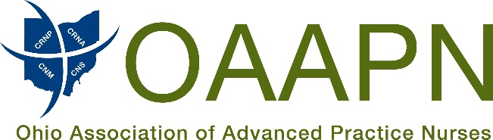

Proponent Testimony
Ohio House of Representatives
Sub. SB 301
November 27, 2018
Ohio Association of Advanced Practice Nurses

Good morning Chairman Burke, Vice Chair Beagle, Ranking Member Tavares, and members of the Senate Health, Human Services and Medicaid Committee. My name is Joscelyn Greaves and I am the President for the Ohio Association of Advanced Practice Nurses (OAAPN).

I want to thank Senator Jordan for carrying this important piece of legislation that will improve patient safety and quality of care, while increasing access and cost savings.

Over the last decade, healthcare has evolved immensely and continues to change at a fast pace. Patients are experiencing access to care issues, mental health problems are on the rise, the opioid epidemic continues to worsen, and a primary care shortage of over 90,000 physicians is expected by 2025. While Ohio has made some progress in removing barriers for Certified Nurse Practitioners, Clinical Nurse Specialists, and Certified Nurse Midwives, it has not addressed the CRNA barriers to patient care.

This bill seeks to clarify that CRNAs may order necessary medications to provide anesthesia care to patients but would not give them prescriptive authority like the other categories of APRN. In fact, SB 301 would outright prohibit a CRNA from prescribing a drug for use outside the facility or setting where the CRNA provides care.

Additionally, CRNAs are highly qualified and educated professionals that have a Bachelor of Science in Nursing along with 3-4 years of patient care training, 2.5 – 3 years of nurse anesthesia training at a Masters or Doctorate level, and a total of over 8 years of patient care experience, with 2.5 – 3 years related to anesthesia. Numerous studies in fact have shown outcomes are comparable and do not vary between CRNA'S, and anesthesiologists when working together or alone. In fact, there have been no complaints filed in Ohio regarding CRNA's causing harm or injury. This proves how safe the patient care is provided by CRNA's.

Lastly, the bill is permissive, allowing hospitals and other facilities to control the utilization of their own workforce, one that helps them keep costs under control, while improving access to care. This bill allows hospitals and other facilities to decide what model of care works best for them.

As an Association representing the over 16,000 APRNs in Ohio, OAAPN believes Sub. SB 301 would improve access to healthcare, retain the ability for facilities to control how their practitioners are utilized, and clarifies a CRNAs scope of practice. We respectfully request the committee support the passage of Sub. SB 301.

Respectfully,

Joscelyn Greaves MSN, APRN-CNP
President, OAAPN

17 S. High Street, Suite 200, Columbus, OH 43215  866-668-3839

