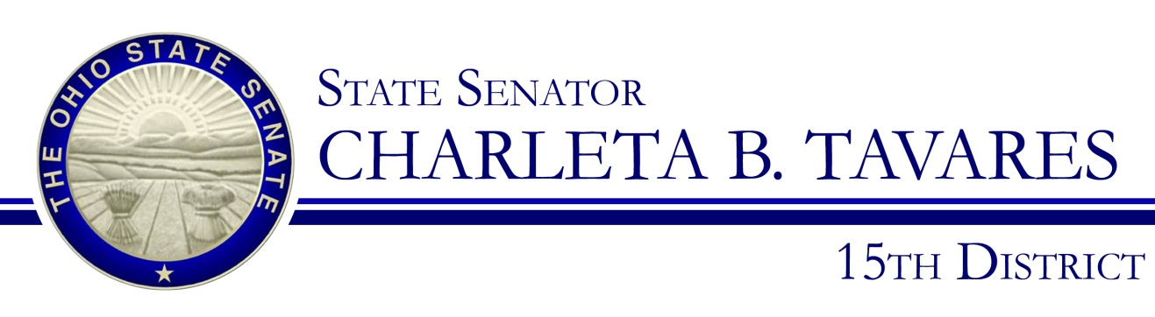

Sponsor Testimony
Presented by: Senator Charleta B. Tavares
Senate Bill 66
Judiciary Committee, Chair, Senator Kevin Bacon
March 7, 2017

Good morning, Chairman Bacon, Ranking Member Thomas, and members of the Senate Judiciary Committee. Thank you for the opportunity to present Senate Bill 66 which will strengthen our criminal justice system and to allow those who have offended to have a fair shot at rehabilitation without being subjected to unfair penalties. This legislation was the product of hard work between the both Senator Eklund and I, as well as the Department of Rehabilitation and Corrections, the Ohio Judicial Conference, and the Ohio Community Corrections Association.

As of February 2017, Ohio has just over 50,000 inmates in our state prison system which is far more than the 38,000 it was designed to house. Recognizing not only the strain this puts on the resources available to the Department of Rehabilitation and Corrections, but the societal costs for families trying to navigate the criminal justice system, Senator Eklund and I have introduced SB 66 which will implement common sense reform. SB 66 will give our judges more discretion, bolsters our Intervention in Lieu of Conviction programs, make changes to the presumptive return to prison for technical parole violations and expand the eligibility for conviction for recording sealing.

Thanks to the changes made by the General Assembly over the last few years, when someone commits a felony of the fourth or fifth degree that is not an offense of violence or a qualifying assault, that person has the presumption of a community control sanction. However, that person must be sentenced to that sanction for a minimum of one year. SB 66 removes the one year minimum allowing judges, who know the needs of their community and citizens best, to impose a length of time they deem most appropriate. SB 66 also adds language that allows for judges to impose a six month sentence in jail or community-based correctional facility when felony offender violates a community control sanction, rather than sentence them to a prison term.

We are also expanding Intervention in Lieu of Conviction (ILC) eligibility in SB 66 allowing more offenders into these diversion programs. Diversion programs are critical in helping the addicted get clean while allowing them to avoid a criminal conviction and all of the negative stereotypes associated with criminal convictions. We are also giving judges more leeway with those who relapse while in these diversion programs. Under current law when a person has failed to comply with a term of their ILC plan, the only option the court has is to find that person guilty and impose a sanction under the felony sentencing law. SB 66 gives judges the discretion to allow the offender to continue in the ILC program rather than binding their hands and forcing hand down a ruling not in the best interest of the offender.

SB 66 makes important changes in what happens when someone violates a term of Post-Release Control (PRC). Currently when someone violates PRC the Parole Board is required consider a return to prison as part of the response even if the violation were only minor and technical in nature. SB 66 would change this to remove that required return to prison consideration for technical violations and have it only apply to violations involving deadly weapons, physical harm or attempted serious physical harm, or sexual misconduct. SB 66 also expands the category of offenders who are eligible to have their records sealed by allowing for records of conviction to be sealed by anyone who has committed a felony of the fourth and fifth degree so long as none of the offenses are offenses of violence or felony sex offenses.

While all the provisions in SB 66 are important, perhaps the most important provision to Senator Eklund and I is adding rehabilitation as a an overriding purpose in felony sentencing because it shows our commitment to bringing Ohio’s criminal justice system into the 21st century. We cannot simply continue to place people behind bars in an effort to be tough on crime, but rather we must make an effort to help change the behaviors of people who stay in our intuitions. We must be as dedicated to rehabilitation as we are to punishment so that we allowing people start again with the ability to become valuable and contributing citizens to the state of Ohio. I believe SB 66 is a step in that direction.

Chairman Bacon and members of the Committee, I appreciate your attention to this important issue and I respectfully request your favorable consideration and passage of Senate Bill 66. Thank you and I am happy to respond to questions from the committee.

