Q. How difficult and costly is it to determine a drug’s weight?

A. Not hard, not expensive. The same gas chromatography test now used to establish drug identity can report weight. No additional equipment is needed. Minimal time or expense is needed to compute weight. Drug weights are not now reported because the state does not ask its instruments to produce the number.

Drug weight: How it’s determined

Gas chromatography does it. Drug tests are done on a gas chromatography (GC) instrument or a gas chromatography-mass spectrometry (GC-MS) instrument. Every BCI drug tester has a GC instrument at his or her lab bench. GC instruments identify drugs and weights using the methods explained below and in an accompanying graphic.

The state’s more expensive GC-MS machines add mass spectrometry analysis after the GC test. However, the MS test is not involved in the weight calculation. The MS test provides the molecular weight of each substance in a sample, providing precise confirmation of drug identity. Notwithstanding the words mass spectrometry and molecular weight, the analysis is not used to calculate drug weight or a sample’s purity.

The less expensive GC analysis alone provides weight and purity. The more expensive MS analysis proves precise drug identity.

Cost. The state could determine drug weights at modest time and expense using existing staff and equipment. Every BCI forensic scientist has a GC instrument at their lab bench. A testing procedural change would be required to calculate weight and is explained in detailed below.

Alternatively, the state could contract out the task of identifying a drug type and weight at a modest cost, perhaps less expensively than having state staff conduct drug tests. The cost of contracting would likely be $100 to $300 per test, depending on the volume of tests in the contract. For example, The Ohio State University Chemical Instrument Center’s published rates for a GC-MS test are:
- $80 per test for a request from a private or public university in Ohio.
- $150 for government or a non-Ohio university.
- $300 for a request from industry.

Procedural change required. To determine drug weight or drug type, a forensic scientist must “normalize” his or her GC instrument like a scale -- to see how the specific GC instrument records specific substances. For example, the Relative Retention Time (used to determine drug type) may be 9.03 minutes for fentanyl. To determine the exact retention time on a particular GC instrument, the tester must run a “reference sample” of known fentanyl through his or her instrument. The analysis is adjusted to reflect whether that specific instrument recorded fentanyl 9.03, 9.06 or another number. It’s similar to establishing the exact length of the track before a 100-meter dash.

To measure drug weight in a seized sample, a portion of the sample is itself weighed, and then processed into a form that can be run through the GC instrument. (Steps 1 and 2 below) The sample submitted to the GC instrument is prepared from a known amount of the seized sample (Step 1: 1 gram) dissolved in a known amount of an inert liquid (Step 2, 10 milliliters).

What is not known prior to analysis is what proportion of the seized sample is the substance of interest. Submitting the unknown and standard reference samples to the same GC analysis lets you figure out the concentration of fentanyl in the unknown (Step 3, 0.12 milligrams per milliliter). Reference samples are simply fentanyl at different concentrations; preparation of these solutions is a standard laboratory technique.

To connect the data from the GC to the content of the original seized sample, you take into account the volume of the sample that was prepared for GC analysis (Step 4a, 10 milliliters of sample). Multiply concentration (0.12 milligrams per milliliter) by amount (10 milliliters). This amount of fentanyl (1.2 milligrams) was present in 1 gram of the seized substance (Step 4b) and so the entire seized sample of 100 grams contains 120 mg fentanyl (Step 4c).

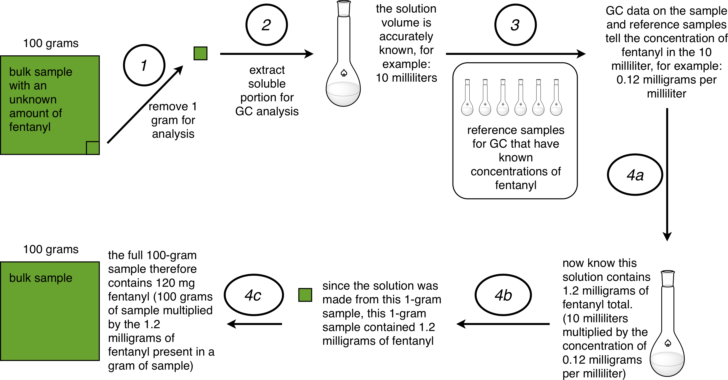

None of this is particularly complex or time-consuming. It’s routine standardization used every day in science, engineering, medicine and cooking. The same reference samples can be used for weeks or months. They are not made for every test.

Accreditation. In a Gonzalez legal brief, the Attorney General said the BCI lab would need to upgrade its current level of accreditation, which could take 18 months. This might be so, although the Attorney General referred only to liquid chromatography in his brief. He did not say whether the BCI lab was accredited to determine weight via a GC analysis.

If true that the BCI lab is not accredited to GC weight analysis, this would be a major failing considering the Attorney General says his #1 budget priority is to “Ensure the BCI is the leading criminal investigation and analysis agency in the country.” Elsewhere, the Attorney General claims that BCI is accredited at the highest level: “The standards CALEA sets represent the highest professional business criteria related to the administration, operation, and personnel practices of law enforcement.” The failure of BCI to be accredited for weight analysis should be corrected as soon as possible, if true.

Conclusion. The state can test for fentanyl weight at a modest expense. Failing to do so creates a perverse legal system that incentivizes fentanyl at its most dangerous, thereby promoting overdose deaths.

Fentanyl is a drug so small that a dramatic inverse relationship exists between the drug’s danger and the total weight of the mixture it’s placed in. The safest fentanyl is diluted to less than 1 part fentanyl to 1,000+ parts other things. Making dilutants the basis of the crime will contribute to overdose deaths and a perverse sentencing scheme.

BCI executive director Tom Stickrath. http://madison-press.com/news/185824/behind-the-scenes-at-bci
BCI estimates the cost of a GC-MS instrument at $243,000. A new high-end GC instrument might cost $30,000. BCI has GC-MS instruments, although it couldn’t be determined how many.
The advantage of a GC-MS instrument is that, by using molecular weight, it can identify substances even when it’s not looking for them. By contrast, a GC test can accurately determine the existence (and total weight) of a substance if it is told to look for it. A GC test can be programmed to look for dozens of substances – heroin, fentanyl, cocaine, etc. – at the same time and during the test, but GC analysis would not identify a substance – a designer drug, for example – that it had not been asked to consider. By contrast, an MS analysis records the molecular weight of each substance in a mixture and can match this number to massive databases containing records for over 200,000 molecules.
Price list for OSU Campus Chemical Instrument Center here: http://www.ccic.ohio-state.edu/msp-rates
Skip this section if technical details are of little interest. It was written with the assistance of two Ph.D. chemists.
http://supremecourt.ohio.gov/pdf_viewer/pdf_viewer.aspx?pdf=778576.pdf
P. 207. http://budget.ohio.gov/doc/budget/FY18-19_Budget_Recommendations.pdf
CALEA stands for Commission on Accreditation for Law Enforcement Agencies. Attorney General reference to state lab’s accreditation found at http://www.ohioattorneygeneral.gov/Law-Enforcement/Bureau-of-Criminal-Investigation The state’s accreditation certificate is here: http://www.ohioattorneygeneral.gov/Files/Law-Enforcement/BCI/Laboratory-Division/150917-OH-BwlgGrn-Accr-Scope-Upd.aspx
Effective doses of fentanyl start at 25 micrograms. A 50 microgram dose of fentanyl accurately diluted into a single 60 milligram dose of street heroin would account for just 1/1,200th of the substance. It would kill nobody. By comparison, nobody survives a 60 milligram dose of fentanyl. This amount could kill 20 to 30 people.

