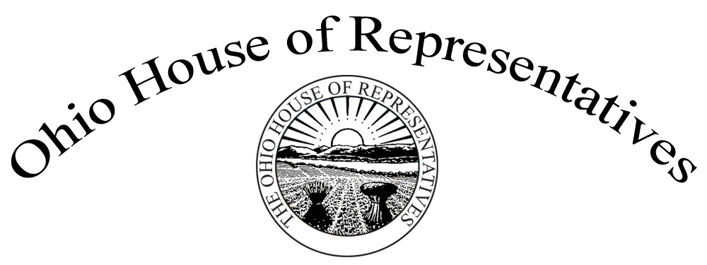

Representative Bill Reineke

Sponsor Testimony HB 354

January 16, 2018

Chairman Bacon, Vice Chair Dolan, Ranking Member Thomas, and Members of the Judiciary Committee. Thank you, for allowing me to present sponsor testimony on House Bill 354. House Bill 354 is a pilot program that consolidates certain drug court proceedings for the Tiffin-Fostoria Municipal Court and the Seneca County Court of Common Pleas when:

* The court finds that the offender’s addiction to a drug of abuse was the primary factor leading to the offender’s commission of the offense charged
* **AND**
* The offender is admitted to participate in the “Participating In Victory Of Transition” (also known as “PIVOT”) drug recovery program.

This pilot program is a collaborative effort between the municipal and common pleas courts in Seneca County, which I represent. Both the Tiffin-Fostoria Municipal Court and the Seneca County Court of Common Pleas are located in the same building, which makes this pilot program unique. Seneca County is a rural county so both courts see the same defendants, dealing with the same type of drugs, and deal with the same issues – regardless of jurisdiction.

This bill is narrow in scope and primarily designed to address low-level drug offenses. It provides that the Tiffin-Fostoria Municipal Court does not have concurrent jurisdiction with the Seneca County Court of Common pleas in a criminal action or proceeding if any of the following applies:

* The defendant is not a resident of Seneca County.
* The defendant is charged with a felony "offense of violence" or a felony-level offense of illegal manufacture of drugs or illegal cultivation of marijuana.
* The defendant is charged with a "felony sex offense" or has a duty to comply with the registration and notification requirements of the Sex Offender Registration and Notification Law.
* The defendant is serving a prison term imposed by another court, is under a community control sanction or post-release control sanction imposed by another court, or is on parole or probation under the supervision of another jurisdiction.
* Criminal proceedings are pending against the defendant for a felony offense in another jurisdiction.
* The defendant is engaged as an "informant" for a law enforcement agency.

To design this piece of legislation, Seneca County Common Pleas Court Judge Kelbley, Seneca County Common Pleas Court Judge Shuff, Tiffin-Fostoria Municipal Court Judge Repp, and myself worked with State Supreme Court staff to make sure the language was narrow and precise. This pilot program will be for a period of five years, the General Assembly can extend, make permanent, or let the program expire.

Thank you for allowing me the opportunity to testify today on this bill, I would be happy to answer any questions at this time.