500 West Wilson Bridge Road
Worthington, OH 43085
www.OLTA.org

December 3, 2018

Testimony in Support of House Bill 407

Chairman Bacon, Ranking Member Thomas, Vice Chair Dolan, and Members of the Senate Judiciary Committee. Thank you for the opportunity to present proponent testimony on House Bill 407.

My name is Charles “Chip” Brigham. I am an attorney at law and licensed title agent with my law practice, Brigham and Brigham, and my title agency, Buckeye Land Title Company, located in Cincinnati, Ohio. I am the current President Elect of the Ohio Land Title Association (i.e. OLTA) and I am testifying on OLTA’s behalf in support of the passage of House Bill 407.

OLTA is a trade association representing licensed title insurance agents, underwriters, abstractors and real estate / title attorneys operating in all 88 Ohio counties. Our members conduct examinations of recorded documents and insure title to real property.

Ohio’s dower statute is found in Revised Code Section 2103.02. In summary, dower is the old right of a spouse to claim a life estate in one third of the real property owned by other spouse.

Most states (47 to be exact) have abolished dower including the repeal of dower in Michigan last year.

Dower remains in only two other states: Arkansas and Kentucky.

Effective March 7, 2017, the State of Michigan joined the long parade of states that have abolished dower, leaving only Ohio, Arkansas, and Kentucky clinging to this archaic law. Michigan’s dower law afforded protection to only the rights of the wife. Although repeal was much argued recently on equal protection grounds, the need to eliminate gender-based distinctions, and the federal mandate to recognize same-sex marriages, Michigan opted for repeal and not simply to revise its dower statute to eliminate such references and distinctions.

The language of House Bill 407 is similar to the Michigan repeal statute. The repeal of dower would not adversely affect a widow’s right to dower that was elected or that vested before the effective date of the act. Substantive, vested rights are preserved.

Key reasons to abolish dower:

- Dower applies to real estate only and was established as an inchoate right during a time when real estate comprised a significantly beneficial asset and when widows would have no other means of security and support after the death of their husbands
- Non-real estate assets such as 401K accounts and other retirement plans have grown in value and importance exceeding more traditional real estate holdings (homestead, farms, etc.)
- Dower does not protect against the disposition, conveyance, or transfer of any other significant marital assets including liquidating cash accounts (even when the other spouse is a co-owner), changing beneficiaries on life insurance policies, or cashing out or leveraging retirement plans (with the exception of 401k accounts governed by federal law) and investment accounts
- Many states “cover” legitimate dower issues by provisions relating to elective shares such as Ohio’s elective share statute found in Revised Code Section 2106.01
- Dower is easily defeated by conveyances to trust and other similar probate avoidance vehicles
- Many Ohio titles are needlessly defective by failures to properly reference or release dower
- Defects caused by dower omissions are not “cured” until the expiration of 50 years!

The repeal of dower would have no adverse effect on the rights of parties to a divorce or dissolution to include all real estate owned by a spouse in the disposition of assets after the termination of marriage.
Ohio domestic relations law provides that any property acquired during the marriage is a “marital asset” subject to equitable division during a divorce or dissolution regardless of which spouse holds title. I have included a document that proves my point.

Attached is a sample of a sua sponte order issued by many domestic relations courts at the commencement of every action. These are restraining orders - like, go to jail if you violate them restraining orders. I know that Hamilton County issues such an order at the commencement of each and every new action. I believe that Franklin County does as well. I would presume that many other Ohio courts have the same procedure. Note, this is an ORDER from an Ohio court (not a mere request) prohibiting each party from disposing of ANY assets, including real estate, during the pendency of the action. So a dishonest spouse interested in concealing a real estate asset can simply hold title in trust, even a naked trust, or in a personal limited liability company or LLC. Just do that and viola: dower is impotent to protect a spouse. But that same dishonest spouse must still resolve to violate the court order regardless of dower or its repeal. Court orders are not impotent in protecting spouses.

So, in poker jargon, I will "see your dower and raise you a contempt of court."

If a particular court in Ohio does not automatically issue a restraining order as part of its initial case procedure, spouses can still avail themselves of a restraining order upon request under Ohio Civil Rule 75(I) and Ohio Civil Rule 65(A). Again, these protections go beyond dower (thus making dower effectively irrelevant) by protecting fraudulent transfers that elude dower (for example, again, transfers made when the property is held in trust or in the name of a personal LLC).

So, when dower is repealed in Ohio (leaving only Kentucky and Arkansas clinging to this ancient relic), parties to a pending domestic relations case remain fully and most effectively protected. Domestic relations court and the Ohio attorneys that practice in them provide the best protections, not dower.

Certainly, protecting spouses in pending domestic relations case is, and should remain, a legitimate concern. That is not the question here, however. The question is: why should Ohio homeowner's, realtors, title insurers, and lenders continue to be burdened with this archaic aspect of Ohio law solely because a notion is advanced that domestic relations attorneys find it somewhat useful?

And let be frank on one final point. The true benefit of dower in domestic relations matters is not that it provides basic the protections that Ohio law and Ohio courts already aptly provide. As many of my colleagues who practice family law have expressed to me, the true value of dower is that provides a leveraging quid pro quo – if one party agrees to release dower; the other party must first acquiesce to a change in previously agreed custody, visitation, or support terms. Many, many times over the years I have seen this exact tactic played out. A wife is needing to close on a new house for her and the kids before the final divorce decree; husband refuses to release his dower on the mortgage unless wife agrees to a change in the visitation agreement. What on earth does this have to do with the original and historically intended purpose of dower?

Arrows in the quill are not easily given up. I get that and frankly, I can appreciate an objection to repeal so framed as more genuine and germane. But when an old and outdated provision of Ohio law provides a boon to a few but a bane to many, it's time for repeal.

Repeal of dower would benefit Ohio landowners, lenders, and all real estate professionals

Dower is an archaic reminder of our agrarian past. It has little present substantive value. Dower baffles Ohio homeowners. It remains a bane to real estate professionals and imposes unnecessary time, cost, and expense on those homeowners who must either comply with these baffling rules or who are left to resolve clouds on title created by an inadvertent failure to properly reference or release dower.

England originated the concept of dower and that country abolished it in 1925. It’s time to give dower a well-deserved demise in the State of Ohio.

Respectfully submitted,
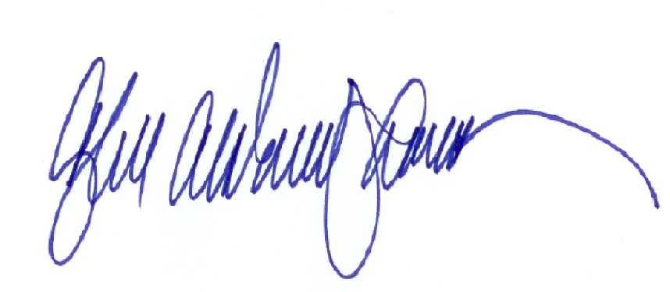
Charles A. Brigham, III
President Elect, Ohio Land Title Association

