

Testimony to the Senate Local Government, Public Safety and Veterans Affairs Committee
Tuesday, September 26, 2017
Patricia Kovacs, Ohio Bicycle Federation member
pkovacs@att.net
(614) 476-9093

Chairman Uecker, Vice-Chair Wilson, Ranking-Member Thomas, ladies and gentlemen of the Senate Local Government, Public Safety and Veterans Affairs Committee, thank you for giving me the opportunity to speak on behalf of HB 95. The Ohio Bicycle Federation supports legislation that increases penalties for distracted driving, and are grateful to Reps. Hughes and Seitz for sponsoring this important legislation to add increased fines for all distracted driving.

There are some concerns that we have with the legislation however. Primarily, this legislation does not increase the enforcement for distracted driving from a secondary to a primary offense. The city of Seattle, WA has implemented a targeted enforcement program in order to achieve their Vision Zero (zero traffic fatalities) initiative. Because hand-held cellphone use while driving is a primary offense, distracted driving is one of the violations being targeted in locations with high pedestrian use, including school zones. The city of Seattle is seeing fewer second violations at these locations.

According to the Governors Highway Safety Association, primary enforcement is specified in all 14 states which prohibit hand-held cellphone use and in 42 of 46 states which prohibit texting while driving. The GHSA policy “supports state legislation that would ban hand-held cell phone use and text messaging for all drivers.”

Distractions have been tracked in crash reports in Ohio since 2011, but motorists are unlikely to admit that they were distracted. But how many of us have not seen motorists drifting out of their lane, and we see them using a phone or looking down at their lap? In 2016 there were 12,994 instances where distracted driving from a source inside the vehicle, such as a phone, was documented as a crash factor (see table). This figure is too high, but we should probably assume that many, many more cases of distracted driving go undocumented. Strengthening the consequences for driving while distracted is an important measure that Ohio can take to lower the number of distracted driving incidents and make our roads safer for all users.

All that would be needed for this would be to remove 4511.204(C)(1), which is the section which prohibits a police officer from stopping a vehicle if he/she suspects a violation of the texting law. This minor change would make all the difference in drivers' perception of the magnitude of this violation, and hopefully change their behavior as well. Do we want to remain one of only 4 states that do not consider texting while driving a primary offense? We should not wait for better reporting of crashes involving driver distractions before taking action to prohibit this unsafe behavior. This will reverse the increasing trend of distracted driving crashes and increase safety for all Ohioans.

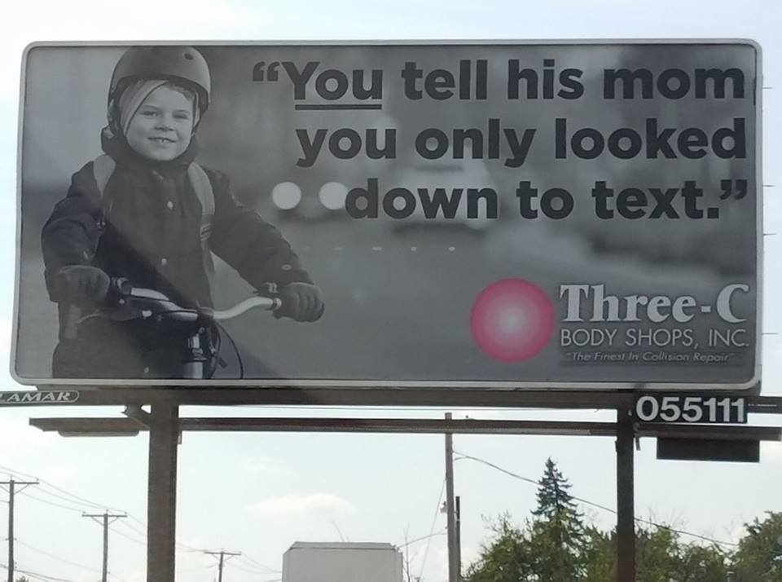

Ohio Distracted Driving statistics (based on crashes reported to Ohio Department of Public Safety)

DistractionName | 2014 Unit 1 | 2014 Unit 2 | 2014 Unit 1 or 2 % | 2015 Unit 1 | 2015 Unit 2 | 2015 Unit 1 or 2 % | 2016 Unit 1 | 2016 Unit 2 | 2016 Unit 1 or 2 %
NoDistraction | 250267 | 171390 |  | 255716 | 177808 |  | 257925 | 182336
Zero | 19167 | 104845 |  | 17695 | 103828 |  | 16617 | 102517
Other Inside Vehicle | 4841 | 2009 | 2.4% | 5247 | 1935 | 2.5% | 5912 | 1834 | 2.7%
External Distraction | 3909 | 1895 | 2.1% | 4354 | 1815 | 2.2% | 5000 | 1655 | 2.3%
Phone | 1748 | 690 | 0.9% | 1875 | 693 | 0.9% | 2065 | 551 | 0.9%
Other Electronic Device (Navigation, Radio, DVD) | 1254 | 543 | 0.6% | 1291 | 505 | 0.6% | 1375 | 480 | 0.6%
Texting/Emailing | 364 | 107 | 0.2% | 337 | 90 | 0.1% | 339 | 75 | 0.1%
Electronic Communication Device | 196 | 109 | 0.1% | 226 | 67 | 0.1% | 289 | 74 | 0.1%

Governors Highway Safety Association Policy on Distracted Driving, www.ghsa.org/about/policies-distracted

