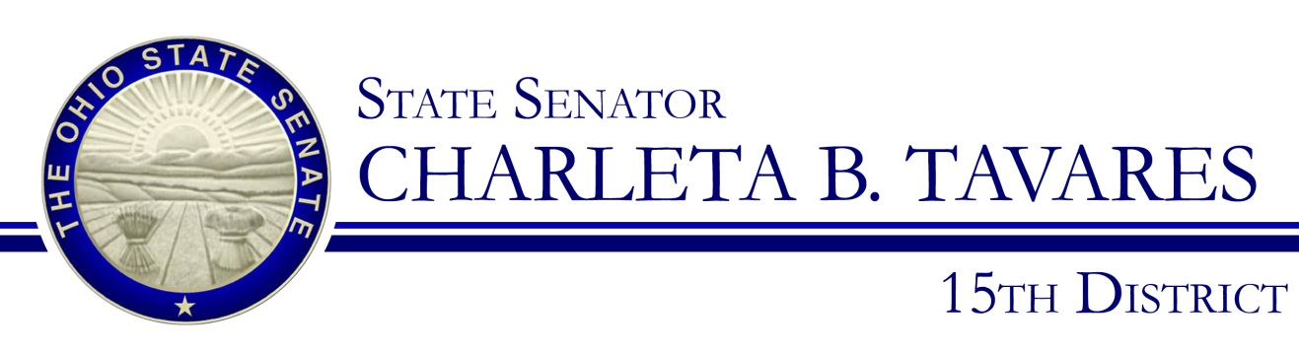

**Sponsor Testimony**

**Presented by: Jean-Philippe B. Dorval, Senior Legislative Aide to Senator Tavares**

**Senate Bill 109**

**Local Government, Public Safety and Veterans Affairs**

**Tuesday January 30, 2018**

Good morning, Chairman Uecker, Ranking Member Thomas and members of the Local Government, Public Safety and Veterans Affairs Committee. Thank you for providing an opportunity for me to offer testimony on Senate Bill 109 on behalf of Senator Tavares. The intent of this legislation is simple but critical – to save lives and deliver timely, accurate care. The Yellow Dot program is a voluntary and free program to assist motor vehicle owners, their passengers and emergency medical responders in the event of an accident.

The first 60 minutes after a car crash can make the difference between life and death for individuals who are critically injured. The yellow dot program provides critical information that will allow first responders to properly treat program participants. Having access to their medical history is a serious benefit following a traffic accident, especially when they may not be able to communicate their needs themselves. The program is free and will be established in the Department of Public Safety.

SB 109, will allow vehicle owners who participate in the program to receive a yellow dot window decal and yellow dot folder for free. The folder will contain the participant’s name, photo, emergency contact information, physician, medical conditions including recent surgeries, allergies and medications being used. This folder would be stored in the glove compartment and accessed by emergency responders if necessary. The yellow dot window decal will serve as an indication to emergency responders that the vehicle owner or their passenger is participating in the “yellow dot” program and has medical information available in the car. Participation in the “yellow dot” program is voluntary and free.

Connecticut was the first state to introduce the Yellow Dot program in 2002. Twenty-three other states have followed suit by implementing some form of the Yellow Dot program including: Illinois, New York, West Virginia, Utah, Pennsylvania, Washington, Massachusetts, Kansas, Iowa, Minnesota, Virginia, New Jersey and Tennessee. We want to give our emergency responders the most accurate health information possible to assist them in saving the lives of Ohioans and give the residents of Ohio the best chance possible of receiving timely and appropriate care.

Chairman Uecker and members of the Committee, I appreciate your attention to this issue and respectfully request your favorable consideration and passage of SB 109.  Thank you for your time and I am happy to respond to questions from the committee.