Senate Ways and Means Committee
S.B. 36 Proponent Testimony
Jenna Beadle, Director of State Policy
February 22, 2017

Chairman Eklund, Vice Chairman Terhar, Ranking Member Williams and members of the Senate Ways and Means Committee, thank you for the opportunity to provide proponent testimony on Senate Bill 36. As Ohio’s largest farm organization, Ohio Farm Bureau feels a strong obligation to uphold the integrity of the Current Agricultural Use Valuation program while ensuring it continues to serve as the state’s most important farmland preservation tool. Considering most other states have similar programs, and in many cases more beneficial programs, CAUV also keeps Ohio agriculture competitive.

What is CAUV?
CAUV is a formula used to value farmland based on its income producing potential from agricultural use only. The authority for the General Assembly to create such a program was included in Ohio’s Constitution in 1973. It was recognized then and still is today that agriculture is the backbone of Ohio’s economy.

In its most basic form, the CAUV calculation looks like this:

Net Income
(Commodity Prices and Soil Productivity and Input Costs)

Capitalization Rate
(Factors in the cost of, and expected return on investment of purchasing the land)

Role of CAUV
As opposed to residential property, there are relatively few farmland sales within a taxing jurisdiction at any given time to establish a basis for what farmland it truly worth. The market is just too small. In addition, those relatively small number of sales can be influenced by many factors leading to a purchase price much higher than an average purchaser is willing to pay.

Without a workable measurement of value based on income producing potential, land values would soar due to development pressures and speculative land purchasing. Many farmers would not be able to continue their operations under such financial pressures. In many cases, what farmers can make off of farming the land is minimal to what they could fetch if they sold that same land to a developer.

Impact of recent increases in CAUV
Recently, farmers across the state have experienced skyrocketing CAUV increases. The average state-wide CAUV value increased by 294% from 2008 to 2014 (See Attachment 1). According to the Legislative Service Commission (LSC), farmland property tax payers paid $370 million more in taxes in 2014 than they did in 2008, a 307% increase. Farmland property tax ratepayers’ share of the local tax burden nearly doubled. While agriculture did experience a time from about 2010-2012 where farm income rose along with commodity prices, the gains farmers made didn’t come close to matching the corresponding increases in CAUV they now face. While commodity prices rose about 100% during the very peak of the short boom, values, and therefore taxes, have increased closer to 300%.

Needed Changes to the Cap Rate
The disconnect between what happened in the farm economy and how much CAUV values increased led Farm Bureau to conduct an exhaustive review of the formula. The review showed that certain non-farm financial assumptions in the formula account for the increases that go beyond what we would expect based on an improved farm economy in the early 2010s. In particular, the formula assumes land is held for only five years when typically it’s held for decades. It also works to inflate farmland value by assuming the land appreciates and landowners achieve equity buildup at predetermined rates. (See Attachment 2).

In addition, the equity yield rate used multiple times in the calculation is artificially low. In fact, it is lower than the borrowing rate included in the formula, a circumstance LSC has noted is “inconsistent with the theoretical underpinnings of the formula.”

The CAUV formula’s equity yield rate, or the expected return on investment (ROI) a land purchaser should expect, is tied to the prime lending rate which is influenced by the Federal Reserve’s Quantitative easing formula. The reliance on the assumption that a land purchaser should expect only a return on investment equal to the prime lending rate plus two percentage points has led the formula to assume a very low ROI in the current economic climate. This also impacts the equity buildup calculation, again by assuming the land purchaser has a very low ROI expectation.

To solve these inaccuracies, Senate Bill 36 would prohibit the use of factors that assume land appreciation and prohibit the use of an equity buildup calculation. We aren’t asking for the Tax Department to completely overhaul how they calculate CAUV, simply end the practice of using these inflationary factors.

Needed Changes to Valuation of Conservation Lands
CAUV makes no adjustment of land-use changes when land is put into conservation practices. Across the state, we are asking farmers to engage in best land management practices to help conserve and protect our natural resources. Particularly in the Western Lake Erie Basin, we are encouraging farmers to put in place grass buffer strips and other conservation practices to help reduce phosphorus runoff, which feeds harmful algal blooms in Lake Erie. To do this farmers must take land out of production. However, under CAUV, a landowner continues to be taxed as if the land is yielding agricultural production income.

In order to address this issue, the bill includes a requirement to value all land dedicated to year-round conservation practices at CAUV’s minimum value, but only if that land remains in a conservation use for at least three years.

Impact of Changes
Mr. Chairman, we understand there will likely be questions about the impact of making changes to other residents who share in the responsibility to pay local property taxes. The fact is, that this proposal works to minimize the sharpest increases in farmland values that we’ve experienced, but does not completely reverse those increases. Even if the changes proposed in this bill had been implemented in 2015, Ohio farmland property taxpayers would still have experienced a net tax burden shift of approximately $300 million from 2008 to 2015. So, as you can see, even with the changes, farms will continue to pay a much higher share of local property taxes than they did just five to six years ago. It’s also important to remember that any rebalancing achieved by the bill will be distributed among a significantly larger number of residential ratepayers helping to minimize the impact on a per-ratepayer basis.

Agriculture faces significant challenges today. Nationally, from 2013 to 2015 we experienced the second largest net farm income decrease in history (See Attachment 3). Only the drop seen from 1919 to 1921 was larger. Commodity prices remain low and input costs remain high, while new challenges in the areas of water quality, animal care, and food safety all add additional costs to farm operations. If we don’t ensure farmland property taxes are accurately reflective of the agriculture income producing potential of the land, many farmers won’t be able to survive.

Thank you for your time and attention to this important matter. I am happy to answer questions the committee may have.

Attachment 1
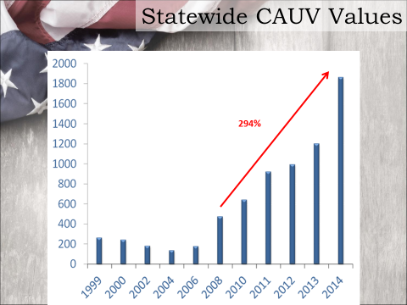

CAUV Timeline
- 1973 - Voters pass constitutional Amendment
“Laws may be passed to provide that land devoted exclusively to agricultural use be valued for real property tax purposes at the current value such land has for such agricultural use” -Article 2, Section 36
- 1980’s Mortgage Crisis, high interest rates and low land values
Equity Buildup calculation added

- 1981 Class 1 properties set as residential and agricultural

- 2006 – Modern crop yields used.
The Ag Community, including Ohio Farm Bureau, supported updating crop yield information to make the formula more accurate.
- 2008 - Federal Reserve implements quantitative easing policy, driving interest rates to near zero.

- 2008-2014 Statewide CAUV values increase 294%

- 2014 Housing bubble bursts, interest rates plunge
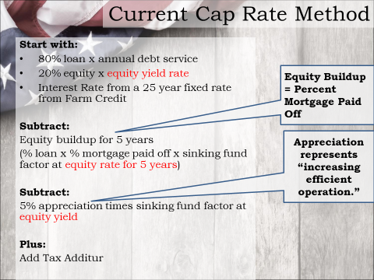
Attachment 2

Attachment 3 (The Next American Farm Bust Is Upon Us – WSJ, Feb. 8, 2017)
