The office of Scioto county Economic Development stands by and supports this legislation.

Many of the requests for companies looking to locate is looking for structures of 100,000 sq/ft+ and there are no structure in Scioto County that could suffice such need.

The possibility of build a structure on "Speculation" is something that the current County Economy could not handle should the building be built. Companies do not want to wait for construction completion so operations should begin. If there is no such speculated building. Thus, this situation automatically disqualifies Scioto County; therefore, proposed legislation is imperative for Scioto County so it may produce a speculative building.

Off all of the companies looking to locate to Ohio unless there is a client looking to occupy "Vacant Land" we ineligible for anything requiring a structure.

In 2019 thus far all request for Information (RFI)'s from JobsOhio; Scioto County has been ineligible for those requesting a building. In 2019 so far there have been roughly four RFI’s we put in as “no-fit” because we do not have structures to suffice. Each of these RFI’s could put in excess of 100 people to work in careers higher than the counties average income.

In 1980 the steel mill closed in Scioto County. Nearly 5,000 people lost their jobs. In 2002 the New Boston Coke Corporation ceased operation and 500 people lost their jobs. We are currently underway building a business park at the Portsmouth Regional, Airport. We are utilizing grant funding via ARC, ODOT, JEDISO, and other means to complete infrastructure on the site. Means to put a new building on the site is difficult at this time. See Attached drawing below.

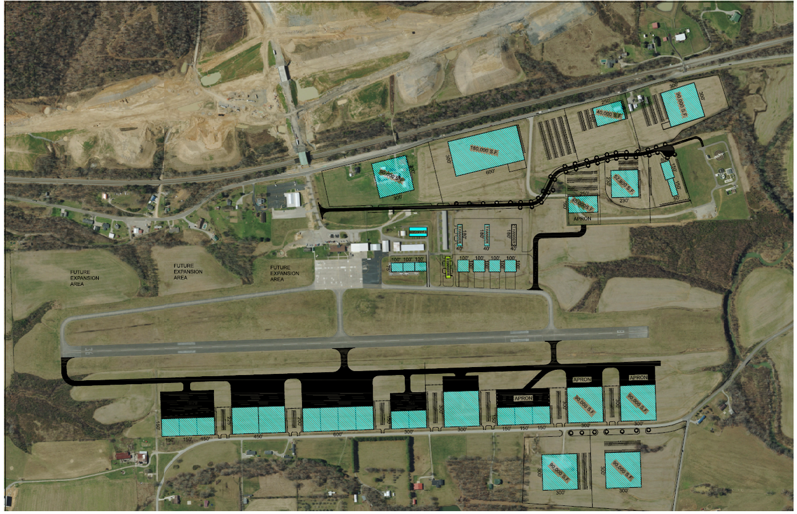

This site is 16 miles from the “Industrial corridor” on the Ohio River. This park could suffice medium, manufacturing, and multiple types of distribution. This site could also serve as a corporate terminal for industries on the Corridor as executives can go directly to the plants, or add a corporate office. We are working with Lawrence County Ohio to help to push the area along both the Ohio River, and the airport itself.

Scioto County is producing graduates from the Career, and Technical Center, and Shawnee State University. Companies looking to locate to the area could find an abundance of skilled labor that could suffice company needs for operations, and growth.

This legislation if passed could allow for the resurgence in the economy. Bringing new businesses, and opportunities to the area; only strengthening the local economy, which will intern boost the state economy as well.

We feel Scioto County could definitely benefit from this program.

Robert Horton Mark C. Ward

Director Assistant Director

Scioto County Economic Development Scioto County Economic Development