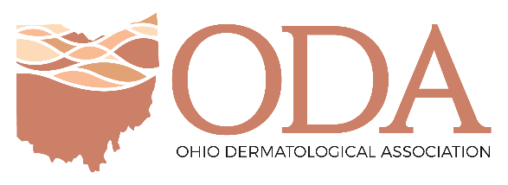

To: Members of the House Health Committee

From: Dr. Elizabeth Muennich, MD

Date: November 19, 2019

Subject: Substitute House Bill 177

On behalf of the Ohio Dermatological Association (ODA) I am writing regarding Substitute HB 177, which would grant independent practice authority to Ohio’s advanced practice registered nurses.
Currently, I am a private practice Board Certified Dermatologist in Mason, Ohio. Dermatology is a highly competitive and academic subspecialty that combines internal medicine and surgery of the skin. In order to become a Dermatologist I had to do 2 years of pre-medicine prerequisites including inorganic and organic chemistry, biochemistry, biology, physics, calculus, psychology and sociology. In the first 2 years of Medical School I studied anatomy, physiology, biochemistry, pharmacology, histology, and microbiology. Wright State starts their clinical training in the first year of medical school so by the end of my second year I had 2 years of clinicals in addition to the hard sciences. I was the first MD/PhD student at Wright State and completed a 4-year PhD after my second year of Medical School. I was required to continue my clinical training, one day a week, through my four years of graduate school. My third and fourth years Of Medical School were all clinical, by graduation I had amassed well over 7000 hours of clinical training. I did two years of Internal Medicine Residency and then 3 years of Dermatology Residency. In those five years I had over 10,000 hours of training. All total over 17,000 hours of clinical training.
I give that background to highlight the differences specifically in clinical training. Substitute HB 177 would allow an APRN to no longer need a standard care agreement after completing just 2,000 hours of “clinical practice”, which is approximately just one year. What is even more troubling, the standard care agreement does not have to be with a physician, it could be with another APRN. Ultimately, Substitute HB 177 will terminate the current method by which physicians and APRNs work together safely and efficiently.
In my practice, I work with two APRNs on a regular basis. I deeply respect their roles in the care team and their ability to contribute to the process of providing high-quality care to our patients. We work in an efficient, collaborative relationship, by which APRNs perform a variety of essential patient care-related functions under my supervision. My two APRNs, do my specific follow up patients, and assist me with small procedures. They do not want to practice independently and appreciate when a patient says, “Hey can you look at this rash?” that I am no more than 50 feet away.
This legislation concerns me for several major reasons, but I would particularly like to elaborate on diagnostic evaluations, based on my years of clinical experience as a physician Dermatologist.
Patients may visit my practice for a multitude of skin conditions, many of which can present with symptoms that upon observation, appear extremely similar. Because of the intricacies involved in the process of medical diagnosis, there is a strong possibility of making an error in identification of diseases and atypical skin lesions if the evaluator does not have extensive clinical background and training on the diagnosis of conditions of the skin. Dermatology takes surgical skill. In addition to my role as the local go to on all things skin rash related and remover of skin tumors I also see Medical Dermatology patients. There are over 2600 rashes that occur on the skin. My APRNs can recognize about 50. They are about equivalent to a 3rd year medical student who has interest in Dermatology and has read the beginning primers on skin. There are rashes and clinical changes to the skin, hair and nails that are indicative of internal cancers and internal disease. One thing that the years of clinical training taught me is to be able to know what I don’t know and be able to do the next steps appropriate to find the answer.
Thank you for the opportunity to provide my comments and explain some of the specific and serious concerns my colleagues and I have with Substitute House Bill 177.

