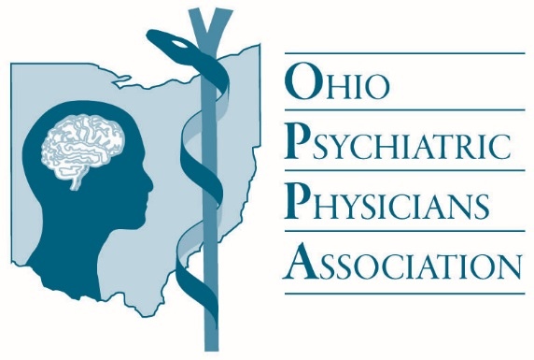

To: Members of the Ohio House Health Committee

From: Victoria Kelly, MD - President, Ohio Psychiatric Physicians Association

Date November 19, 2019

Subject: Substitute House Bill 177

I am writing today on behalf of the Ohio Psychiatric Physicians Association (OPPA) regarding substitute House Bill 177, which would grant independent practice authority to Ohio’s advanced practice registered nurses. We have worked with the legislature and interested parties on this issue for several years, and continue to have serious concerns about this legislation.

When the OPPA worked on HB 216 in the 131st General Assembly, language was added as part of the enacted version of the bill which set up a method by which APRNs specializing in mental health care could provide such care by the means of a standard care arrangement with a family medicine physician or pediatrician, rather than only with a psychiatric physician. This opened up more opportunities for Ohio APRNs to collaborate in the team-based care model in order to bring necessary mental health care to Ohioans, while maintaining the integrity and safety of the team-based care model.

We are disappointed to see that the new substitute HB 177 has struck out these provisions in favor of unsupervised practice authority of APRNs under undefined parameters, much like the original version of HB 216 proposed.

Additionally, substitute House Bill 177 now requires that an APRN complete 2,000 hours of “clinical practice” within a standard care arrangement with a licensed practitioner in order to obtain the authority to practice independently, but the nature of this “clinical practice” is not described or defined. Our association is concerned that in this legislation, the practitioner supervising the APRN in this period is not required to be a physician, and can instead be another nurse. This is not how the collaborative team-based approach to care functions. Under this bill, patients, including those in highly sensitive and vulnerable conditions, may receive treatment from less-experienced practitioners with no oversight by a physician. This weakens the team-based care model significantly and could create additional patient safety risks. Ohioans with mental illness and/or substance use disorders should receive the same high-quality, safe treatment from medically-trained clinicians as is received by those who have other medical conditions. The evidence-based method for this care delivery is through a physician-led team.

We welcome the opportunity to discuss this issue further. Thank you for your consideration of our concerns about substitute House Bill 177.