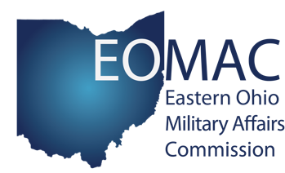
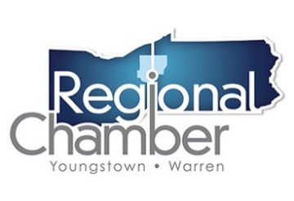

House State & Local Government Committee
Testimony: HB 133
James D. Dignan
Youngstown/Warren Regional Chamber
April 1, 2019

Chairman Wiggam, Vice-Chairman Ginter, Ranking Member Kelly and members of the House State & Local Government Committee, I am James Dignan, President and CEO of the Youngstown/Warren Regional Chamber and the former Wing Commander of the 910th Airlift Wing in Vienna, Ohio. The Regional Chamber is a private, non-profit organization that provides leadership and business services to promote the growth of our nearly 2,600 members—representing more than 125,000 employees in the Mahoning Valley; and the 910th Airlift Wing is the home of nearly 3,000 Reserve-Citizen Airmen. I appreciate the opportunity to write to you today regarding House Bill 133, as it is an important piece of legislation that will have a significant impact on Ohio and the Mahoning Valley.

The Regional Chamber, as a champion of military advocacy and investment, launched the Eastern Ohio Military Affairs Commission (EOMAC) in 2015 to preserve and promote the military value of the missions that call Northeast Ohio home, namely, the Youngstown Air Reserve Station, home of the 910th Airlift Wing, and Camp James A. Garfield in Ravenna, Ohio.

Because of EOMAC’s involvement in our community and the Regional Chamber’s strong support of our fighting men and women, we encourage the support and passage of HB 133. While the Mahoning Valley prides itself as a “Defense Community,” the time has come for the State of Ohio to stand with our servicemen, women and their families that make Ohio home, even if it is only for a short amount of time.

HB 133 will allow for transferability of licensures and certificates, across state lines, for those stationed here to practice their occupation without the undue hardship of having to secure new licensure or certification from Ohio. This Bill will act as an economic catalyst, pouring hundreds, if not thousands, of new qualified workers in to the areas of Ohio that need them most and raising household incomes so that families can patronize our hometown businesses to the fullest extent possible. Our Chamber is also supportive of changes that can be made to HB 133 and hope that future proposals will include the National Guard and Reserve. With the inclusion of National Guard and Reserves, it demonstrates that Ohio is creating an inclusive, competitive, workforce ready and military friendly state.

I am happy to provide any further insight or clarification and we appreciate your consideration.

