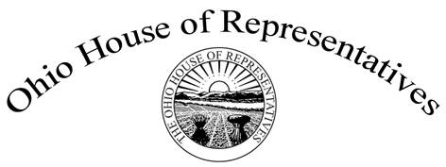

Representative Tom Brinkman

Ohio’s 27th House District

Chair Wiggam, Vice Chair Ginter, Ranking Member Kelly, and members of the House State and Local Government Committee, thank you so much for the opportunity to testify on behalf of House Bill 152, which would change the manner in which some levies can be placed on a local ballot.

Currently, mental health districts and school districts must take their proposed tax levies before the elected officials who govern them, for vetting and approval before submitting for inclusion on the local ballot. However, not all subdivisions must operate in this manner.

For example, unelected officials who operate the library and bus systems in Hamilton County can place levies on the local ballot without any approval or vetting from elected authorities. This provides zero checks and balances. It also permits these unelected officials to tax residents in a county they may or may not reside in themselves.

This simple bill will require certain subdivisions and their unelected officials to obtain the approval of the legislative body that created them before they can levy a tax. In an effort to stay true to a key principle of our nation in the checks and balances system, this bill aims to make sure the voters and their choices in elected officials are not overlooked.

Thank you for your time, and I look forward to any questions you might have.