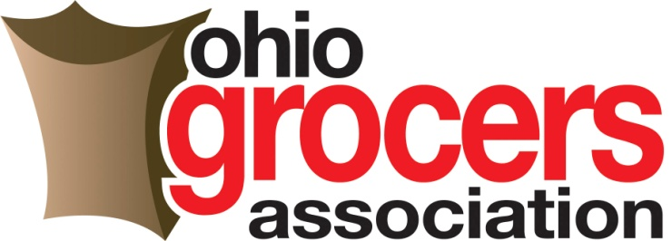

House Bill 242 – Written Testimony
Kristin Mullins, President/CEO
Ohio Grocers Association – June 5, 2019

Chairman Wiggam, Vice Chair Ginter, Ranking Minority Member Kelly, and members of the House State and Local Government Committee, thank you for the opportunity to offer written testimony in support of House Bill 242, legislation that would establish commerce uniformity pertaining to the regulation of auxiliary containers in Ohio.
As President of the Ohio Grocers Association, I proudly represent over 400 food retail, wholesale and supply companies across the Buckeye state. My members range from the largest chain stores to the smallest “mom and pop” independent grocers as well as some convenience stores and of course the food wholesalers who supply these stores.
Recently, we’ve seen a national influx of city and local ordinances pertaining to types of auxiliary containers such as plastic bag fees, taxes and even outright bans. Several municipalities in Ohio have either explored the idea of a fee and/or ban or introduced language. Plastic bag fees/taxes and outright bans can pose a significant burden for grocery and retail food establishments. There are numerous potential hardships associated with instituting a bag fee, particularly at the local level, that negatively impact our industry.
Many OGA members operate across multiple municipalities and having varying rules and regulations relating to fees would be a logistical nightmare and prove difficult to manage. We have also seen that these regulations create customer and employee confusion. We are on the front line of the customer experience; employees need to be adequately trained at the checkout in order to promptly adhere to the regulations. Furthermore, without proper education, consumers often associate these fees with the store itself and will simply choose to shop elsewhere. Lastly, the reporting and remittance requirements associated with a plastic bag fee would create devastating drawbacks to our small business’ ability to effectively operate their stores – and in the most challenged of demographics - could even result in store closures.
House Bill 242 establishes fixed regulations for the day to day operations of running a retail food establishment. Dictating that the state has sole authority, under Ohio EPA, in matters related to laws on auxiliary containers will provide our members with the much-needed consistency they need to efficiently operate their stores.
We commend the leadership of Representative Lang and Representative Jones for their sponsorship of this important legislation and urge your favorable consideration of House Bill 242.
1335 Dublin Road Suite 207B  Columbus, Ohio 43215  T 614.442.5511  F 614.441.4292  www.ohiogrocers.org

