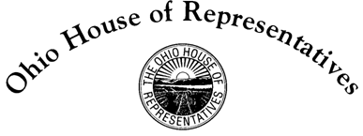

**Tom Brinkman, Jr.**

State Representative

27th House District

Chair Green, Vice Chair McClain, Ranking Member Sheehy, and members of the House Transportation and Public Safety Committee, thank you for the opportunity to testify on behalf of House Bill 148. This legislation’s purpose is to clarify the right of way for vehicles attempting to park or exit at an angled or parallel parking spot.

A constituent of mine brought this to my attention. In the past all cars were the same height and tinted windows were not available. Drivers could easily see thru dozens of others cars’ windows when backing out of angled parking and thus legislation was unnecessary. Now cars and trucks come in various heights and many have tinted windows.

When drivers attempt to exit an angled parking spot, they often cannot see oncoming traffic, while oncoming traffic can see the backing vehicle. This bill simply clarifies that oncoming traffic must yield to the vehicle entering or exiting an angled spot. The bill also clarifies that cars with their parking lights on (typically white lights) have the right of way.

Similarly, when a driver is attempting to park or exit a parallel spot, some drivers will either pass the vehicle or place their vehicle such that parking or exiting is difficult. This bill would clarify that the driver attempting to park has the right of way. Current law is silent on both of these subjects. Our discussion with the Department of Public Safety over the Summer indicated that they were also surprised that this area of the code had not been updated to take into account newer vehicles causing this situation.

In many respects this is about common courtesy but that is waning throughout society. Passage of HB 148 is not meant to raise revenue or put folks in jail. Rather it will give guidance when these issues occur. And once law, I will work to have this placed into the driver’s training literature and classes because we must begin by educating new drivers so that over time knowledge of this situation will lead to better safety.

Again, thank you for the opportunity to speak on this bill. I welcome any questions you might have.