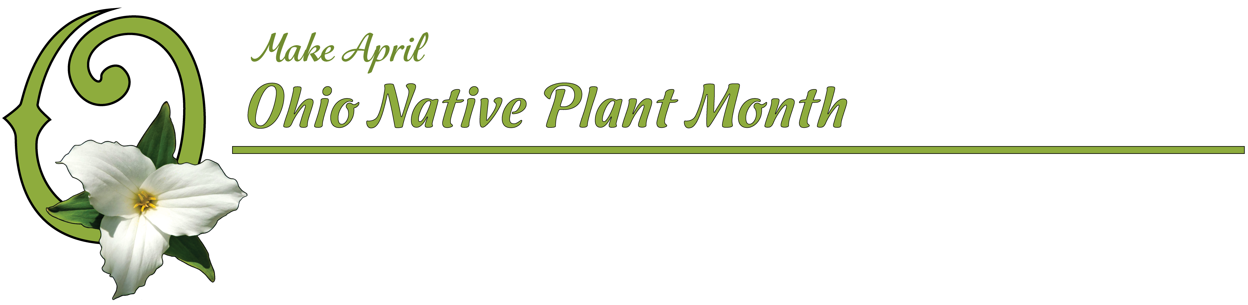
Why Making April Ohio Native Plant Month is Important for Ohio

Good afternoon Chairman Hoagland, Vice Chairman Schaffer, Ranking Minority Member O’Brien, and members of the Agriculture and Natural Resources Committee.

When you look at a typical residential neighborhood in Ohio today, it generally consists of a house surrounded by a lush, green lawn. This view of suburbia is accepted today as the norm, with neighbors competing with each other to have the best, thickest, and greenest lawns in their neighborhoods.

It is now known that the single largest crop grown in the United States is not corn, wheat or soy beans, but turf grass. In a study published in Environmental Management in 2005, researchers estimated there were 40 million acres of turf grass in the U.S., covering almost 2% of the land in our country. Turf grass not only consumes massive amounts of water for survival, but does not provide any nectar for our pollinators, or shelter for our wildlife.

In Ohio we have over 1000 native trees, shrubs, perennials, vines and grasses that are important to pollinators, birds, insects, and all wildlife…including humans. They are part of an intricate, balanced web, that helps to filter and clean our drinking water, remove contaminates from the air we breathe, cool our planet, and feed the bees that pollinate most of our food crops. At the very core of this elaborate system, are our native plants.

Native plants are well adapted to Ohio’s local soils, temperatures, precipitation and environmental conditions. Because of this, they often require less water and little maintenance once established.

And native plants are beneficial to our native insects. Over thousands of years, our native insects have evolved alongside our native plants, and as a result, these insects are more tolerant of the unique chemical defenses of native plants. Today, our landscapes contain plants collected from around the world, but many of our insects have not evolved quickly enough to be able to eat these strange and exotic foods.

You have probably heard that pollinators are declining across the Midwest and the entire country. Native plants provide abundant nectar for important pollinators including hummingbirds, native bees, butterflies, moths, and bats. Caterpillars of the iconic Monarch butterfly eat only native species of milkweed. Without our native milkweeds, we would have no Monarchs.

There are a few plant species that, in addition to being non-native, are also highly invasive. Invasive plants can quickly dominate large areas and push out beneficial natives. Extremely aggressive, hard to control, and usually of little value to wildlife, these invasive plant species can overwhelm and destroy entire ecosystems. Researchers at NASA have stated that invasive species are, “perhaps the most devastating biological phenomenon of modern times.” Removal of highly invasive non-native plants should be a priority in Ohio.

Last August we conducted a survey among a sample of people across the State of Ohio representing home gardeners, landscapers, landscape designers, nurserymen, garden centers, greenhouse growers, arboretums, garden clubs, and non-profits including zoos, parks, nature centers, and others in the green industry. Based on their feedback, 99% supported the idea of having an Ohio Native Plant Month, and April was identified as the best month for all of Ohio. It turns out that April is the month our State Wildflower, the trillium, is in bloom. It is also the month of both Arbor Day and Earth Day.

Since August, we have heard from hundreds of people across the State of Ohio excited about the possibility of having an Ohio Native Plant Month. Some non-profit organizations said they would use April to offer special classes and workshops dedicated to native plants. These events would focus on both the removal of invasive non-native plant species, and the planting of native trees, shrubs, perennials and wildflowers.

In April, students are still in school, offering numerous educational opportunities to learn about the benefits of planting native plants. Students should be taught the importance of removing invasive plants from our communities, and the economic and environmental benefits of planting and protecting our native plants.

A recent Washington Post article by Adrian Higgins shed light on the increasing shortage of employees in horticulture, botany, plant sciences, and related fields. His article, “The horticulture industry age problem is bigger than you think,” discusses the fact than many young people have not heard of horticulture or are unaware of employment opportunities in this or related areas. According to Higgins, “The gulf between jobs and takers is so obvious and alarming to insiders that more than 150 green industry employers, colleges, botanical gardens and others in April launched a national initiative seeking to reverse the decline.” Building awareness of native plants in Ohio will help encourage citizens to seek jobs in the horticulture field.

Given the importance of our native plants, every month should be Native Plant Month. But having one month dedicated each year as Ohio Native Plant Month (ONPM) will serve as an annual reminder to renew our commitment to the removal of non-native invasive plant species, and the planting of our native species. The proposed legislation would make Ohio one of the first States in the nation to have a month dedicated to native plants. And it will provide a platform for the horticulture industry, home gardeners, schools, public agencies, and non-profit organizations to work together to restore and improve the health of Ohio’s natural ecosystems.

Please vote to pass HB 59, and make April Ohio Native Plant Month.

