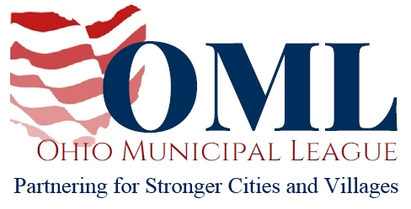

WRITTEN TESTIMONY TO THE SENATE AGRICULTURE AND NATURAL RESOURCES COMMITTEE

PROPONENT TESTIMONY
HB 168

December 4, 2019

Chair Hoagland, Vice Chair Schaffer, Ranking Member O’Brien and members of the Senate Agriculture and Natural Committee, thank you for the opportunity to write in support of HB 168.

HB 168 would positively impact municipalities by incentivizing economic development. Many formerly industrial properties in cities and villages throughout Ohio, often called brownfields, are not being purchased for rehabilitation and re-use because the risk of environmental liability to a prospective purchaser is too great. HB 168 addresses this issue by establishing state-level immunities for those who buy such properties, provided they follow protocols established in current federal law.

Blighted properties stymie growth in municipalities by robbing them of additional tax revenues and making it financially difficult or impossible to turn those existing properties into productive use. Urban revitalization is a key part of what is known as “placemaking” which is the process of making a downtown area a place where the younger workforce can live and walk to amenities, thereby attracting businesses to that area as well. HB 168 would encourage job creation and economic development throughout the state while respecting existing environmental safeguards.

Eighty percent of businesses in Ohio have elected to locate in a municipality, making cities and villages the economic engines of the state. HB 168 recognizes the key role municipalities play in the overall economic health and vitality of the state by incentivizing prospective purchasers to invest in municipalities. Thank you for your consideration, and we urge for your favorable passage of this bill.

Sincerely,
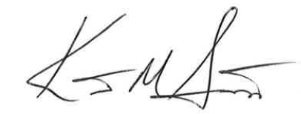
Kent Scarrett
Executive Director
Ohio Municipal League

