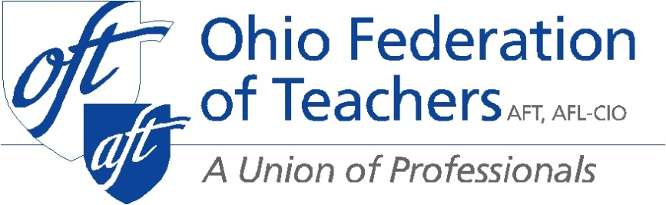

Proponent Testimony on SB 121
Presented by Darold Johnson
President, Ohio Federation of Teachers
October 1, 2019

Chair Lehner, and ranking member Fedor my name is Darold Johnson, Legislative Director of the Ohio Federation of Teachers (OFT). OFT represents 20,000 teachers and paraprofessionals in rural and urban school districts and public employees across the state of Ohio. OFT supports Senate Bill 121, which repeals the current prohibition on the State Board of Education from adopting or revising any standards or curriculum in the area of health unless the legislature approves the standards.

OFT supports SB 121 because it streamlines the process for the Department of Education and the legislature to develop health standards. Ohio is the only state that doesn’t have health standards.

OFT supports the National Health Education Standards (NHES) because it takes a holistic approach to talk and thinking about health and it is one of the options included in the bill. The NHES were revised in 2007 by the Joint Committee on National Health Education Standards, which included the American Association of Health Education, the American Public Health Association, the American School Health Association, and the Society of State Leaders of Health and Physical Educators.

According to the Centers for Disease Control and Prevention’s website, the NHES standards “were developed to establish, promote and support health-enhancing behaviors for students in all grade levels – from pre-Kindergarten through grade 12.” The standards provide a framework for curriculum development, but do not contain specific curriculum or content and do not address any particular health content areas. NHES emphasizes student’s opportunity to become proficient in and master the concepts and skills outlined at each grade level. The eight standards are as follows:

- Standard 1: Students will comprehend concepts related to health promotion and disease prevention to enhance health.

- Standard 2: Students will analyze the influence of family, peers, culture, media, technology, and other factors on health behaviors.

- Standard 3: Students will demonstrate the ability to access valid information and products and services to enhance health.

- Standard 4: Students will demonstrate the ability to use interpersonal communication skills to enhance health and avoid or reduce health risks.

- Standard 5: Students will demonstrate the ability to use decision-making skills to enhance health.

- Standard 6: Students will demonstrate the ability to use goal-setting skills to enhance health.

- Standard 7: Students will demonstrate the ability to practice health-enhancing behaviors and avoid or reduce health risks.

- Standard 8: Students will demonstrate the ability to advocate for personal, family, and community health.

Research has shown that school health programs can reduce the prevalence of health risk behaviors among young people and have a positive effect on academic performance.

The school day provides students the opportunity to learn the importance of behaviors and skills needed to engage in a healthy lifestyle. It is more natural and more effective to develop healthy behaviors during childhood than to change unhealthy behaviors during adulthood. Schools can contribute directly to a student’s ability to practice behaviors that promote healthy lifestyles successfully.

SB 121 is a simple bill that allows Ohio to join every other state with health standards. It provides the state and local school districts with options for how standards are implemented. Helping children make good health choices, participate in physical education, and helping parents learn positive parenting skills are possible outcomes of health standards. More importantly, it lets those with health expertise make decisions about health standards.

We urge you to pass this bill, and I will be happy to answer any questions.

