Alejandra Rojas Silva
2543 Mount Holyoke Rd.
Columbus OH, 43221
(240) 997-0866

October 11, 2019

Senator Andrew O. Brenner
Senate Building
1 Capitol Square
Ground Floor
Columbus, OH 43215
(614) 466-8086

Senator Peggy Lehner
Senate Building
1 Capitol Square
2nd Floor
Columbus, OH 43215
(614) 466-4538

RE: Establish Dyslexia Screen Program
Dear Members of the Senate Education Committee,
I write to strongly voice my support for Bill 102 Establish Dyslexia Screen Program for Schools. As a parent of a dyslexic child in the district, my family has personally experienced the detriment of not having a screening for dyslexia in all public schools.
After my child entered Kindergarten in the Columbus City Schools District, I started to notice that his reading gains were not commensurate to his intellectual abilities and that after years in pre-School and a year in Kindergarten he had not made any gains in reading. A normally cheerful child, eager to learn an attend school, was crying everyday after class and could not pinpoint the cause of his frustration, but was beginning to wonder about his own abilities to learn. I became increasingly concerned, approaching his very caring teachers with specific questions about my son’s growth in the area of reading and writing. His obvious issues were disregarded as issues typical. Most alarming, they assured me that Teo was in fact capable of reading. Teo himself knew well that he did not have the skills other kids were displaying and could easily articulate it. He would say he could “not read the words”. When I insisted that he could not read, they said that could recite whole books. I kindly expressed that memorization and reading were different skills. They countered with the expansive vocabulary Teo had and how although he could not read exact words, he could look at pictures and say synonyms of the words in print. As a person who speaks many languages, I know there is a huge gap between the spoken and the reading word, and that reading is a skill, not akin to speaking, even though they both use words. More significantly perhaps, saying the synonym of a word is far from reading, it means the child has not sense of the relationship between written letters and sounds integral to the skill of reading.
Without knowing much about the topic, I wondered out loud whether the teachers were concerned about a reading disability, to which they flatly said, “dyslexia cannot be diagnosed until 3rd grade”. Surprised, I decided to explore outside of school what might be causing my son’s unexpected reading delay. After making a substantial financial effort to test Teo privately, we got a definitive diagnosis of dyslexia. It is often difficult for a classroom teacher to recognize dyslexia, especially is the child, like mine, has a very high IQ. In the early years these children are good at masking their deficiencies with other skills. Thus my child memorized whole books so as not to be embarrassed when asked to do something in front of his peers and teachers that he knew for a fact he could not do. However, a simple and cheap solution to this would have been a dyslexia screener, which focuses on aspects necessary for accurate and fluent reading: phonological awareness and rapid naming, for example. My son was clearly deficient in both.
I was correctly informed that this quick, cheap test would not be enough to convince Teo’s school of his need for remediation, or of his dyslexia for that matter. I tested him more, again at some expense, and came back to the school confident that they would take his extensive testing as a sign not only of the correct diagnosis but of the need for immediate remediation.
I am an academic, and as such, before meeting with the school, I educated myself on dyslexia and the most effective forms of remediating it. As I knew that the teachers thought dyslexia could not be identified until 3rd grade, I assumed little knowledge of the problem, and as the professor I am, produced a two-page fact sheet with definitions, summaries and sources for what I had learned in the hope that we could work as a team, learning about my son’s issue and working together to give him the remediation. When my meeting finally arrived, the team was not interested in my knowledge, and refused to even use the word dyslexia, but agreed to test Teo further.
A few months later, when his results arrived, the dyslexia diagnosis was unavoidable, in part because of the gap between his intellectual ability and his academic capacity in reading and writing. The truth is, the extensive testing that Teo got at school was unnecessary for the diagnosis of dyslexia. A simple screener can already point towards the kind of remediation that will be useful for a child like mine. Sadly, without the extra tests, it would have been difficult to convince teachers ideologically convinced that dyslexia cannot be identified until later in life. Sadder still, the school like to wait until the child has failed a grade or two before testing. Not to mention anything about the costs of this delay. First, if the school had believed me based on a screener, they would not have wasted months of expensive neuro-psychological testing. Worse yet is the cost of remediating children after 3rd grade rather than after Kindergarten. Remediating a child in 4th takes 4 times as long as remediating a child in 1st grade. Why not do it earlier, when it costs the taxpayers less not to mention the emotional costs to the child.
All children can learn to read and it is out duty to help them do so. A dyslexia screener as soon as a child enters an Ohio school, will help the 10-20% of Ohio children who are dyslexic get identified. If after that identification we provide these children Structured Literacy, they will learn to read. This type of early intervention will allow them to access their curriculum, flourish in school, and become integral parts of a thriving community.
When I realized my child was not going to be given the type of intervention he required I moved to a different district. In Upper Arlington Teo gets exactly what he needs to become a strong reader and a contributor to his society. However, my experience pointed at a larger and more worrisome social issue that I felt compelled to dedicate my life to. If, given my level of privilege, because of my own education and economic security, I had such difficulty getting my child screened, diagnosed, and remediated, how many children are going through life without ever being identified of being taught to read? And what type of future do these children have? It is not surprising to me that 80% of the incarcerated population cannot read at a basic level? How many of these people would have a different outcome if they had been screened and remediated?
We can’t all move to Upper Arlington. We cannot expect parents to have more knowledge about common learning disabilities than the people who educate their children. We cannot wait for children to fail before we remediate them. It is a moral imperative for us to identity and remediate dyslexic children. But if you are not moved by ethics, it is also a fiscal necessity. It is simply cheaper to screen and correctly remediate these children, rather than take on the costs of repeating years, extensive testing, ineffective remediation, low graduation rates, under-employment, and incarceration.
We can and must do better. Please vote for the passage of Bill 102.

Gratefully,
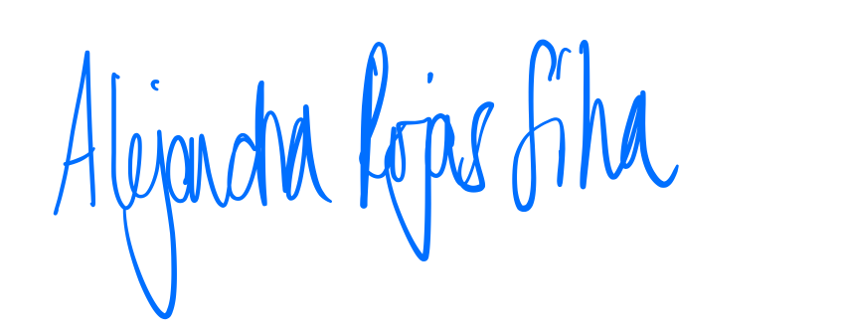
Alejandra Rojas Silva

