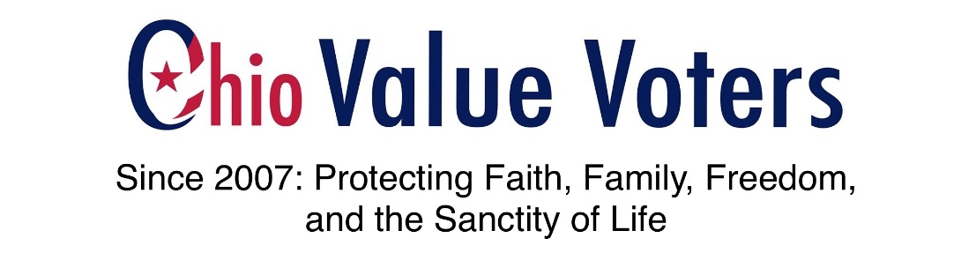
Tuesday, October 29, 2019
Diane Stover, Ohio Value Voters (www.ohiovaluevoters.org)
Chairwoman Lehner and Members of the Committee:
Today I testify in opposition to Senate Bill 121 (Health Standards for Ohio)
Over the last two years I have been leading the “Protect Ohio Children Coalition” that opposes Comprehensive Sexuality Education. Our team has found evidence and created two reports (200 pages of information) that shows that even though ORC 3313.6011 mandates that schools in Ohio stress to students to abstain from sexual activity until marriage, unlawful and obscene curriculum and materials are being presented in classrooms. (Reports can be found at https://ohiovaluevoters.org/evidence-cse-in-ohio.html )
Through research and public records requests we know that Planned Parenthood and their allies, working closely with Ohio universities and through county and federal grants and private donations, have infiltrated Ohio schools by presenting harmful materials to minors.
We have learned from our research, interviews, and the public records request process that to gather information and to find out what is being taught in Ohio classrooms is a grueling and tedious process; often impossible.
Curriculums we have found, such as All About Life; 216Teens.Org; Draw the Line; FLASH & Perfectly Normal; Get Real; Life Skills; Making Proud Choices; Reducing the Risk; Safer Choices; and vendors like Syntero (that partners with Planned Parenthood) teach:
- how to negotiate sexual encounters and how to get consent from one another to engage in sexual acts;
- present abortion as a safe or positive option and refer students to abortion providers and encourage the use of contraceptives, while failing to present failure rates or side effects;
- promote affirmation of and/or exploration of diverse gender identities and teach children they can change their gender or identity as multiple genders.
I am deeply concerned and alarmed that the Ohio Senate by way of SB 121 is taking steps to expand local school districts’ ability to contract for additional Planned Parenthood curriculum when we have no controls in place to ensure that children be protected from harmful curriculum. I am additionally concerned that the Senate would select a less than optimum health standards option.

I urge Ohio leaders to immediately take the necessary steps to correct and require Ohio schools to follow existing law found in Ohio Revised Code 3313.6011 and take actions to amend the law in the following areas:
Give Transparency to Parents
Require school districts to give parents the ability to know the name(s) of sex education curriculum being used in their local schools. Require that schools make curriculum readily available for inspection. Give parents and tax-payers recourse for non-compliance and a civil right of action if a school is out of compliance with ORC 3313.6011.
Require the Ohio Department of Education Protect Children
Ensure a process and accountability for oversight of local school districts’ sexual health curriculum. It is necessary to codify an auditing role for the Ohio State School Board to audit each school district and post results of compliance and non-compliance to ORC 3313.6011 on the Department of Education website.
Thank you
Diane Stover
Ohio Value Voters / Protect Ohio Children Coalition

