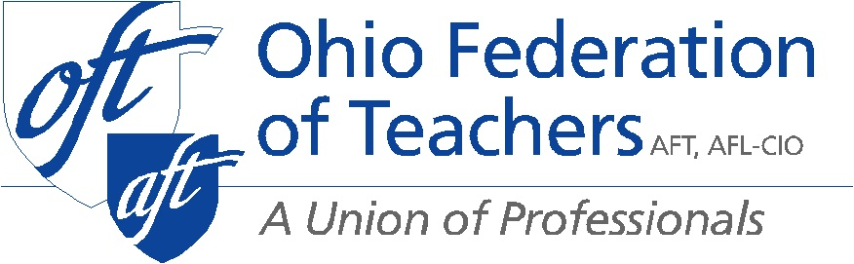

Senate Education Committee
Proponent Testimony HB 123
Presented by Melissa Cropper
OFT President
October 29, 2019

Chair Lehner, Vice-Chair Brenner, Ranking Member Fedor, and members of the Senate Education Committee thank you for the opportunity to testify today. I am Melissa Cropper, President of the Ohio Federation of Teachers. OFT represents teachers, paraprofessionals, school nurses, higher education staff and faculty, and public employees.

OFT support HB 123 because it mandates the use of evidence-based research that addresses the root causes of violence. The bill uses an Everytown model. It is based on evidence-based information about effective ways to prevent violence and suicide. HB 123, focuses on engaging students and staff in the process of reaching out to other students to avoid isolation and help them identify the signs and symptoms of depression, suicide, and self-harm in their peers.

Everytown for Gun Safety supports HB 123. Everytown is a national organization that seeks to improve the public’s understanding of the causes of gun violence and the means to reduce it. They do this by conducting groundbreaking original research, developing evidence-based policies.

The bill can help create a process that de-escalate emergencies in a proven way to intervene before gun violence such as firearm suicide or mass shooting, takes more American and Ohioans lives. Ohio has the opportunity to do something to reduce the risk of violence. Addressing firearm suicide is an essential element of any strategy to reduce gun violence in this country. Passing HB 123 is one of those ways.

Finally, we support HB123 because its objectives align very well with the student wellness and success funds. Therefore, we urge you to support HB 123.

