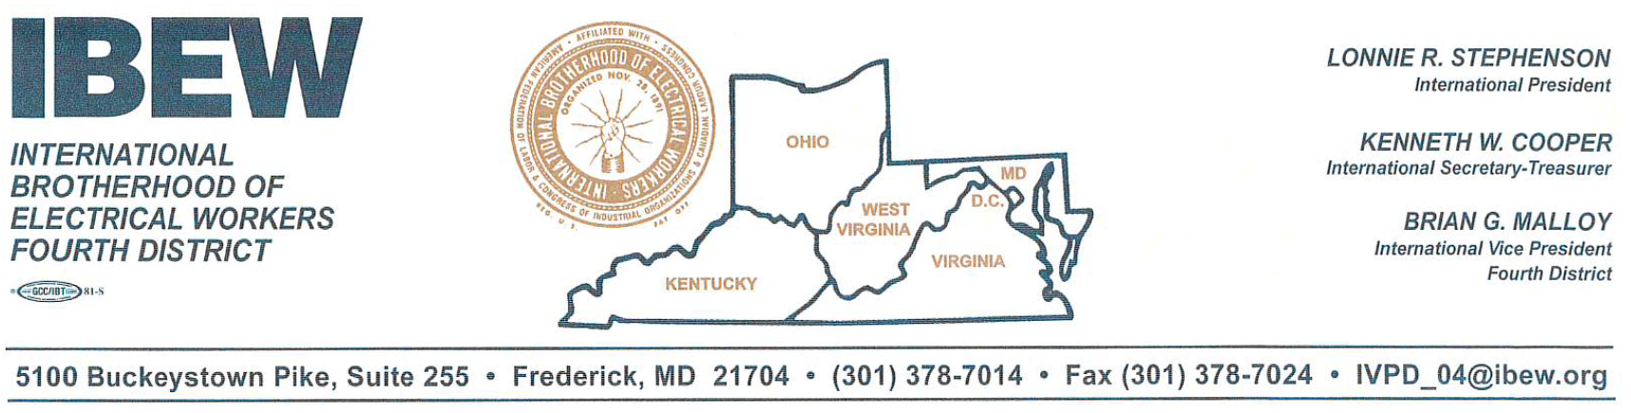
Testimony of David E. Moran
Resident, Ohio District 35
International Representative, International Brotherhood of Electrical Workers
Before the Ohio Senate Energy and Public Utilities Committee
June 12, 2019

Good Morning Chair Wilson, Vice Chair McColley, Ranking Member Williams, and members of the Senate Energy and Public Utilities Committee. Thank you for allowing me to provide testimony today.
I am a life-long Ohio resident and a 40-year member of the International Brotherhood of Electrical Workers, the IBEW. The IBEW is the largest energy union in the world, representing over 775,000 active members and retirees across the United States, United States’ territories, and Canada. I have worked thousands of hours throughout Ohio in the electrical trade. IBEW members from the construction branch work approximately 100,000 manhours each year in Ohio’s nuclear power plants. I have worked with IBEW members from our utility branch that keep these plants running daily. I have made a living, supported my family, given back to my community and when the time comes, I will be able to retire comfortably. I have built my life on jobs that will be directly impacted by House Bill 6.
I think my time here today is best spent focusing on jobs and the actual effect House Bill 6 will have on the citizens of Ohio. Make no mistake, when I talk about the jobs impact this legislation will have, it is not limited to those that will be lost if the Davis-Besse or Perry Nuclear Power Plants were to close. If House Bill 6 fails, thousands of families will be impacted, thousands of jobs will be lost in our communities.
Based on recently published data, the jobs multiplier for the utility industry is the highest of all measured industries, with over 950 indirect jobs impacted by every 100 direct jobs lost or
gained in the industry. Currently Davis-Besse and Perry Nuclear Power Plants employ approximately 1,400 individuals. Do the math – if these 1,400 jobs are lost – almost 13,000 jobs will be impacted. 13,000.
The IBEW represents nearly 20,000 workers in Ohio, over 6,000 of these members are employed in the Utility industry under 30 collective bargaining agreements. At Davis-Besse alone, the IBEW represents nearly 400 workers in 15 different positions. IBEW-represented employees at Davis-Besse make on average over $40 an hour plus benefits. Nuclear salaries are typically 36% higher than average local salaries. The jobs at stake here are highly-skilled, family-sustaining, community-supporting, lifelong jobs – they are careers with room for advancement. I am here on behalf of these workers and their families.
Since 1970, when construction began on the Davis-Besse Nuclear Power Station, and in 1974, when construction began on the Perry Nuclear Power Station, entire communities in Northern Ohio have relied on these plants. As I stated earlier, in addition to the workers that keep these plants running on a daily basis, IBEW members and members of Ohio’s affiliated construction trade unions average nearly a quarter of a million hours – sometimes up to and exceeding 500,000 hours in facility upgrades and maintenance at these two plants per year.
Aside from the direct jobs impact, Davis-Besse and Perry are huge revenue generators and contributors to the tax base in their Ohio communities. It is estimated that thirty million dollars in tax revenue flows directly back into these communities from the plants, providing critical support for schools, roads, and first responder services. Entire communities, many of which are small, would be decimated if House Bill 6 fails.
In addition to supplying almost 15% of Ohio’s power and 90% of Ohio’s carbon-free power – around the clock, no matter the weather - Davis-Besse and Perry provide significant power to customers in the PJM Interconnection. Nuclear power is an important part of Ohio’s generation mix and a critical component of emission-free electricity world-wide. In 2017, nuclear power accounted for 34% of emission-free power globally, with hydropower accounting for 51%, and other renewables such as wind and solar accounting for 15%.
The IBEW supports a sensible, “all of the above” energy policy. In order to ensure grid reliability and resiliency, Ohio must have a diverse and balanced energy portfolio. Nuclear power is an important part of this portfolio, as are other renewable sources.
I urge you to support jobs, grid stability, the environment, and most importantly the citizens of Ohio by supporting House Bill 6. Thank you for the opportunity to address you today. The IBEW looks forward to continuing its work with you on this important issue.

Submitted by:

David E. Moran
456 Lindenwood Avenue
Akron, Ohio 44301
(330)696-5013
David_Moran@ibew.org

