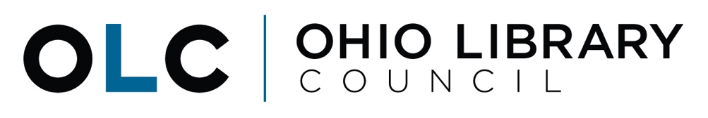

Senate Finance Committee
House Bill 166 Testimony
May 22, 2019

Good morning, Chairman Dolan, Ranking Member Sykes, and members of the Senate Finance Committee. Thank you for the opportunity to testify today on House Bill (HB) 166 and Ohio’s public libraries.

My name is Michelle Francis and I am the Director of Government and Legal Services for the Ohio Library Council. The Ohio Library Council is the statewide association representing Ohio’s 251 public library systems (rural, urban and suburban) and the 8.4 million library cardholders they serve.

We are here to share our thoughts on certain provisions in the budget proposal related to the Public Library Fund (PLF) and we hope to give you a glimpse of the wide array of services provided to Ohioans everyday through public libraries.

Public Library Fund
The Public Library Fund is not a line-item appropriation like the numerous programs and state agencies before you in HB 166. It is in permanent law and is a set percentage of the state’s monthly tax receipts that go into the General Revenue Fund (GRF). It ebbs and flows each month depending on state revenues and is currently set in temporary law at 1.68% of the GRF for FY 2019.

The current version of HB 166 would maintain our state funding at the 1.68% rate for FY20-21. Under the Governor’s proposal, OBM was estimating the PLF will grow by 5.1% in FY20 and 1.8% in FY21. However, these estimates were based on natural growth in Ohio’s economy and no additional policy changes impacting the GRF. Am. Sub. HB 166 as passed by the House includes significant tax reform changes that will both increase and decrease the GRF. It is also important to note that funding for both the Ohio Public Library Information Network (OPLIN) and the Library for the Blind are deducted from the PLF – these two important programs together account for about $5 million each year.

State funding through the PLF is critically important because it remains a primary source of revenue for public libraries. Statewide, more than 48% of the total funding for Ohio’s public libraries comes from the state through the PLF. In addition, 20% of Ohio’s public library systems (50 of 251) do not have a local property tax levy and rely solely on their state funding as their main source of revenue for day-to-day operations.

Furthermore, state funding for Ohio’s public libraries has not increased with inflation or fully recovered from the recession. Since FY 2001, our state funding has been cut by more than $113 million, from $497 million to $384 million in FY 2018 – a 23% reduction in funding. (See Attachment A).

We would like to formally thank Gov. Mike DeWine for highlighting the work and importance of Ohio’s public libraries in his first state budget proposal. Investing in libraries is critical as the usage and demand for our services is growing and broadening – especially in the areas of early childhood education, broadband connectivity and workforce development. Making public libraries a priority in this budget and maintaining the PLF at 1.68% is a step in the right direction. However, there are still several unknowns following the House’s changes that could impact the state’s GRF base and ultimately reduce the PLF. We are asking the Ohio Senate to restore the PLF to 1.7% for FY20-21.

State funding is not only essential for libraries, but for the communities they serve. Libraries today provide a wide range of services to Ohio’s citizens based on the needs of each individual community. In your local communities, public libraries serve as a critical resource by providing connectivity to the Internet and computers for personal, employment and student use. They provide wraparound services through afterschool homework help centers and feed children during the summer through the Summer Food Service Program. When schools and OhioMeansJobs centers are closed, Ohio’s public libraries are open. Ohioans utilize their local libraries for job search assistance, online training and to start small businesses. Libraries will always have books on the shelves, but services in today’s public libraries go far beyond books. These are just a few examples of the services provided to Ohioans through local libraries every day and provide an extremely small snapshot. (See Attachment B).

There are a few of these key areas I will touch on briefly that directly align with Gov. DeWine’s priorities related to early childhood education, workforce development and connectivity.

Early Childhood Education/Wraparound Services
We know that only 40% of Ohio’s kindergartners come to the classroom ready to learn and only 39% of Ohio’s 4th graders scored “proficient” on the national reading test. Education is at the heart of public library services and we are here to help – every library in the state provides early childhood education and literacy programs. Whether it is Storytime, Ready to Read and Ready for Kindergarten programs or wraparound services like Afterschool Programs, Homework Help Centers and Summer Food Service Programs – Ohio’s public libraries provide educational opportunities based on the needs of their local community.

Workforce Development
We know that only 43% of Ohio’s adult workforce has a postsecondary degree or credential and that the workforce needs of the state are changing. In 2018, Ohio’s public libraries were able to leverage our state funding to do a first-of-its-kind in the nation agreement between LinkedIn and a statewide system of public libraries. OPLIN signed a 3-year contract that enables any Ohioan with a public library card to access more than 7,500 online courses and 250,000 video tutorials. Individuals can access these courses from any location, as long as they have an internet connection and their library card. They can be in the library or at their kitchen table. In the single month of April 2019 alone, almost 84,000 Ohioans utilized this online educational platform through their local library. Lynda.com/LinkedIn Learning can be an essential tool for upskilling and reskilling as the landscape for Ohio’s workforce needs continues to change.

Connectivity/2020 Census
Another area that has garnered much attention is the 2020 Census. Next year’s census will be very different from 10 years ago when individuals went door-to-door with clipboards. The 2020 Census will be conducted primarily online for the first time. As we prepare for this extremely important nationwide count, we know that a significant number of Ohioans still lack access to this basic utility. In 2017, Ohioans utilized public library computers more than 15 million times and our Wi-Fi more than 19.5 million times. In fact, 83 of our library systems currently loan Wi-Fi hotspots. We know that the digital divide and the need for access to broadband connectivity is real – we have not only the anecdotal stories to prove it, but the statistical data to support it. Children and seniors are some of the most high-risk populations for being undercounted and billions of dollars in federal funding is on the line. We need to ensure all Ohioans are counted – including those without access to the internet. Public libraries can and will serve a critical role as primary points of service for Ohioans who need help accessing the online census – but the libraries themselves will have technology and infrastructure needs to meet that additional demand.

Many libraries are already feeling the strain on their technology and facilities. While we are extremely grateful to Andrew Carnegie and his generous contributions to libraries in the early 1900s – the original Carnegie Library buildings were meant for the early 20th century, not the 21st century technology needs of today or the 71 million in-person visits we have each year. In addition, we have library facilities that are not ADA compliant and are literally crumbling. Unlike school districts and other local governments, public libraries do not receive state funding for facilities/buildings through the Capital Appropriations Bill. Our only options for building repairs or new facilities is to utilize operating funds, pass a bond levy, or borrow an extremely limited amounts of funds against our state funding.

In HB 166, Ohio’s public libraries are simply looking for revenue stability in an effort to respond to the needs of Ohio’s citizens as the demand for services is continuing to increase. Keeping up with the growing demand is only possible with adequate funding.

Return on Investment
Based on state and national data, we know that our libraries are extremely popular and in high-demand with the highest use per capita in the nation. We have the highest percentage of registered borrowers, highest number of visits, and highest circulation. From that same data we also know that we are a wise investment with nearly $2.7 billion in direct economic value to the state. For every $1 spent by libraries, $5 in economic value is returned to Ohio residents. The ROI makes it abundantly clear that Ohio’s investment in public libraries is both cost effective and of high value to Ohioans.

Conclusion
Libraries are open to all and a resource that Ohio’s citizens increasingly turn to for vital services. Our success is dependent on the strong partnership between the State and the local library systems. We know that our state funding through the Public Library Fund is essential to delivering services at the local level.

In conclusion, we are urging members of the Ohio Senate to make public libraries a priority in this budget and to restore the PLF to 1.7% - this will help to hold us harmless from any additional unintended reductions in state funding that may result from tax reform changes. We look forward to working with you over the next few weeks as you work your way through the budget process.
Attachment A

Ohio’s Public Library Fund
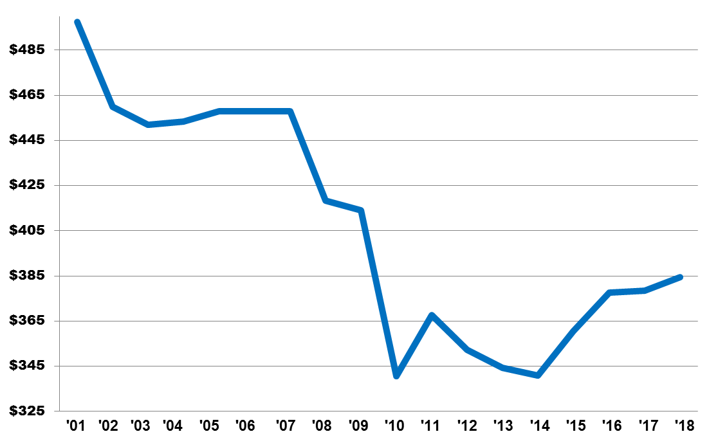
$497M
$384M

Fiscal Year | PLF Percentage of GRF Taxes | PLF Distributions
2008 | 2.22% | $418.2
2009 | 2.22% | $414.2
2010 | 1.97% | $340.6
2011 | 1.97% | $367.6
2012 | Freeze with 95% | $352.2
2013 | Freeze with 95% | $344.3
2014 | 1.66% | $341.0
2015 | 1.66% | $360.5
2016 | 1.7% | $377.6
2017 | 1.7% | $378.5
2018 | 1.68% | $384.6

Fiscal Year Public Library Fund (PLF) Distributions in Millions
Attachment B

Public libraries offer Ohioans a wide variety of programs, services, and materials based on the needs of their local community, including, but not limited to:

Examples of Lending Examples of Services
Personal Wi-Fi Devices Wi-Fi
Laptops, Tablets & iPads 3-D Printers
Musical Instruments Homework Help Centers
Digital Materials (eBooks, eAudiobooks, etc.) MakerSpaces
Artwork eGovernment Assistance
Bicycles Income Tax Assistance/Tax Form Booklets
Auto Code Readers Job Search Assistance
Tools (Air Quality Monitors/Energy Check) Resume Assistance
Toys (Including Adaptive Toys) Storytime
Physical Books, Music, Movies Summer Food Service Program Feeding Sites
Kitchen Equipment Musical & Theatrical Performances
Memory Kits Passport Services
Early Learning Kits Summer Reading Programs
Telescopes Early Literacy Programs (Ready to Read)
Board Games Early Childhood Programs (Ready for Kindergarten)
Educational/Computer/Technology Programs/Classes
GED/ACT/SAT Test Preparation Programs
Meeting Room Space
Polling Locations & Training
Computers
Online Educational Courses
Yoga
Cooking Classes

