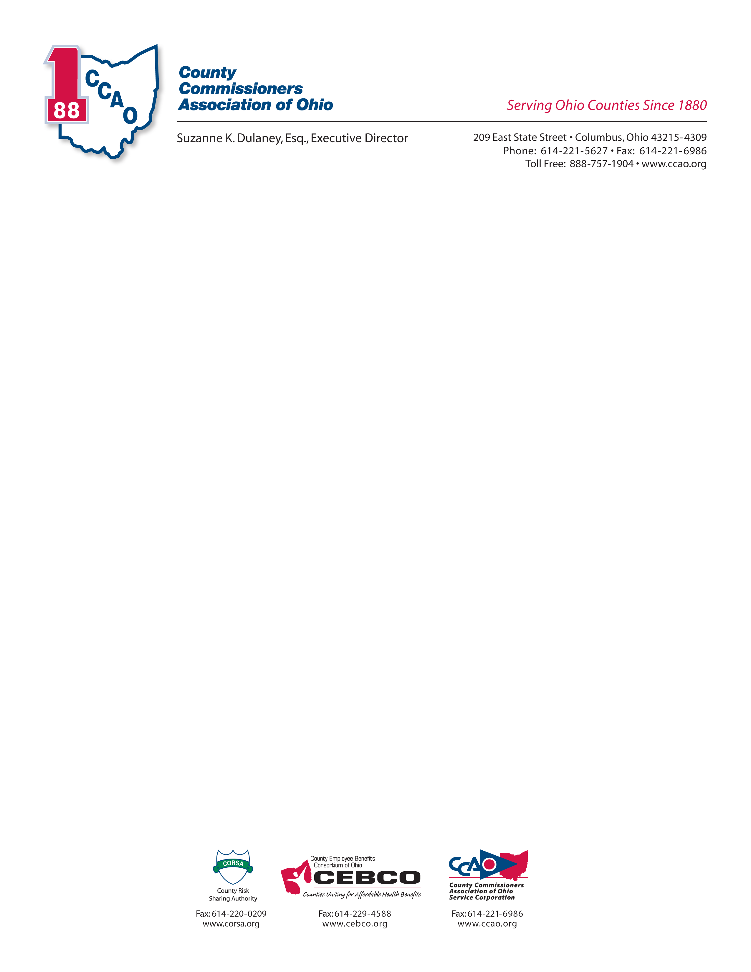

May 23, 2019

OHIO SENATE FINANCE COMMITTEE

PROPONENT TESTIMONY- SUBSTITUTE HOUSE BILL 166

Julie Ehemann, Shelby County Commissioner

Chair Dolan, Vice Chair Burke, Ranking Member Sykes, and members of the Senate Finance Committee, I am Julie Ehemann, a Shelby County Commissioner and President of the County Commissioners Association of Ohio (CCAO). I have served in an elected position in local government for 25 years.

Ohio’s 88 counties serve as the arm of state government charged with providing vital services on the state’s behalf. The counties and the state are fundamentally connected, and it is our shared responsibility to make Ohio stronger so that our citizens and communities can thrive.

As you are aware, Ohio counties have experienced a collective $351 million annual revenue loss due to reductions in the Local Government Fund, Medicaid Managed Care sales tax elimination, and tangible personal property tax. Ohio counties are also anticipating a $50 million collective sales tax revenue loss by State Fiscal Year 2021 due to the implementation of the prescription eyewear sales tax exemption and the expiration of Ohio’s grandfather clause to the federal Internet Tax Freedom Act of 1998.

CCAO’s main legislative priority for this budget is to have the state fully reimburse the counties for their costs incurred in fulfilling the state’s constitutional obligation to provide counsel to indigent defendants. Governor DeWine’s budget committed an additional $60 million each year in general revenue funds for indigent defense while the House included an additional $35M in the second year of the biennium with the intention of meeting our goal for full reimbursement. We are very appreciative of these investments and strongly encourage you to retain them.

Indigent defense is a demand driven service. Consequently, actual costs are hard to predict. Furthermore, we have recently learned that public defender system pressures may mean that what we thought would be a fully funded program in year two will likely fall short. We ask the Senate to work with us on adding language and funding that would provide a mechanism to transfer remaining dollars to fully fund the system in year two.

The House also added language that CCAO strongly supports to create a study committee to bring the requisite parties to the table to address system reforms to improve client services and provide greater efficiencies. We ask that you support this language.

In addition, the sales tax reforms currently contained in Substitute HB 166 are greatly appreciated by the counties and will help counties obtain revenue stability.

Moreover, the significant investment in supporting children’s services will strengthen our counties’ ability to make a difference in the lives of our most precious resource - our children.

The recently adopted transportation budget also was an important step in providing resources to allow counties to invest in our roads and bridges - critical infrastructure necessary to support Ohio’s economic health and prosperity.

There are two provisions added by the House that CCAO opposes and asks that you remove from the bill.

First, the House added a provision that requires the auditor to issue a warrant for money payable from the county treasury upon presentation of a court order, without the necessity for any evidentiary material. CCAO believes that all public officials, including the judicial branch, have an obligation to present basic information before spending tax dollars. This provision sets a bad precedent and undermines the oversight function of the auditor.

Second, CCAO is opposed to the inclusion of language freezing the level of property taxes on new residential development for up to three years or until the completion of the next six-year reappraisal. If this language goes into effect, property taxes will not change until the land is sold or construction begins, regardless of the auditor’s determination of fair market value. This tax exemption is an attempt to override local decision-making on land use, community planning, and economic development incentives.

Your actions in this budget proposal will lay a strong foundation for a meaningful state/county partnership that will serve Ohio well and improve the quality of life for the residents of our great state. Our slogan at CCAO is - Stronger counties, stronger partnership, stronger Ohio. We ask the Senate to join with the governor and House in giving real meaning to these words.

